Lesson 2: Scale Factors and Making Scaled Copies
Let’s draw scaled copies.

2.1: Number Talk: Multiplying by a Unit Fraction
Find each product mentally.
$\frac{1}{4}⋅32$
$\left(7.2\right)⋅\frac{1}{9}$
$\frac{1}{4}⋅\left(5.6\right)$

2.2: Scaled Triangles
Here is Triangle O, followed by a number of other triangles.
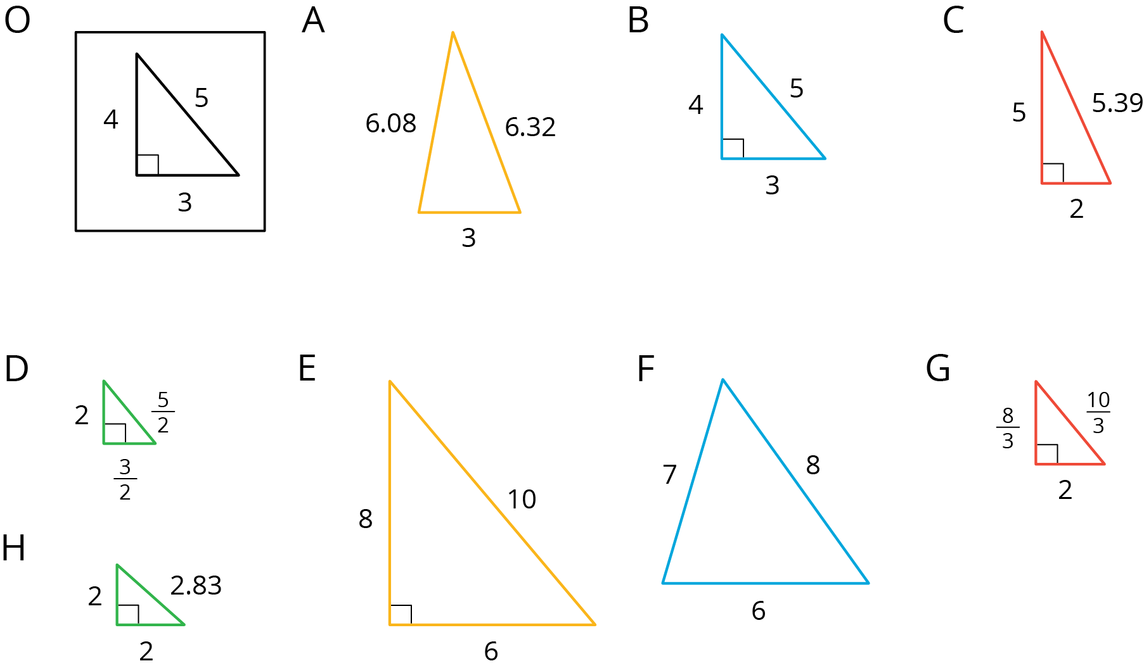
Your teacher will assign you two of the triangles to look at.
- For each of your assigned triangles, is it a scaled copy of Triangle O? Be prepared to explain your reasoning.
- As a group, identify all the scaled copies of Triangle O in the collection. Discuss your thinking. If you disagree, work to reach an agreement.
- List all the triangles that are scaled copies in the table. Record the side lengths that correspond to the side lengths of Triangle O listed in each column.
- Triangle O | - 3 | - 4 | - 5
- Explain or show how each copy has been scaled from the original (Triangle O).

Are you ready for more?
Choose one of the triangles that is not a scaled copy of Triangle O. Describe how you could change at least one side to make a scaled copy, while leaving at least one side unchanged.

2.3: Which Operations? (Part 1)
Diego and Jada want to scale this polygon so the side that corresponds to 15 units in the original is 5 units in the scaled copy.
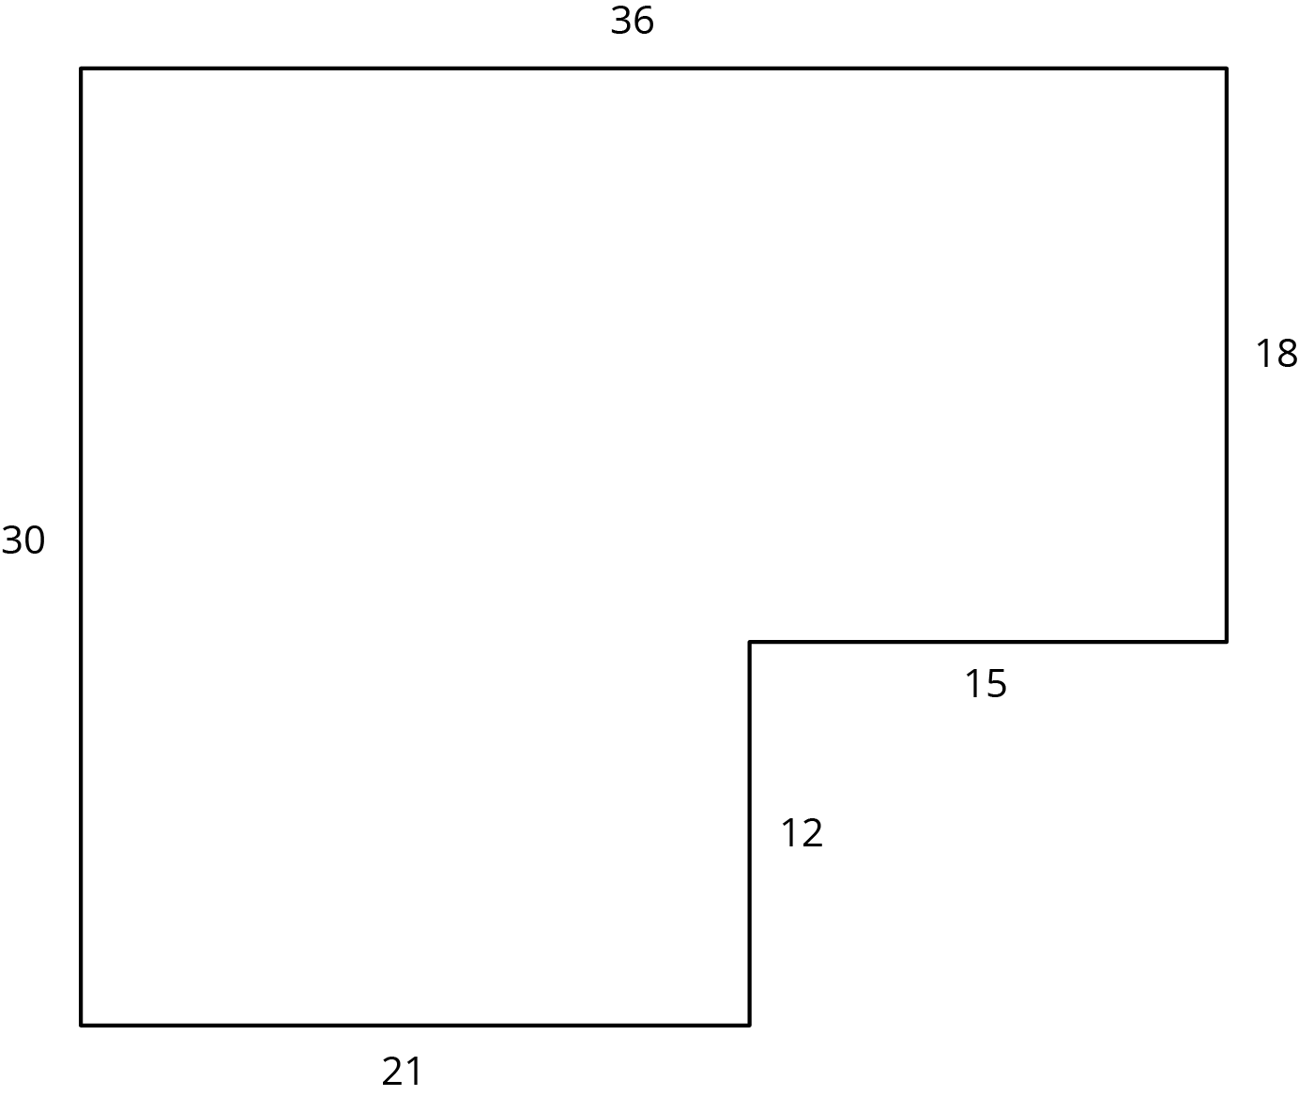
Diego and Jada each use a different operation to find the new side lengths. Here are their finished drawings.
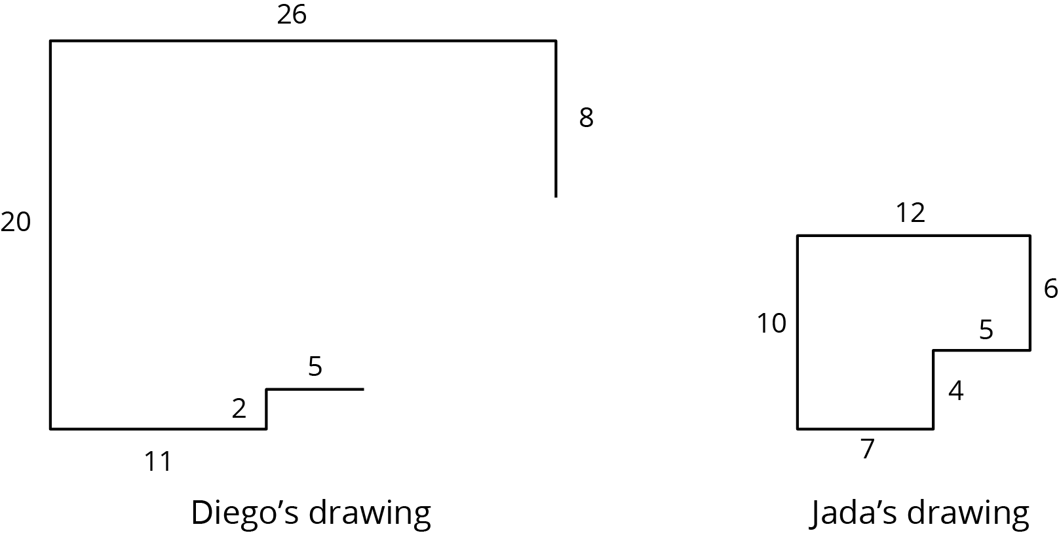
- What operation do you think Diego used to calculate the lengths for his drawing?
- What operation do you think Jada used to calculate the lengths for her drawing?
- Did each method produce a scaled copy of the polygon? Explain your reasoning.

2.4: Which Operations? (Part 2)
Andre wants to make a scaled copy of Jada's drawing so the side that corresponds to 4 units in Jada’s polygon is 8 units in his scaled copy.
- Andre says “I wonder if I should add 4 units to the lengths of all of the segments?” What would you say in response to Andre? Explain or show your reasoning.
- Create the scaled copy that Andre wants. If you get stuck, consider using the edge of an index card or paper to measure the lengths needed to draw the copy.
- 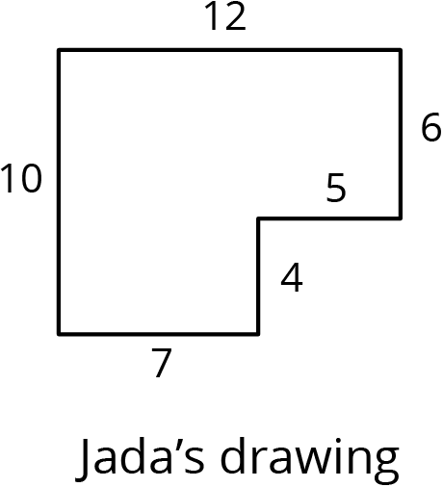

Are you ready for more?
The side lengths of Triangle B are all 5 more than the side lengths of Triangle A. Can Triangle B be a scaled copy of Triangle A? Explain your reasoning.

Lesson 2 Summary
Here are two polygons. Polygon 2 is a scaled copy of Polygon 1.
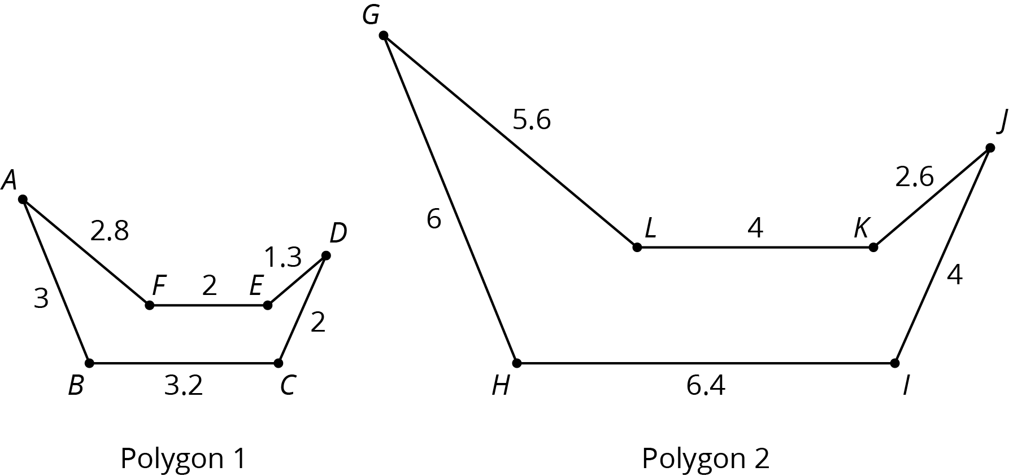
The scale factor between Polygon 1 and Polygon 2 is 2, because all of the lengths in Polygon 2 are 2 times the corresponding lengths in Polygon 1. The angle measures in Polygon 2 are the same as the corresponding angle measures in Polygon 1. For example, the measure of angle $JKL$ is the same as the measure of angle $DEF$.
Creating a scaled copy involves multiplying the lengths in the original figure by a scale factor.
For example, to make a scaled copy of triangle $ABC$ where the base is 8 units, we would use a scale factor of 4. This means multiplying all the side lengths by 4, so in triangle $DEF$, each side is 4 times as long as the corresponding side in triangle $ABC$.
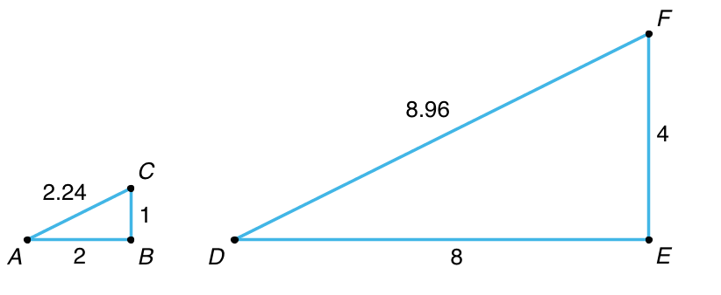
© CC BY Open Up Resources. Adaptations CC BY IM.

