Unit 2 Lesson 9: More, Fewer, or the Same

WU Questions About Us: Apples or Bananas? (Part 1) (Warm up)

Student Task Statement

1 Compare 5-frame Cards

Images for Launch
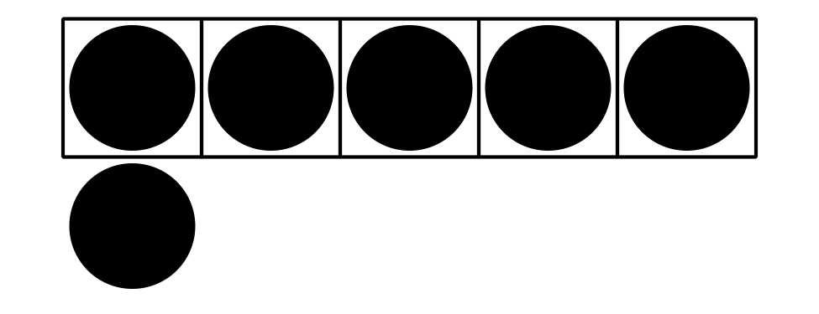

Student Task Statement

Activity Synthesis
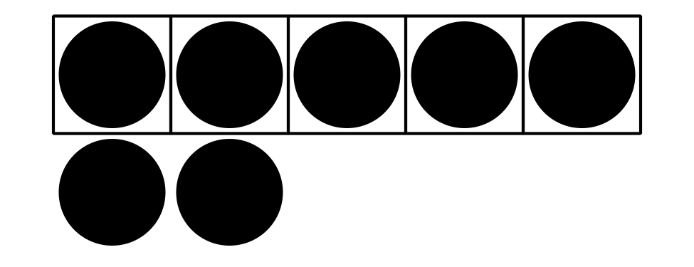

2 More and Fewer with 5-frames and Fingers

Images for Launch

Student Task Statement

Activity Synthesis
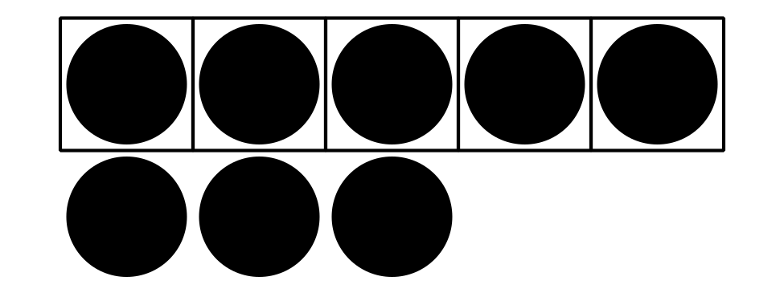

3 Introduce Bingo, Images

Images for Launch

Student Task Statement
Choose a center.
Bingo
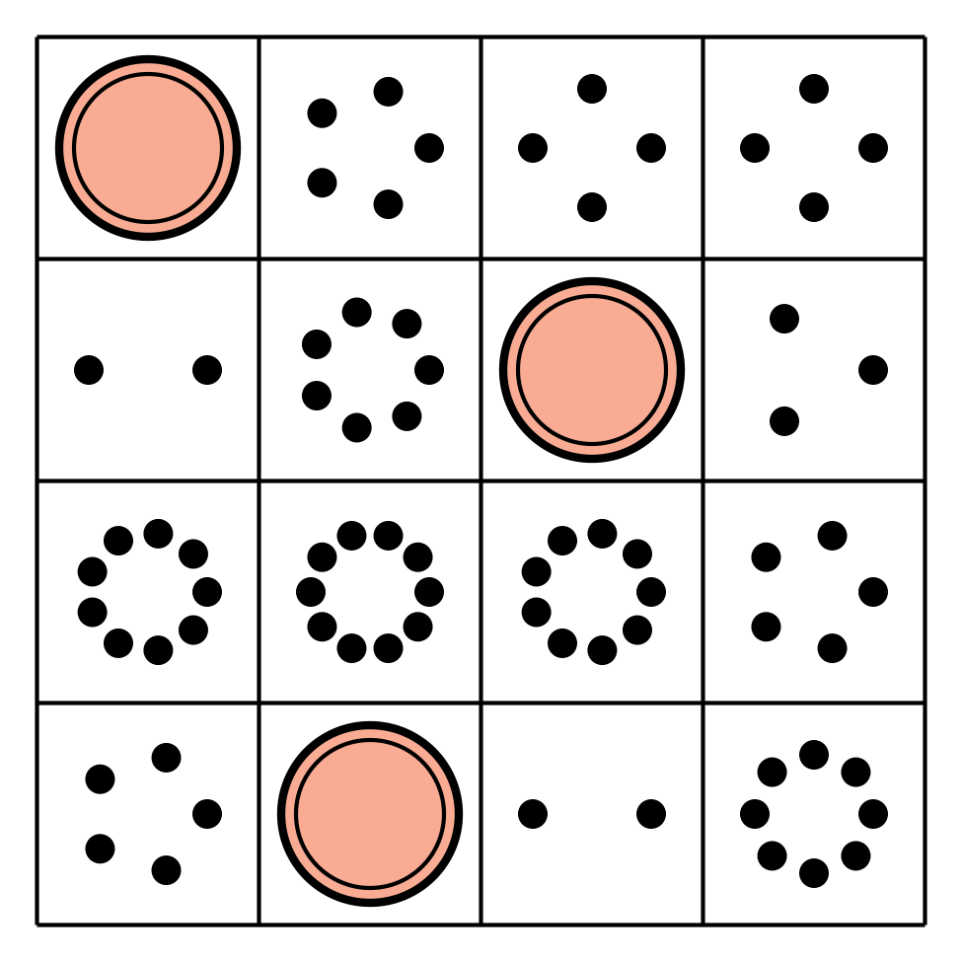
Math Stories
Connecting Cubes
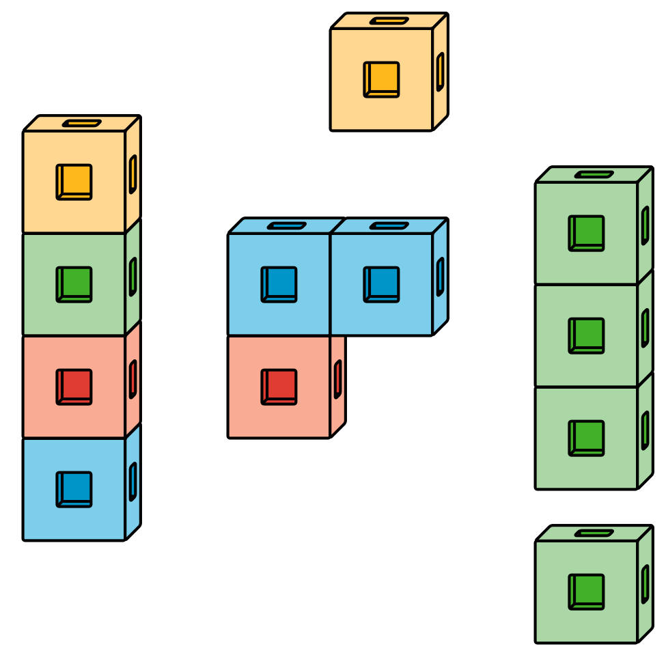
Number Race
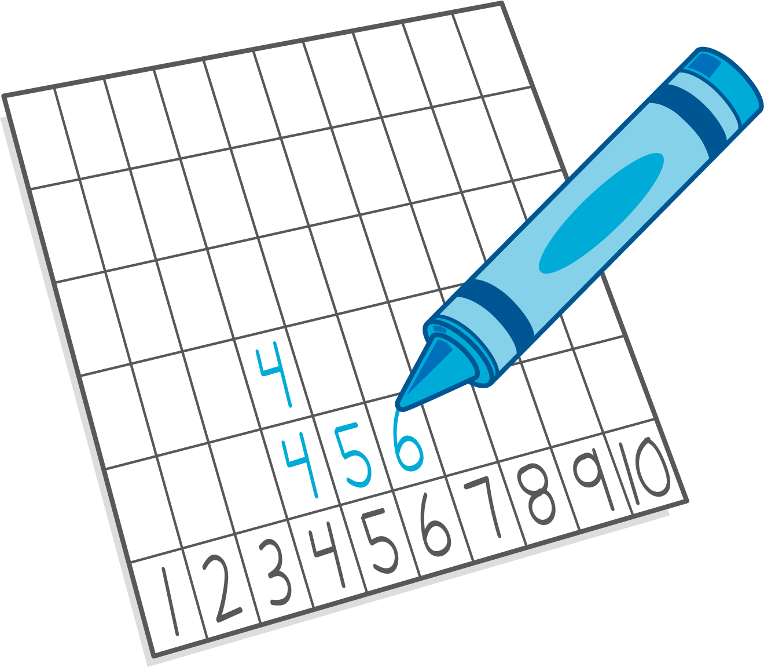

Images for Activity Synthesis
© CC BY 2021 Illustrative Mathematics®

