Unit 3 Lesson 4: Dilating Lines and Angles

1 Angle Articulation (Warm up)

Student Task Statement
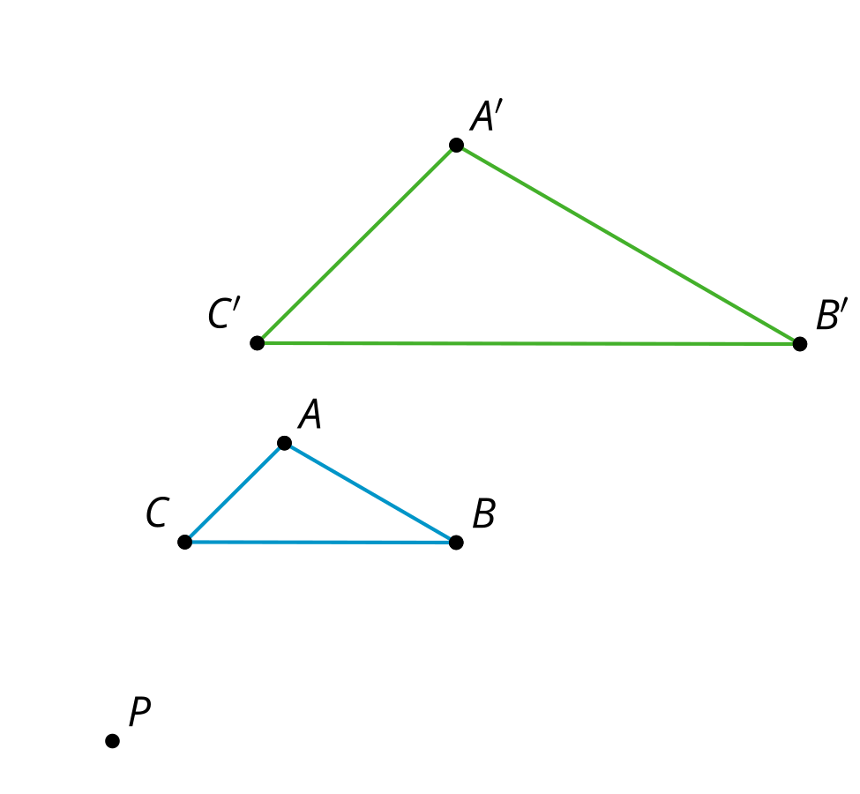
Triangle $A^{′}B^{′}C^{′}$ is a dilation of triangle $ABC$ using center $P$ and scale factor 2.
- What do you think is true about the angles in $A^{′}B^{′}C^{′}$ compared to the angles in $ABC$?
- Use the tools available to figure out if what you thought was true is definitely true for these triangles.
- Do you think it would be true for angles in any dilation?

Activity Synthesis

$△A^{′}B^{′}C^{′}$ is a dilation of $△ABC$ so $∠B≅∠B^{′}$
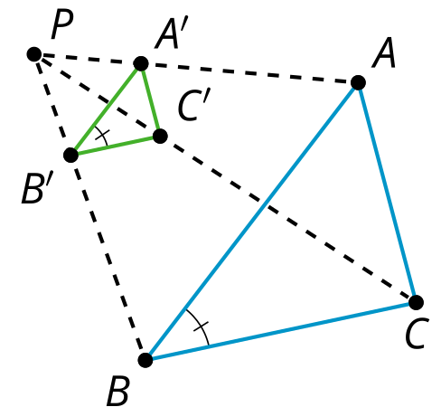

2 Dilating Lines

Student Task Statement
- Dilate point $A$ using center $C$ and scale factor $\frac{3}{4}$.
- Dilate point $B$ using center $C$ and scale factor $\frac{1}{3}$.
- Dilate point $D$ using center $C$ and scale factor $\frac{3}{2}$.
- Dilate line $CE$ using center $C$ and scale factor 2.
- What happens when the center of dilation is on a line and then you dilate the line?
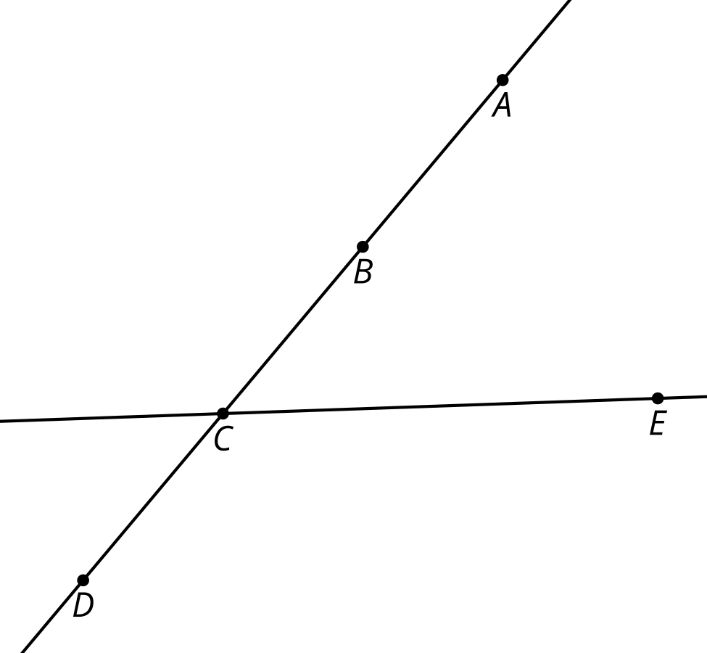

3 Proof in Parallel

Student Task Statement
Jada dilated triangle $ABC$ using center $P$ and scale factor 2.
- Jada claims that all the segments in $ABC$ are parallel to the corresponding segments in $A^{′}B^{′}C^{′}$. Write Jada's claim as a conjecture.
- Prove your conjecture.
- In Jada’s diagram the scale factor was greater than one. Would your proof have to change if the scale factor was less than one?

Activity Synthesis

Dilate using center $C$. $\overset{↔}{DE}∥\overset{↔}{D^{′}E^{′}}$
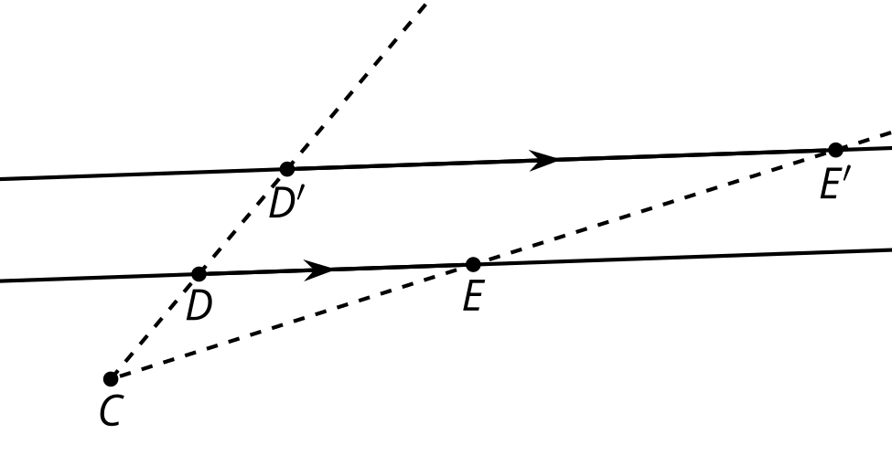
© CC BY 2019 by Illustrative Mathematics®

