Unit 6 Lesson 5: The Pythagorean Identity (Part 1)

1 Circle Equations (Warm up)

Student Task Statement
Here is a circle centered at $(0,0)$ with a radius of 1 unit.
What are the exact coordinates of $P$ if $P$ is rotated counterclockwise $\frac{π}{3}$ radians from the point $(1,0)$? Explain or show your reasoning.

2 Cosine, Sine, and the Unit Circle

Student Task Statement
What are the exact coordinates of point $Q$ if it is rotated $\frac{2π}{3}$ radians counterclockwise from the point $(1,0)$? Explain or show your reasoning.

3 A New Identity

Student Task Statement
- Is the point $\left(\text{-}0.5,\text{sin}(\frac{4π}{3})\right)$ on the unit circle? Explain or show your reasoning.
- Is the point $\left(\text{-}0.5,\text{sin}(\frac{5π}{6})\right)$ on the unit circle? Explain or show your reasoning.
- Suppose that $\text{sin}(θ)=\text{-}0.5$ and that $θ$ is in quadrant 4. What is the exact value of $\text{cos}(θ)$? Explain or show your reasoning.

Images for Activity Synthesis
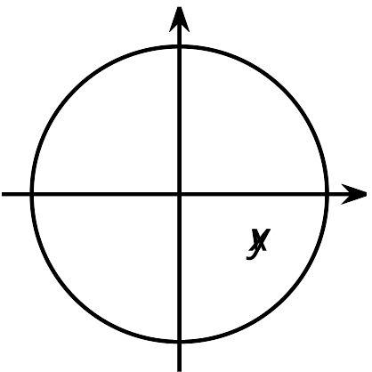
© CC BY 2019 by Illustrative Mathematics®

