Lesson 3 Practice Problems
- Solve each equation mentally.
  - $2x=10$
  - $\text{-}3x=21$
  - $\frac{1}{3}x=6$
  - $\text{-}\frac{1}{2}x=\text{-}7$
- (From Unit 5, Lesson 15.)
- Complete the magic squares so that the sum of each row, each column, and each diagonal in a grid are all equal.​
- 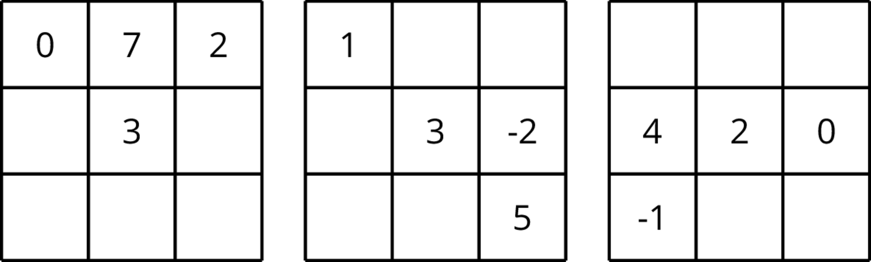
- (From Unit 5, Lesson 3.)
- Draw a tape diagram to match each equation.
  - $5\left(x+1\right)=20$
  - $5x+1=20$
- Select all the equations that match the tape diagram.
- 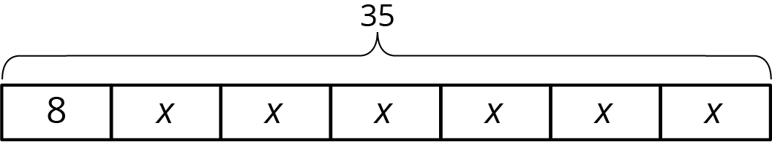
  - $35=8+x+x+x+x+x+x$
  - $35=8+6x$
  - $6+8x=35$
  - $6x+8=35$
  - $6x+8x=35x$
  - $35−8=6x$
- Each car is traveling at a constant speed. Find the number of miles each car travels in 1 hour at the given rate.
  - 135 miles in 3 hours
  - 22 miles in $\frac{1}{2}$ hour
  - 7.5 miles in $\frac{1}{4}$ hour
  - $\frac{100}{3}$ miles in $\frac{2}{3}$ hour
  - $97\frac{1}{2}$ miles in $\frac{3}{2}$ hour
- (From Unit 4, Lesson 2.)
© CC BY Open Up Resources. Adaptations CC BY IM.

