Unit 4 Lesson 12 Cumulative Practice Problems
- In this hanger, the weight of the triangle is $x$ and the weight of the square is $y$.
- 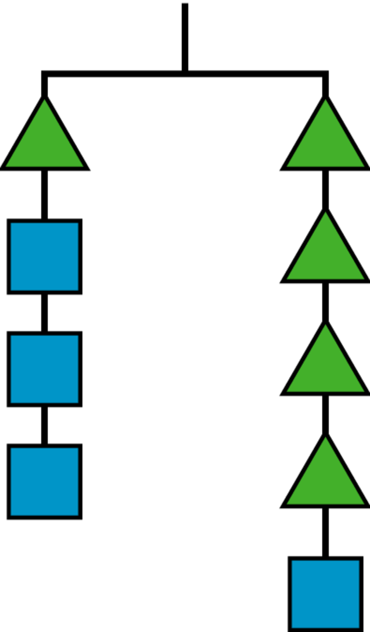
  - Write an equation using $x$ and $y$ to represent the hanger.
  - If $x$ is 6, what is $y$?
- Andre and Diego were each trying to solve $2x+6=3x−8$. Describe the first step they each make to the equation.
  - The result of Andre’s first step was $\text{-}x+6=\text{-}8$.

  - The result of Diego’s first step was $6=x−8$.
- Match each set of equations with the move that turned the first equation into the second.
  - $6x+9=4x−3$
$2x+9=\text{-}3$
  - $\text{-}4(5x−7)=\text{-}18$
$5x−7=4.5$
  - $8−10x=7+5x$
$4−10x=3+5x$
  - $\frac{\text{-}5x}{4}=4$
$5x=\text{-}16$
  - $12x+4=20x+24$
$3x+1=5x+6$
  - Multiply both sides by $\frac{\text{-}1}{4}$
  - Multiply both sides by $\text{-}4$
  - Multiply both sides by $\frac{1}{4}$
  - Add $\text{-}4x$ to both sides
  - Add $\text{-}4$ to both sides
- What is the weight of a square if a triangle weighs 4 grams?
- Explain your reasoning.
- 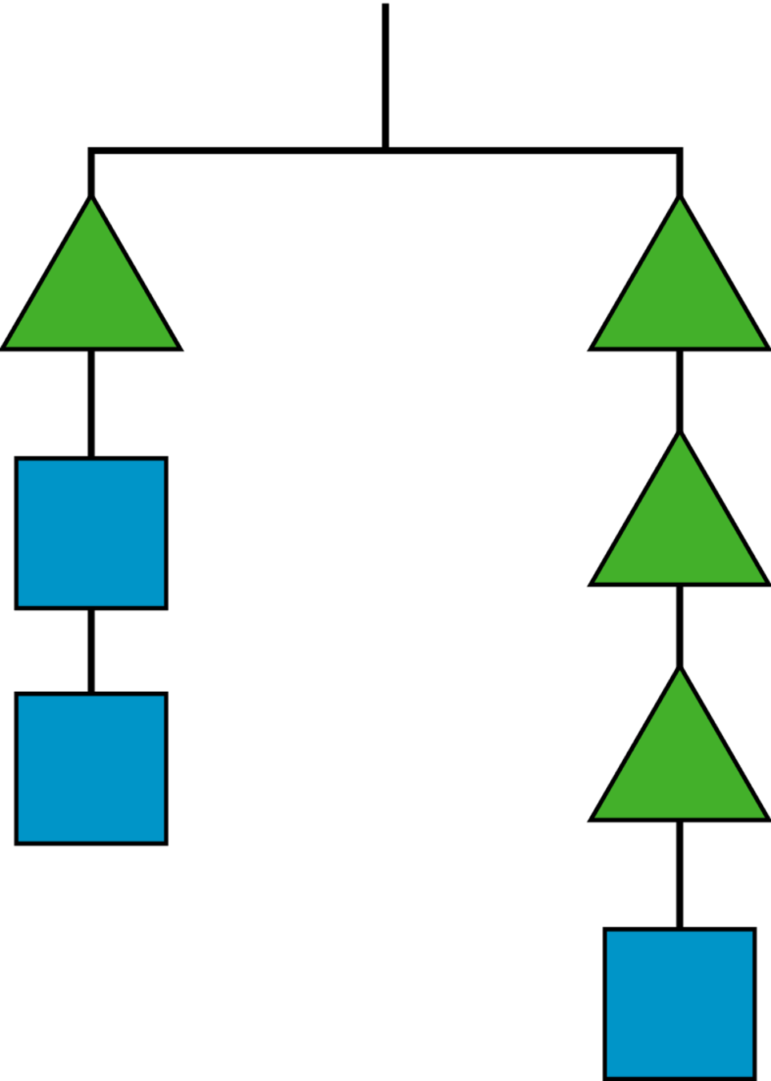
- Here is a balanced hanger diagram.
- Each triangle weighs 2.5 pounds, each circle weighs 3 pounds, and $x$ represents the weight of each square. Select all equations that represent the hanger.
- 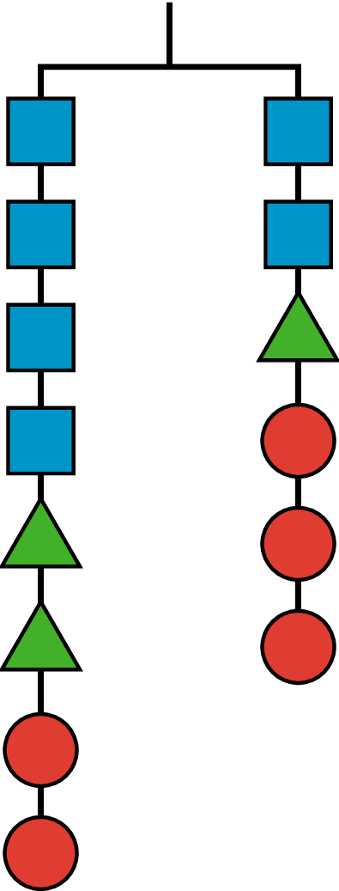
  - $x+x+x+x+11=x+11.5$
  - $2x=0.5$
  - $4x+5+6=2x+2.5+6$
  - $2x+2.5=3$
  - $4x+2.5+2.5+3+3=2x+2.5+3+3+3$
© CC BY Open Up Resources. Adaptations CC BY IM.

