Lesson 10 Practice Problems
- Select all equations that are parallel to the line $2x+5y=8$.
  - $y=\frac{2}{5}x+4$
  - $y=\text{-}\frac{2}{5}x+4$
  - $y−2=\frac{5}{2}(x+1)$
  - $y−2=\text{-}\frac{2}{5}(x+1)$
  - $10x+5y=40$
- Prove that $ABCD$ is not a parallelogram.
- 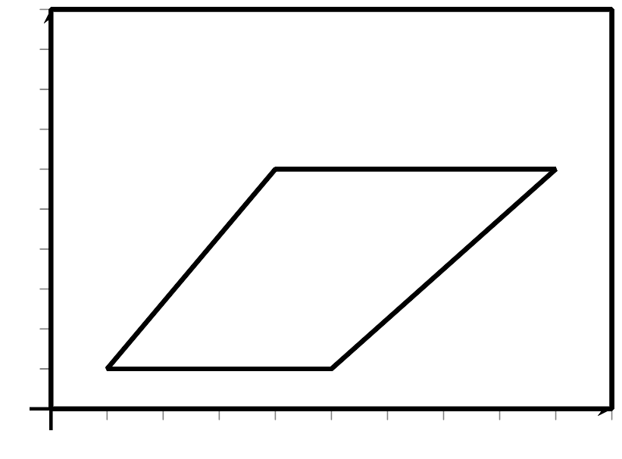
- Write an equation of a line that passes through $(\text{-}1,2)$ and is parallel to a line with $x$-intercept $(3,0)$ and $y$-intercept $(0,1)$.
- Write an equation of the line with slope $\frac{2}{3}$ that goes through the point $(\text{-}2,5)$.
- (From Unit 6, Lesson 9.)
- Priya and Han each wrote an equation of a line with slope $\frac{1}{3}$ that passes through the point $(1,2)$. Priya’s equation is $y−2=\frac{1}{3}(x−1)$ and Han’s equation is $3y−x=5$. Do you agree with either of them? Explain or show your reasoning.
- (From Unit 6, Lesson 9.)
- Match each equation with another equation whose graph is the same parabola.
  - $(x−3)^{2}+(y−2)^{2}=y^{2}$
  - $(x−2)^{2}+(y−3)^{2}=(y+3)^{2}$
  - $(x−3)^{2}+(y−4)^{2}=(y+2)^{2}$
  - $(x−2)^{2}+(y−2)^{2}=(y+2)^{2}$
  - $y=\frac{1}{8}(x−2)^{2}$
  - $y=\frac{1}{12}(x−2)^{2}$
  - $y=\frac{1}{4}(x−3)^{2}+1$
  - $y=\frac{1}{12}(x−3)^{2}+1$
- (From Unit 6, Lesson 8.)
- A parabola is defined as the set of points the same distance from $(\text{-}1,3)$ and the line $y=5$. Select the point that is on this parabola.
  - $(\text{-}1,3)$
  - $(0,5)$
  - $(3,0)$
  - $(0,0)$
- (From Unit 6, Lesson 7.)
- Here are some transformation rules. For each rule, describe whether the transformation is a rigid motion, a dilation, or neither.
  - $(x,y)→(2x,y+2)$
  - $(x,y)→(2x,2y)$
  - $(x,y)→(x+2,y+2)$
  - $(x,y)→(x−2,y)$
- (From Unit 6, Lesson 2.)
© CC BY 2019 by Illustrative Mathematics®

