Lesson 18: Problemas sobre dinero

Standards Alignments
Addressing | 2.MD.C.8, 2.NBT.B.5, 2.OA.A.1

Teacher-facing Learning Goals
- Solve addition and subtraction story problems in the context of money.

Student-facing Learning Goals
- Resolvamos problemas sobre dinero.

Lesson Purpose
The purpose of this lesson is for students to use addition and subtraction to solve story problems in the context of money.
In previous lessons, students used addition to find the total value of a set of coins and identified 100 cents as a dollar.
In this lesson, students solve story problems in the context of money. In the first activity, students continue practicing finding the value of a collection of coins and use the coins and their total value to solve problems in the context of a class store. In the second activity, students add and subtract values in cents in the same context, but are not provided images of coins. The second activity also gives students an opportunity to solve two-step story problems where the first step is not explicitly stated.

Access for:

Students with Disabilities
- Engagement (Activity 1)

English Learners
- MLR5 (Activity 1)

Instructional Routines
How Many Do You See? (Warm-up)

Lesson Timeline
Warm-up | 10 min
Activity 1 | 15 min
Activity 2 | 20 min
Lesson Synthesis | 10 min
Cool-down | 5 min

Teacher Reflection Question
Reflect on who participated in math class today. What assumptions are you making about those who did not participate? How can you leverage each of your student’s ideas to support them in being seen and heard in tomorrow’s math class?

Cool-down
(to be completed at the end of the lesson) 5min
Los útiles de Mai

Standards Alignments
Addressing | 2.MD.C.8

Student-facing Task Statement
- Mai tiene estas monedas para comprar sus útiles escolares:
- 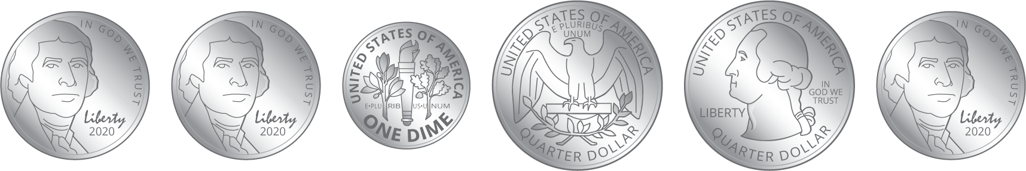
  - ¿Cuánto dinero tiene Mai para los útiles?
  - Si Mai compra un lápiz por 27¢, ¿cuánto dinero le quedará?
Muestra cómo pensaste. Usa dibujos, números, palabras o una ecuación. Si te ayuda, puedes usar un diagrama.

Student Responses

  - 75¢ Sample response:
$25+25=50$
$50+10=60$
$60+15=75$
  - 48¢ Sample responses:
$75−27=48$
$75−20=55$
$55−5=50$
$50−2=48$

