Unit 2 Lesson 6: Use More, Fewer, or the Same Number to Describe Groups

WU How Many Do You See: Fingers 1–10 (Warm up)

Images for Launch

Student Task Statement

1 Match Bags to Comparison Statements

Student Task Statement

2 Cube Tower Walk and Talk

Student Task Statement

3 Centers: Choice Time

Student Task Statement
Choose a center.
Less, Same, More
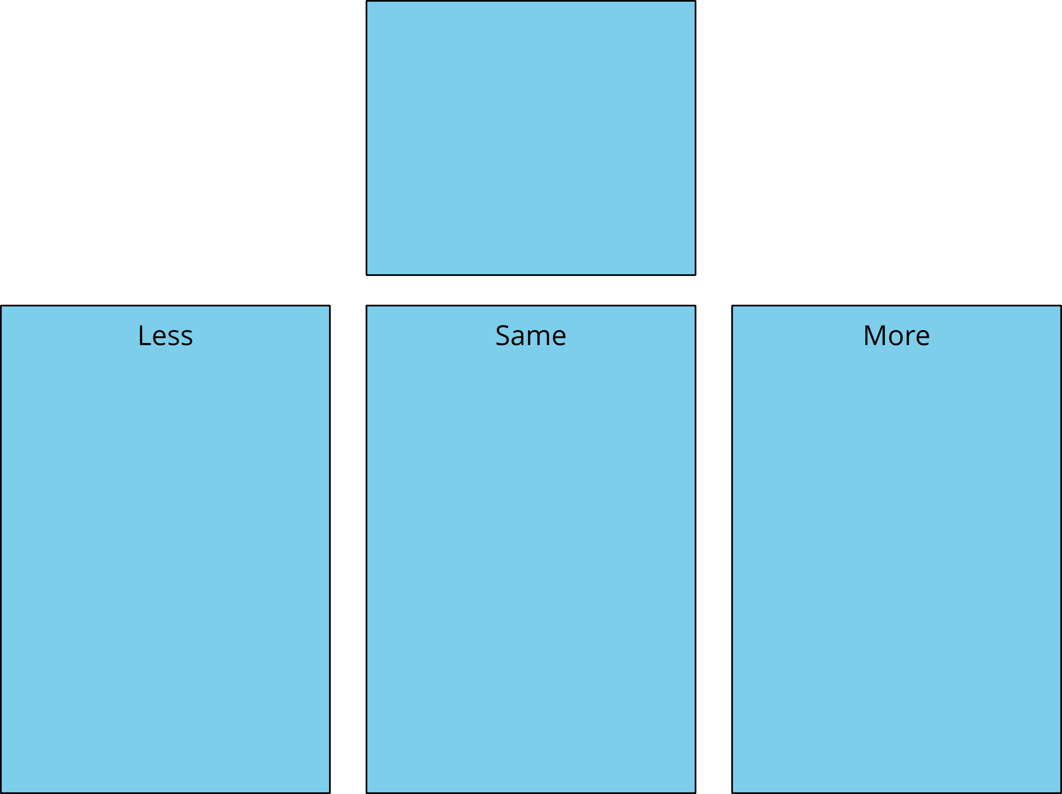
Shake and Spill
Number Race
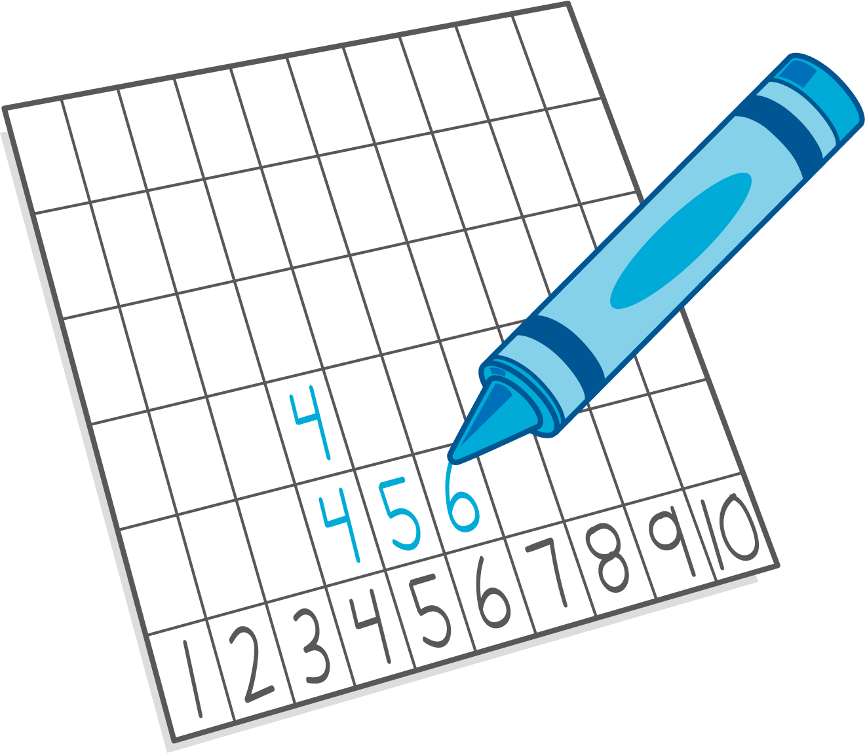
Math Fingers
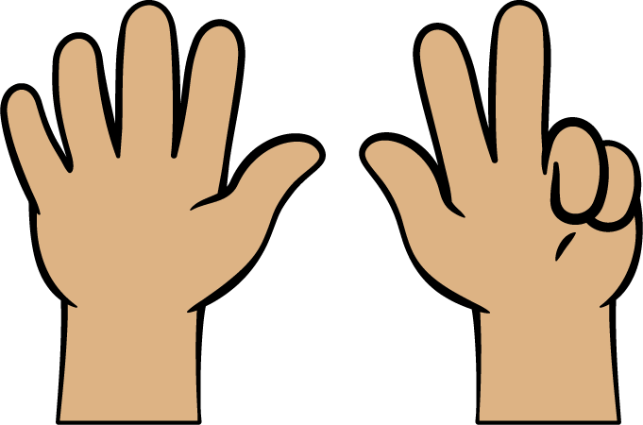
Pattern Blocks
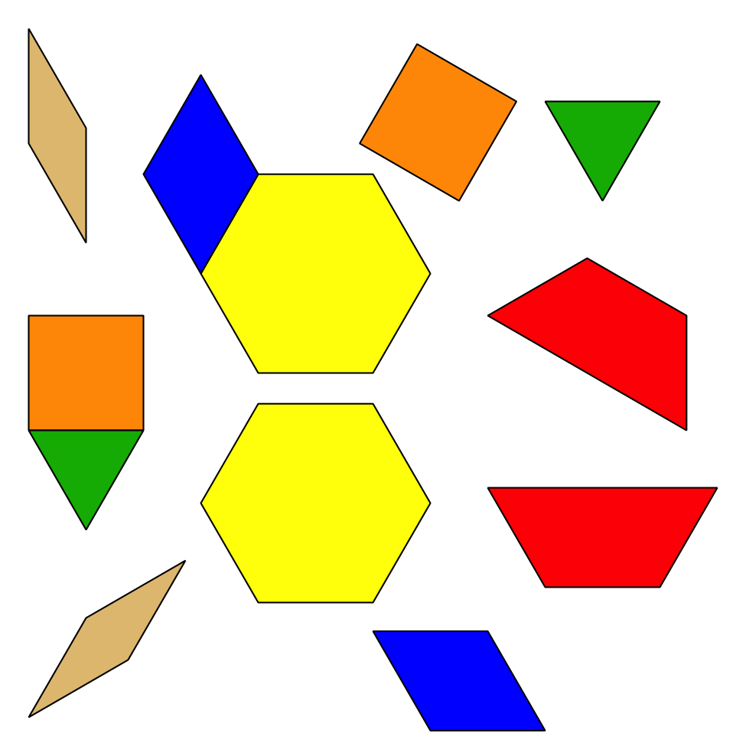
Picture Books
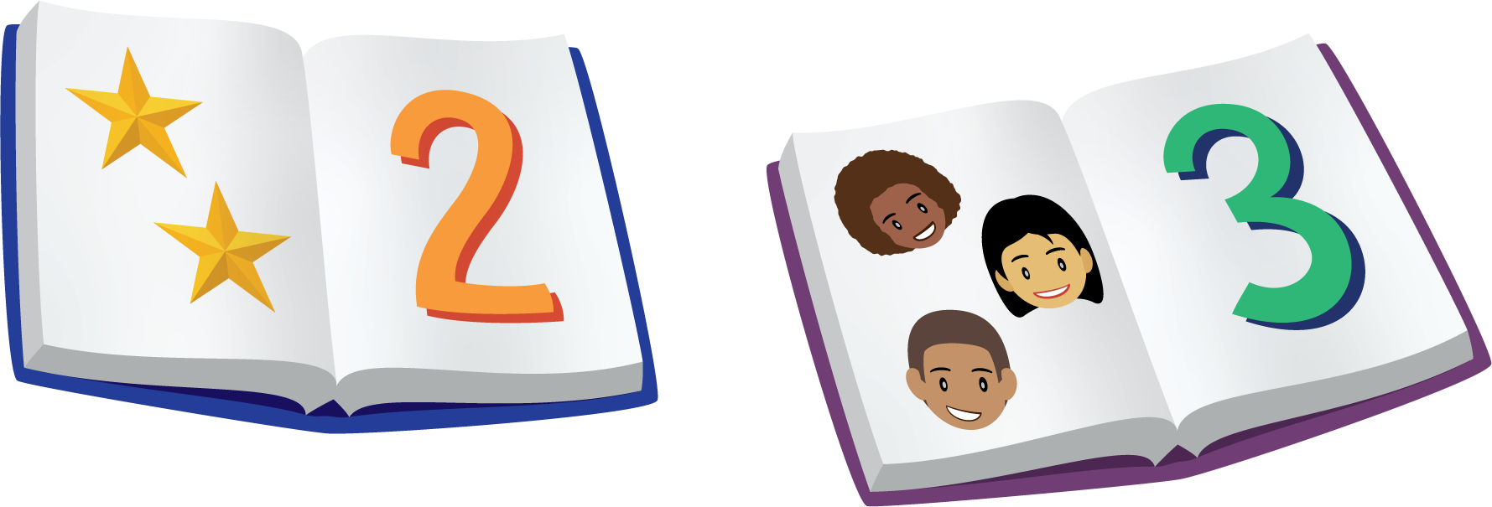
© CC BY 2021 Illustrative Mathematics®

