Unit 5 Lesson 12: Connections between Graphs and Equations

1 Math Talk: Evaluating a Function (Warm up)

Student Task Statement
Here is a function: $g\left(x\right)=100−5x$
Evaluate mentally:
$g\left(0\right)$
$g\left(1\right)$
$g\left(4\right)$
$g\left(20\right)$

2 Bank Accounts

Student Task Statement
Each function represents the amount in a bank account after $t$ weeks.
$A\left(t\right)=500$
$B\left(t\right)=500+40t$
$C\left(t\right)=500−40t$
$D\left(t\right)=500⋅{\left(1.5\right)}^{t}$
$E\left(t\right)=500⋅{\left(0.75\right)}^{t}$

- Make a table for each bank account showing the money in the account at 0, 1, 2, and 3 weeks.
- Describe in words how the money in the account is changing week by week.
- Use technology to create a graph of each function. How can you see your description in each graph?

3 Build a New Function

Student Task Statement
Consider the same five functions:
$A\left(t\right)=500$
$B\left(t\right)=500+40t$
$C\left(t\right)=500−40t$
$D\left(t\right)=500⋅{\left(1.5\right)}^{t}$
$E\left(t\right)=500⋅{\left(0.75\right)}^{t}$

- Starting with one of the functions, change it so that it represents an account that . . .
  - Starts with a balance of $300, and loses $40 each week.
  - Starts with a balance of $500, and gains $15 each week.
  - Starts with a balance of $500, and loses $\frac{1}{10}$ of its value each week.
  - Starts with a balance of $700, and gains $\frac{3}{10}$ of its value each week.
- Here are four graphs. Which graph matches each of your new equations?

- graph 1
- 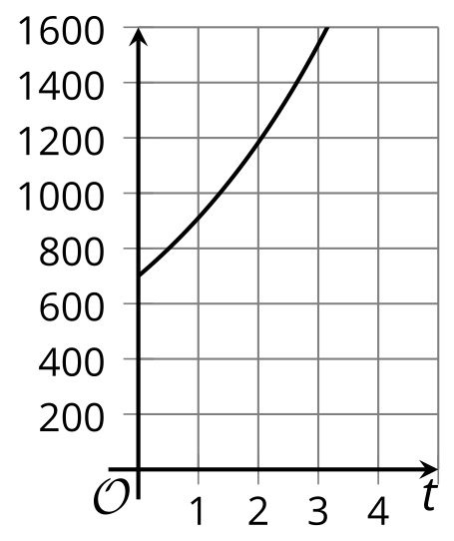

- graph 2
- 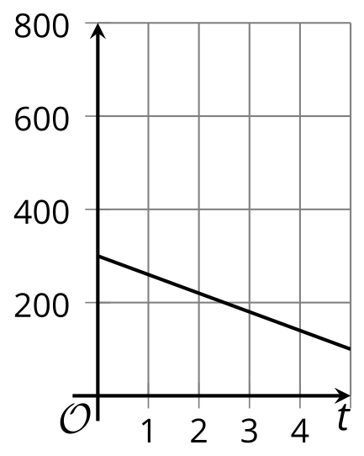

- graph 3
- 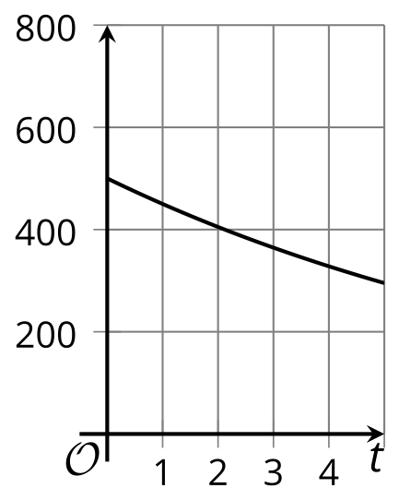

- graph 4
- 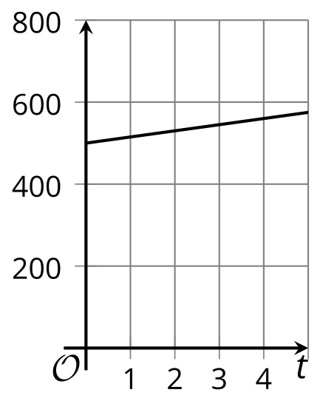
- To check, use technology to graph your equations. Make sure to use the same graphing window. Check that the graph of your equation matches the graph you chose.
© CC BY 2019 by Illustrative Mathematics®

