Unit 4 Lesson 5 Cumulative Practice Problems
- Solve each of these equations. Explain or show your reasoning.
- $2(x+5)=3x+1$
- $3y−4=6−2y$
- $3(n+2)=9(6−n)$

- Clare was solving an equation, but when she checked her answer she saw her solution was incorrect. She knows she made a mistake, but she can’t find it. Where is Clare’s mistake and what is the solution to the equation?
- $\begin{matrix}12(5+2y) & =4y−(5−9y) \\ 72+24y & =4y−5−9y \\ 72+24y & =\text{-}5y−5 \\ 24y & =\text{-}5y−77 \\ 29y & =\text{-}77 \\ y & =\frac{\text{-}77}{29} \end{matrix}$
- Solve each equation, and check your solution.
- $\frac{1}{9}(2m−16)=\frac{1}{3}(2m+4)$
- $\text{-}4(r+2)=4(2−2r)$
- $12(5+2y)=4y−(6−9y)$

- Here is the graph of a linear equation.
- Select all true statements about the line and its equation.
- 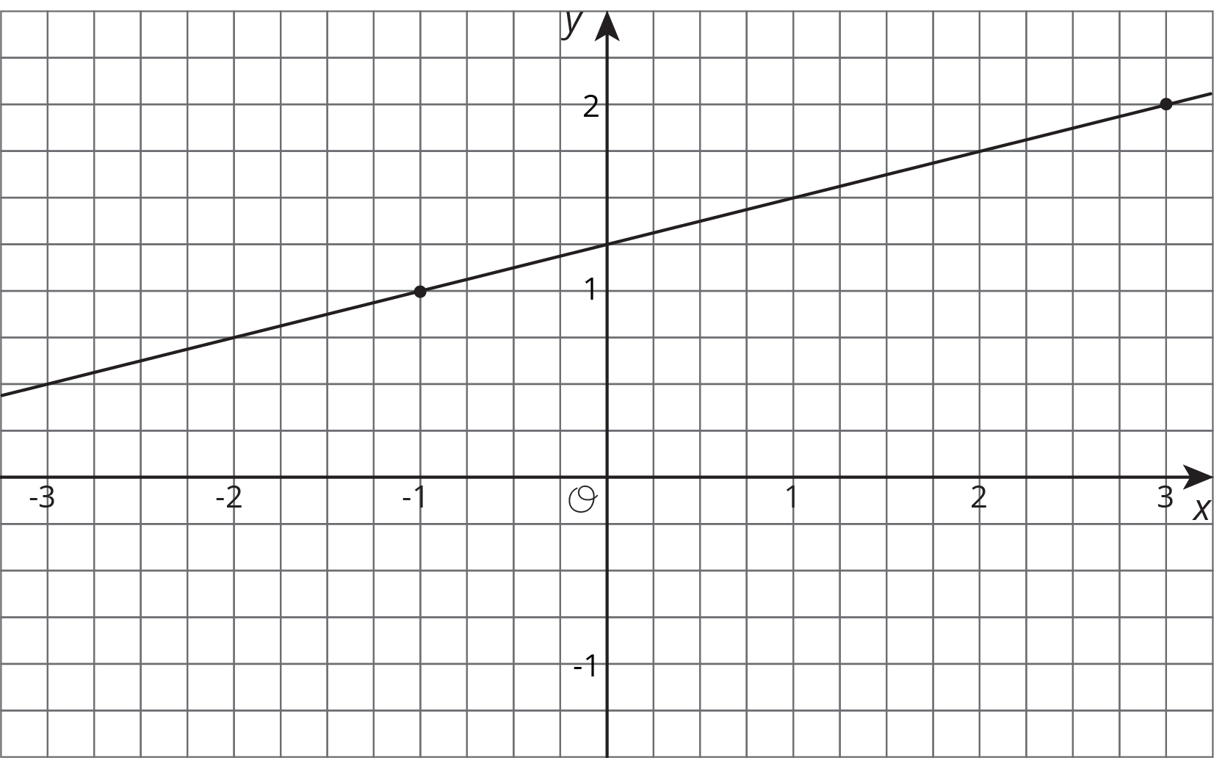
  - One solution of the equation is $(3,2)$.
  - One solution of the equation is $(\text{-}1,1)$.
  - One solution of the equation is $\left(1,\frac{3}{2}\right)$.
  - There are 2 solutions.
  - There are infinitely many solutions.
  - The equation of the line is $y=\frac{1}{4}x+\frac{5}{4}$.
  - The equation of the line is $y=\frac{5}{4}x+\frac{1}{4}$.
- (From Unit 3, Lesson 13.)
- A participant in a 21-mile walkathon walks at a steady rate of 3 miles per hour. He thinks, “The relationship between the number of miles left to walk and the number of hours I already walked can be represented by a line with slope $\text{-}3$.” Do you agree with his claim? Explain your reasoning.
- (From Unit 3, Lesson 9.)
© CC BY Open Up Resources. Adaptations CC BY IM.

