Unit 4 Lesson 22: Center Day 4

WU True or False: Tens and Ones (Warm up)

Student Task Statement
Decide if each statement is true or false.
Be prepared to explain your reasoning.
- $92=90+2$
- $90+2>80+12$
- $20+13<30+13$

1 Introduce Mystery Number, Two-digit Numbers

Student Task Statement

2 Center: Choice Time

Student Task Statement
Choose a center.
Mystery Number
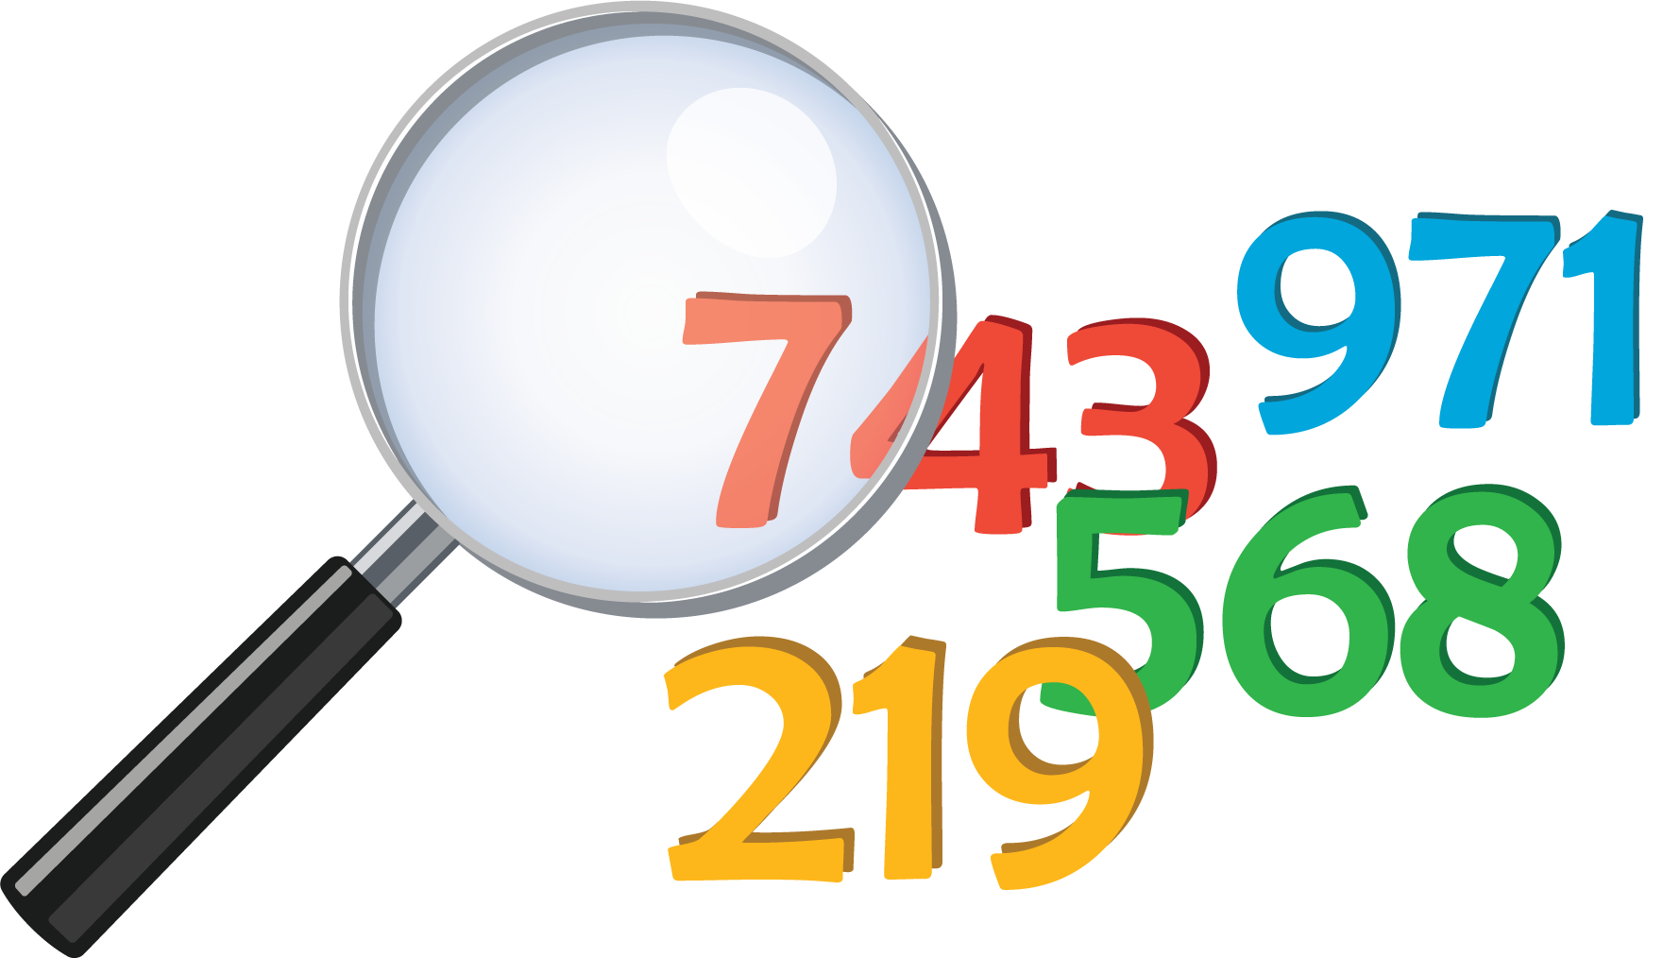
Get Your Numbers in Order
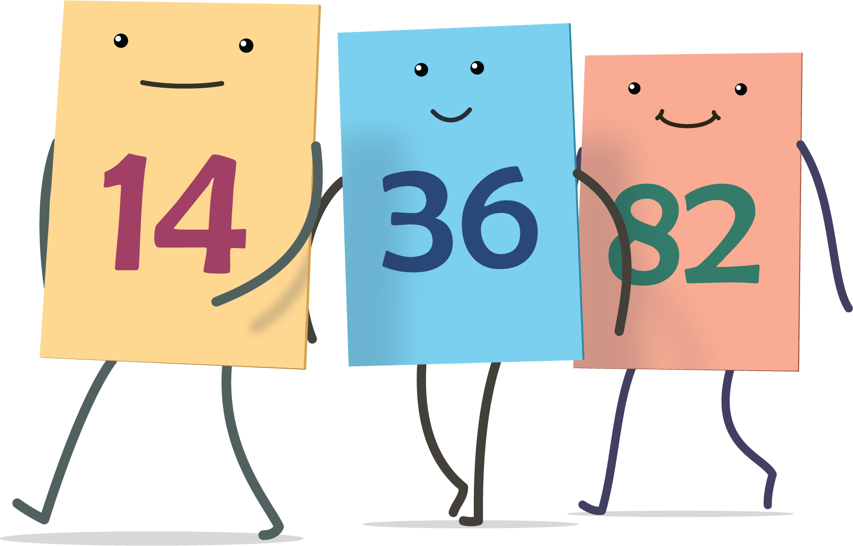
Greatest of Them All
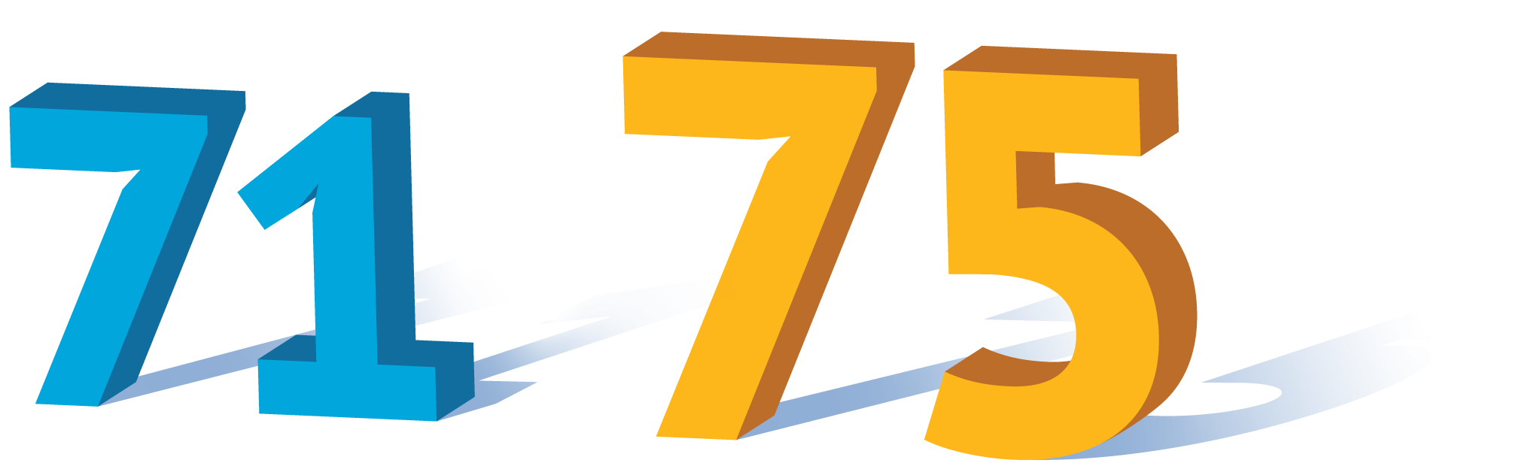
© CC BY 2021 Illustrative Mathematics®

