Unit 6 Lesson 15: Situations Involving Area

WU Estimation Exploration: Area of a Soccer Field (Warm up)

Student Task Statement
Estimate: What is the length of the soccer field in meters?
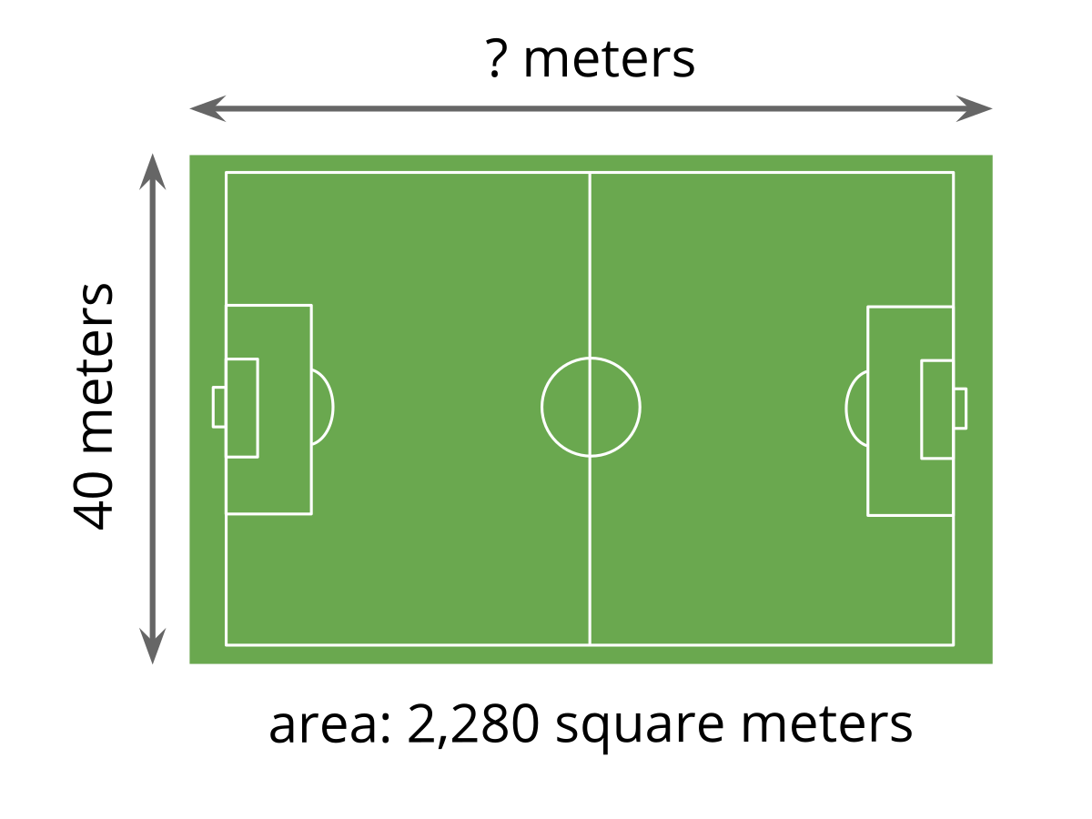
Record an estimate that is:
too low | about right | too high

1 Elena’s Mural

Student Task Statement
Elena used 189 square tiles to create a rectangular mural for the art club. The mural is 7 tiles wide.
- How many tiles long is Elena’s mural? Be prepared to explain or show how you know.
- Write one or more equations that show how you solved this problem.

2 Tyler’s Mural

Student Task Statement
Tyler is also creating a rectangular mural for the art club. He has 197 tiles for his mural. His mural is 6 tiles wide.
- Will Tyler use all of his tiles in the mural? Explain your reasoning.
- How many tiles long is Tyler’s mural? Show your reasoning using numbers, pictures, or words.
© CC BY 2021 Illustrative Mathematics®

