Unit 6 Lesson 6: The Pythagorean Identity (Part 2)

1 Math Talk: Which Quadrant? (Warm up)

Student Task Statement
For an angle $θ$ in the quadrant indicated, use mental estimation to identify the values of $\text{cos}(θ)$, $\text{sin}(θ)$, and $\text{tan}(θ)$ as either positive or negative.
Quadrant 1
Quadrant 2
Quadrant 3
Quadrant 4

Activity Synthesis
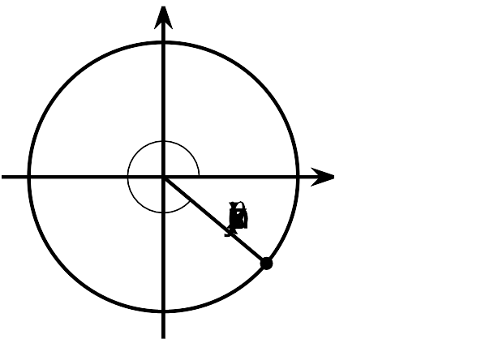

2 Andre's Calculations

Student Task Statement
Suppose that the angle $θ$, in radians, is in quadrant 4 of the unit circle. If $\text{cos}(θ)=0.28$, what are the values of $\text{sin}(θ)$ and $\text{tan}(θ)$?
Andre uses the Pythagorean Identity and determines that the value of $\text{sin}(θ)$ is -0.96. Using the values of sine and cosine, he then calculates the value of tangent:
$\begin{matrix}\text{tan}(θ) & =\frac{\text{sin}(θ)}{\text{cos}(θ)} \\ & =\frac{\text{-}0.96}{0.28} \\ & ≈\text{-}3.43\end{matrix}$
Do you agree with Andre? Explain or show your reasoning.

3 Card Sort: Where's the Point?

Student Task Statement
Your teacher will give you a set of cards that should be arranged face up with cards showing values for sine, cosine, and tangent on one side and cards showing quadrants on the other.
- Take turns with your partner matching pairs of cards. Identify 2 pairs that are possible on the unit circle and 2 pairs that are not possible, in any order.
  - For each pair, explain to your partner how you know if the pair is or is not possible on the unit circle. Once a pair is identified, place the cards in front of you to use later.
  - For each pair that your partner draws, listen carefully to their explanation. If you disagree, discuss your thinking and work to reach an agreement.
- Once you and your partner have identified 4 pairs each, pick 1 of your possible matches and then calculate the values of the two missing trigonometric ratios for that match. When you finish, trade calculations with your partner and check each other's work. If you disagree, discuss your thinking and work to reach an agreement.

Images for Activity Synthesis
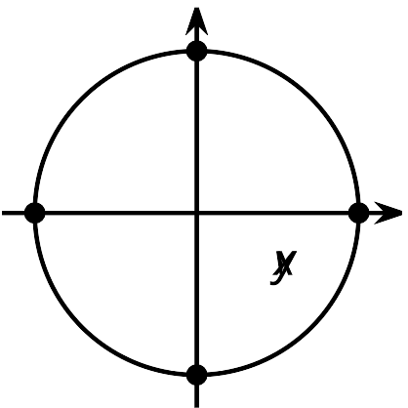
© CC BY 2019 by Illustrative Mathematics®

