Unit 3 Lesson 4: What Fraction of a Group?

1 Estimating a Fraction of a Number (Warm up)

Student Task Statement
- Estimate the quantities:
  - What is $\frac{1}{3}$ of 7?
  - What is $\frac{4}{5}$ of $9\frac{2}{3}$?
  - What is $2\frac{4}{7}$ of $10\frac{1}{9}$?
- Write a multiplication expression for each of the previous questions.

2 Fractions of Ropes

Student Task Statement
Here is a diagram that shows four ropes of different lengths.
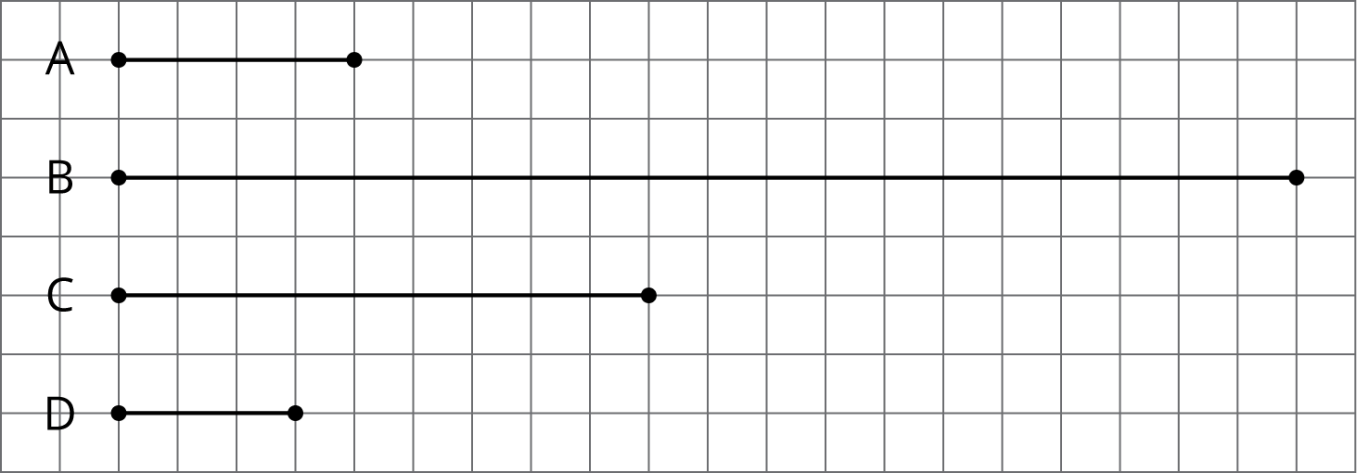
- Complete each sentence comparing the lengths of the ropes. Then, use the measurements shown on the grid to write a multiplication equation and a division equation for each comparison.
  - Rope B is _______ times as long as Rope A.
  - Rope C is _______ times as long as Rope A.
  - Rope D is _______ times as long as Rope A.
- Each equation can be used to answer a question about Ropes C and D. What could each question be?
  - $?⋅3=9$ and $9÷3=?$
  - $?⋅9=3$ and $3÷9=?$

3 Fractional Batches of Ice Cream

Images for Launch
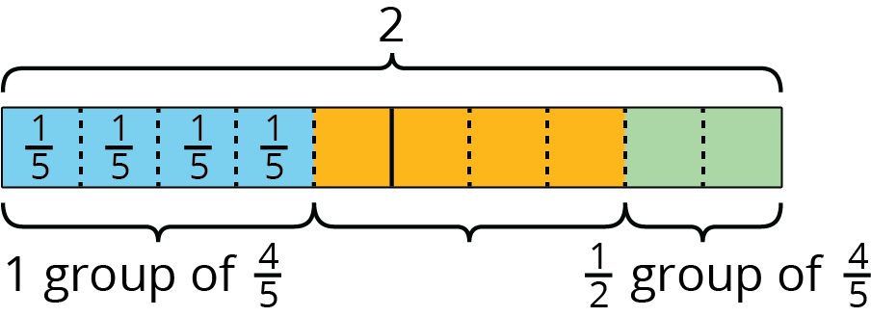
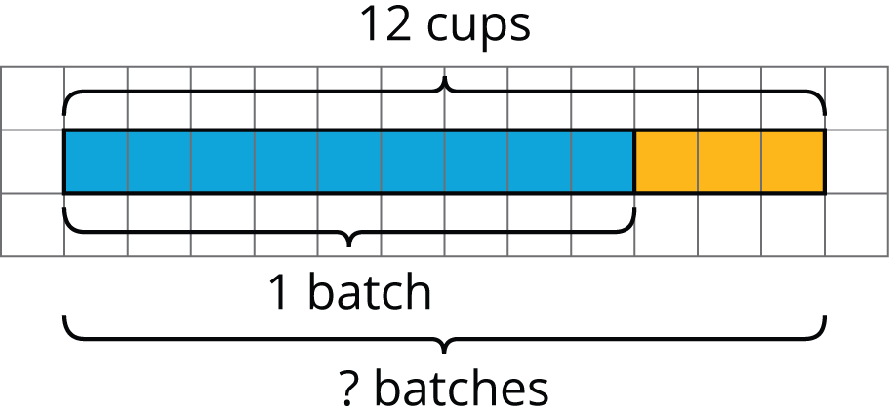
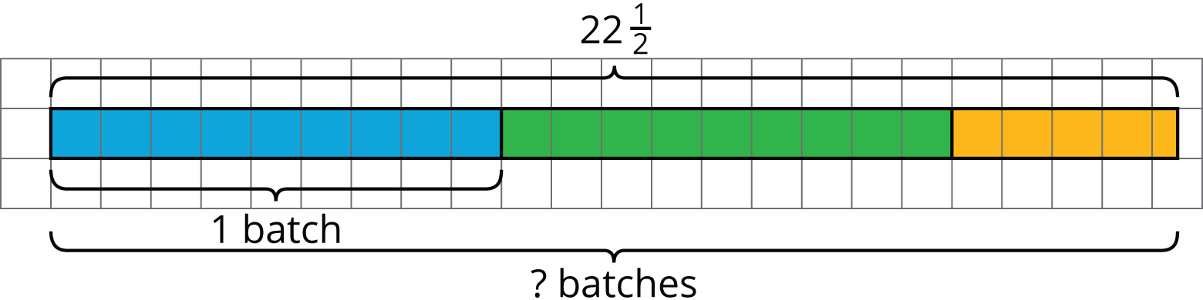
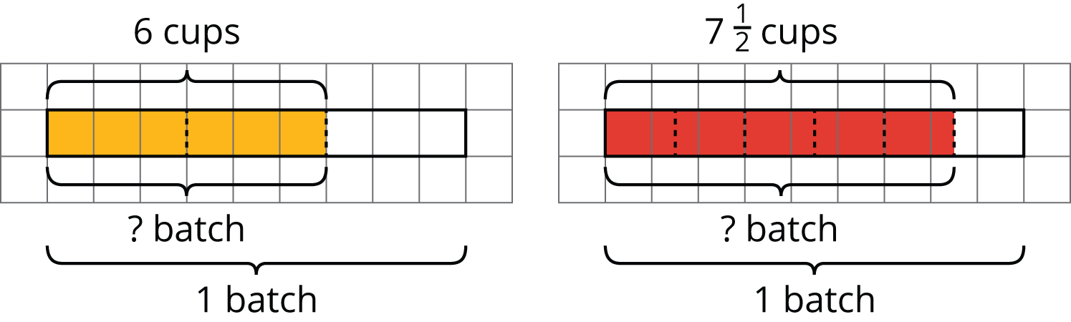

Student Task Statement
One batch of an ice cream recipe uses 9 cups of milk. A chef makes different amounts of ice cream on different days. Here are the amounts of milk she used:
- Monday: 12 cups
- Tuesday: $22\frac{1}{2}$ cups
- Thursday: 6 cups
- Friday: $7\frac{1}{2}$ cups
- How many batches of ice cream did she make on these days? For each day, write a division equation, draw a tape diagram, and find the answer.
  - Monday
  - Tuesday
- What fraction of a batch of ice cream did she make on these days? For each day, write a division equation, draw a tape diagram, and find the answer.
  - Thursday
  - Friday
- For each question, write a division equation, draw a tape diagram, and find the answer.
  - What fraction of 9 is 3?
  - What fraction of 5 is $\frac{1}{2}$?

Activity Synthesis
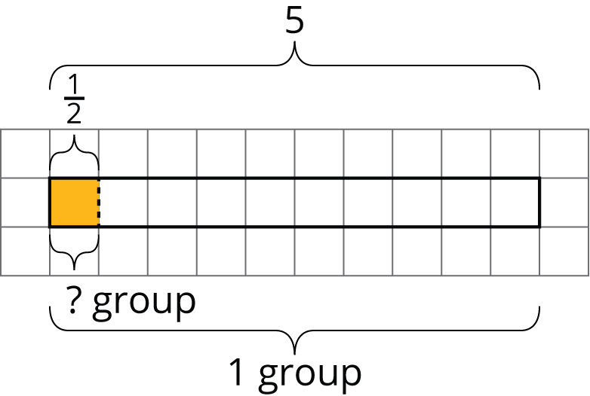
© CC BY Open Up Resources. Adaptations CC BY IM.

