Unit 2 Lesson 7: Count Images in Different Arrangements

WU Questions About Us: Dogs or Cats? (Part 1) (Warm up)

Student Task Statement

1 Images in Stations

Student Task Statement

Activity Synthesis

2 Count Images (Optional)

Student Task Statement

3 Introduce Math Stories, How Many?

Student Task Statement
Choose a center.
Math Stories
Connecting Cubes
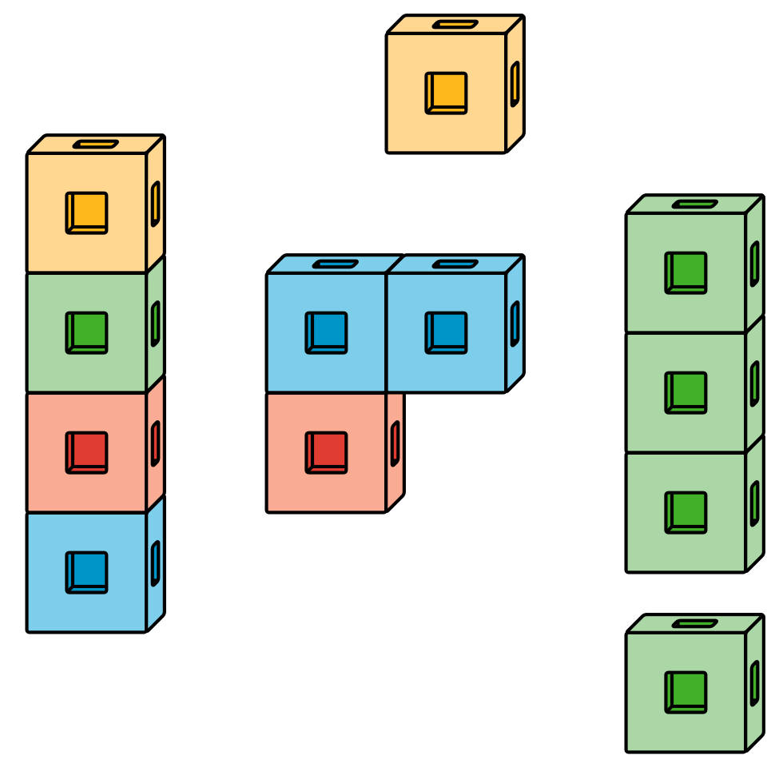
Number Race
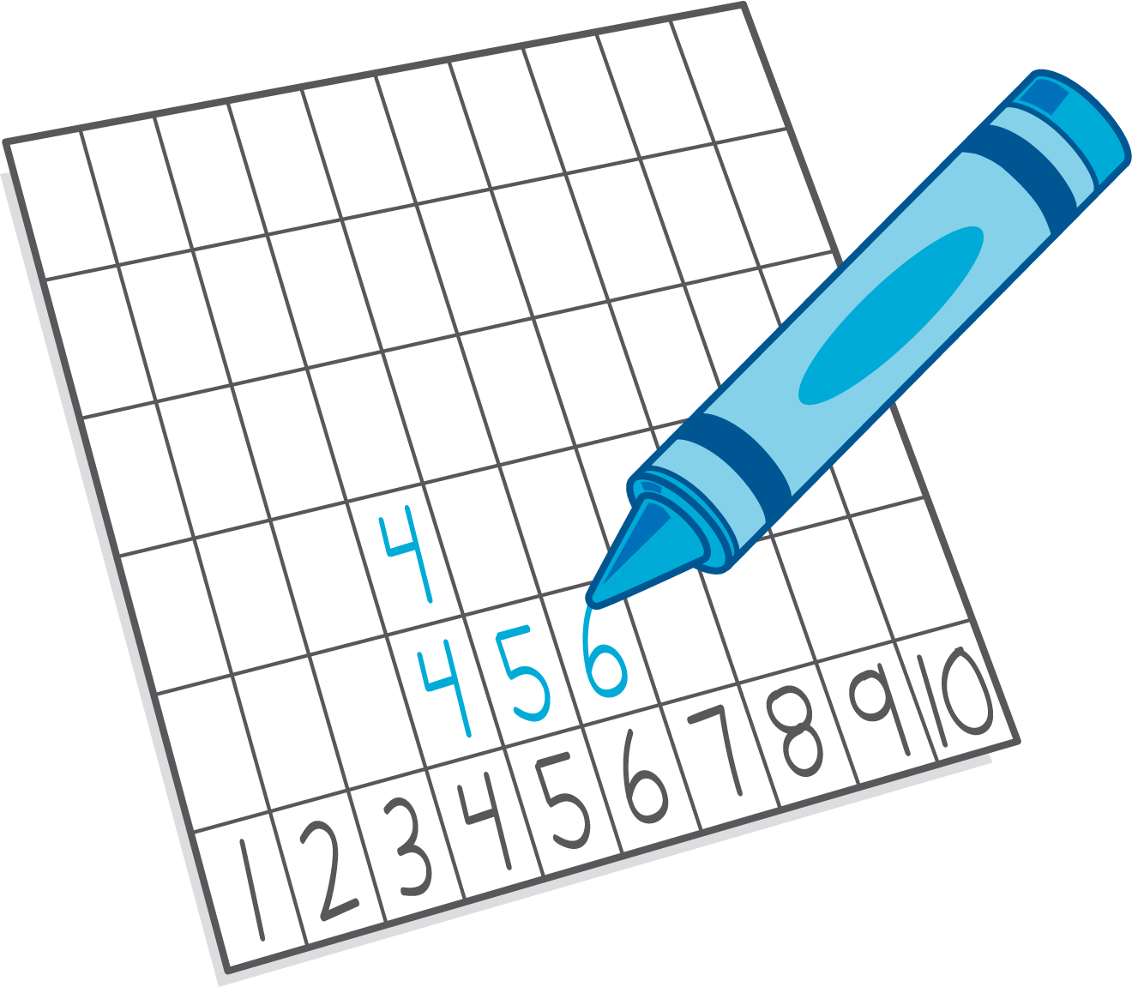

Activity Synthesis
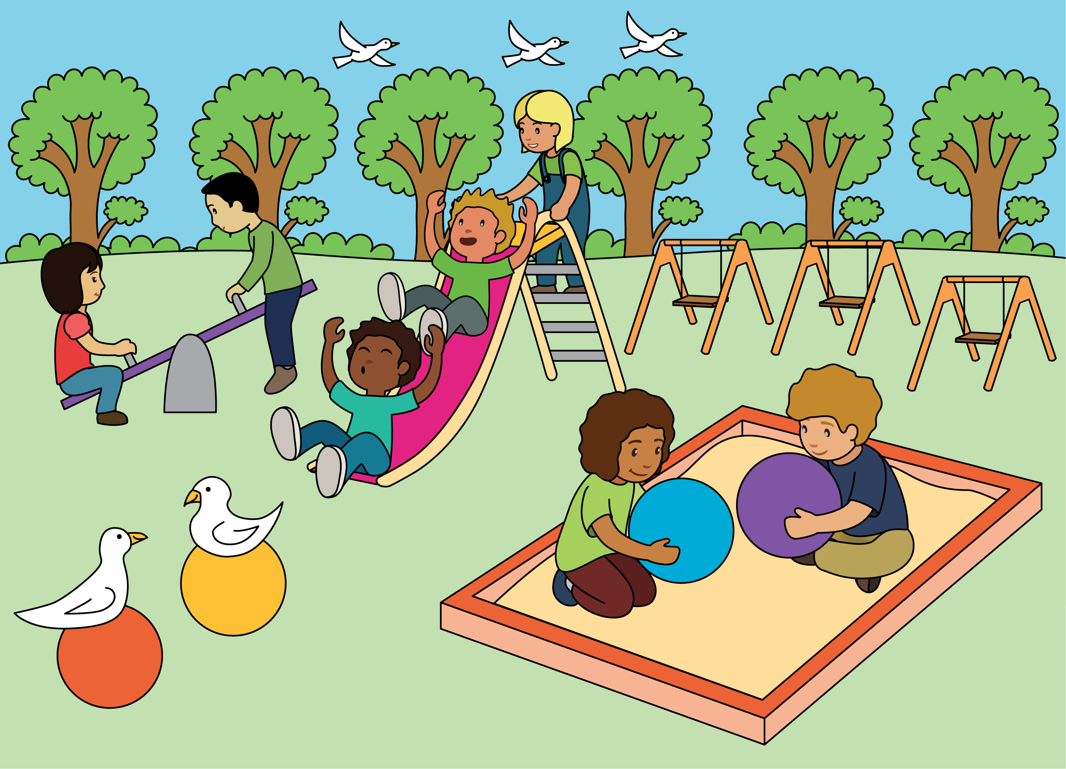

Images for Activity Synthesis
© CC BY 2021 Illustrative Mathematics®

