Lesson 10: Equations and Relationships
- Let’s match graphs and equations.

10.1: Which One Doesn't Belong: Slopes and Intercepts
Which one doesn't belong?
A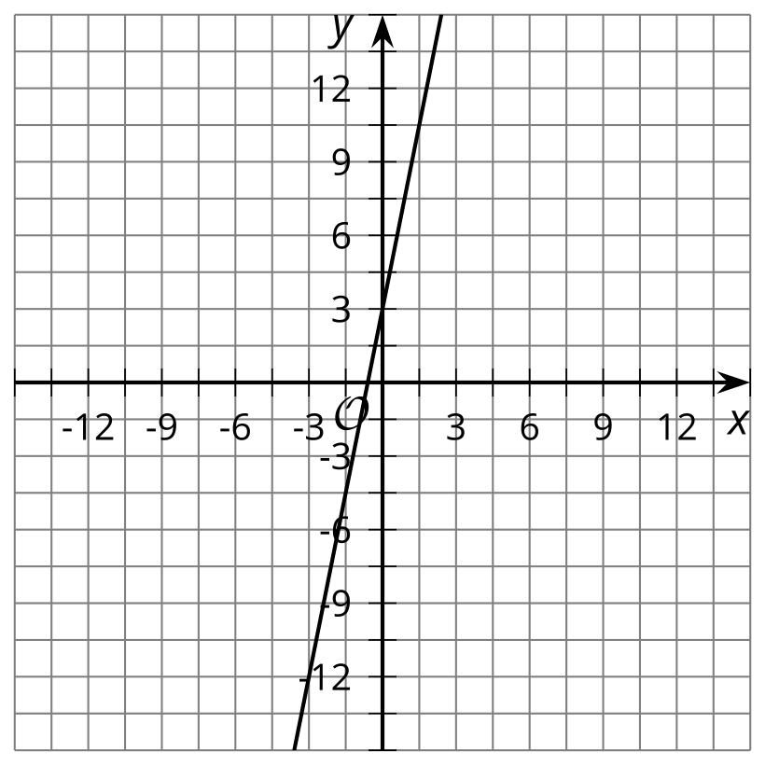
B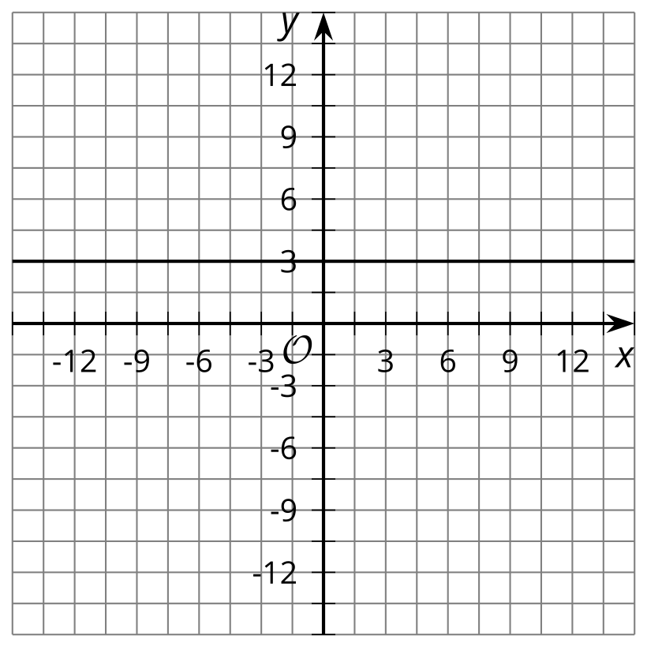
C. $y=\text{-}2.5x−7.5$
D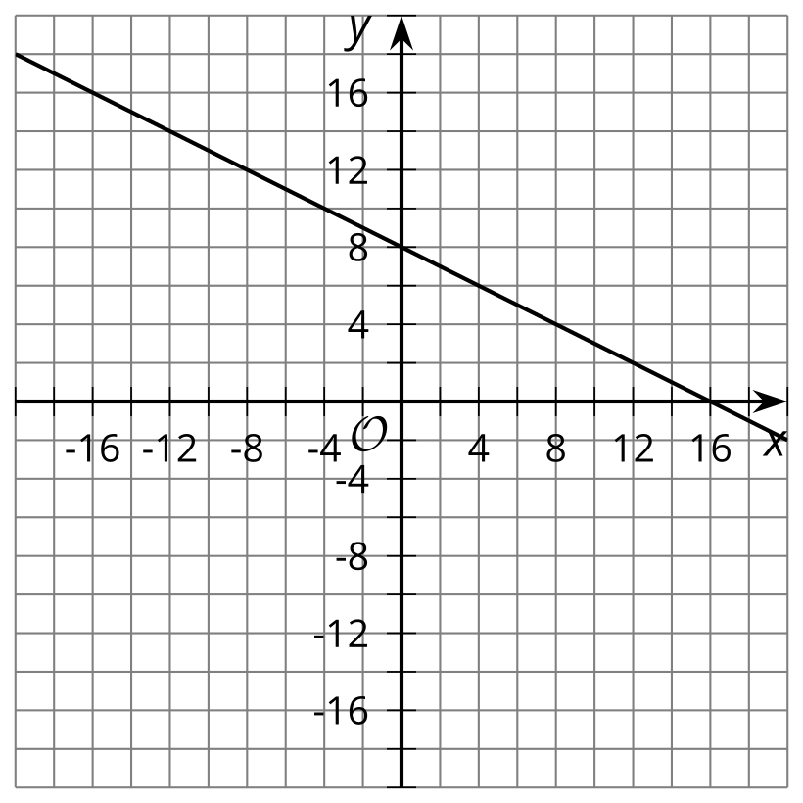

10.2: What’s the Same? What’s Different?
Here are the graphs of four linear equations.

Graph A
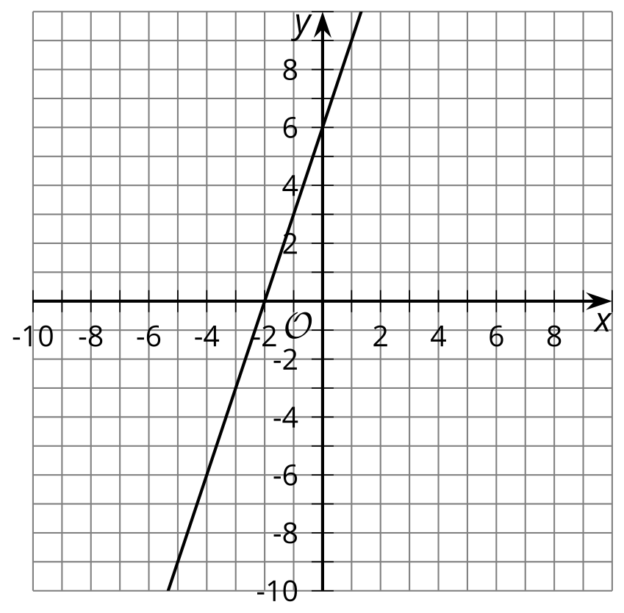

Graph B
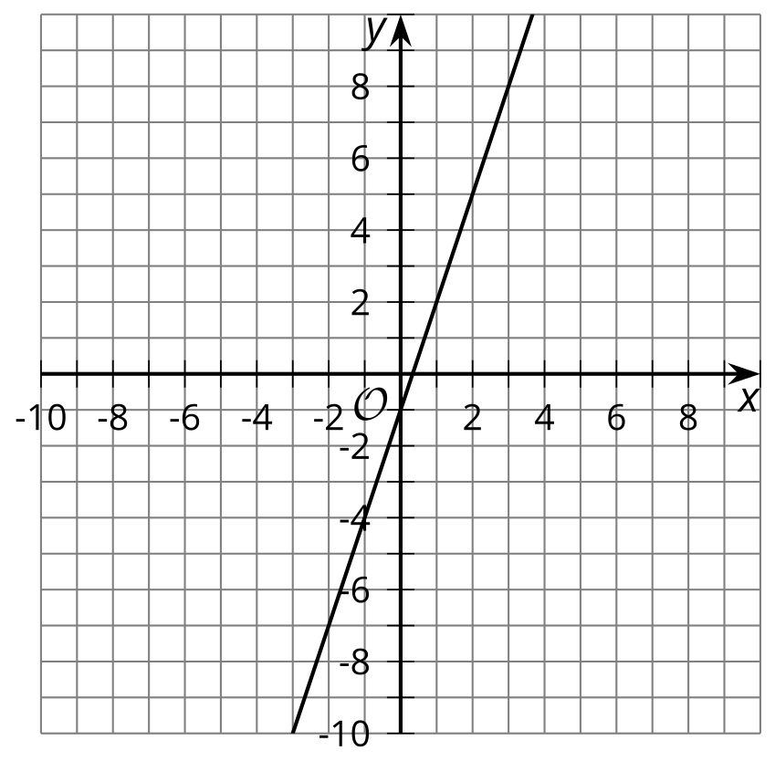

Graph C
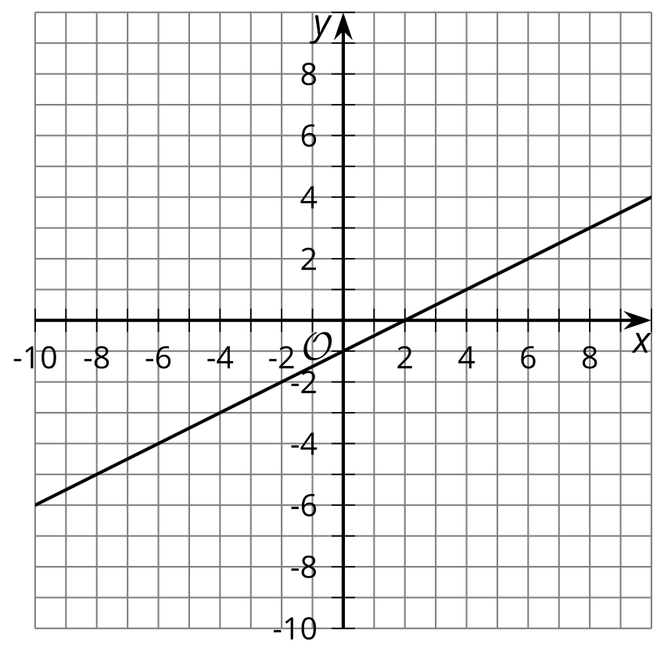

Graph D
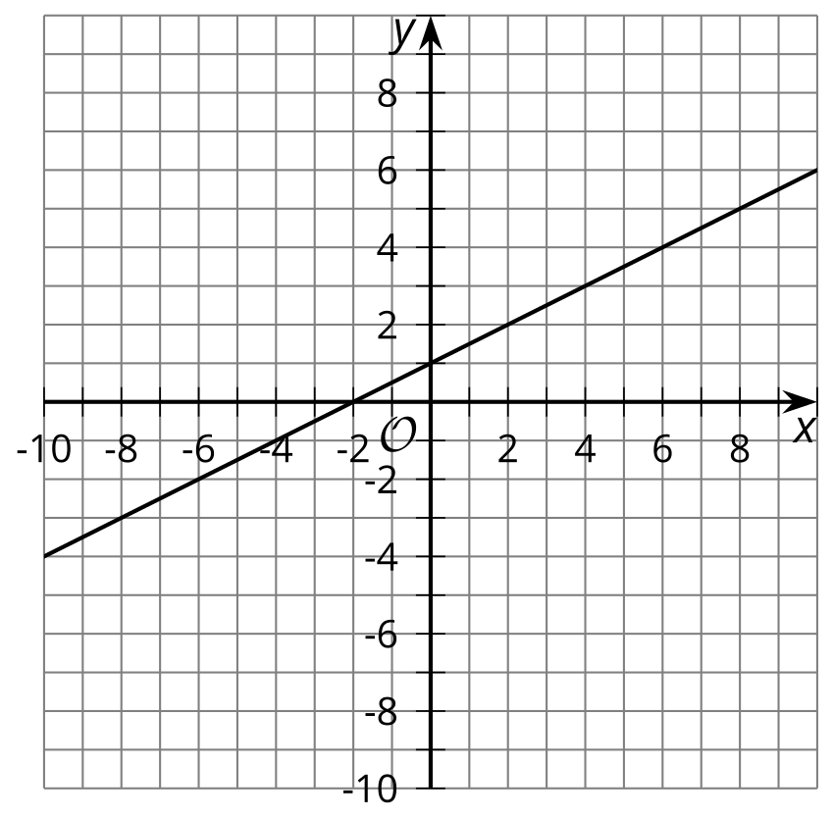
- Which graphs have a slope of 3?
- Which graphs have a slope of $\frac{1}{2}$?
- Which graphs have a $y$-intercept of -1?
- Which graphs have an $x$-intercept of -2?
- Graph A represents the equation $2y−6x=12$. Which other equations could graph A represent?
  - $y−3x=6$
  - $y=3x+6$
  - $y=−3x+6$
  - $2y=−6x+12$
  - $4y−12x=12$
  - $4y−12x=24$
- Write three equations that graph B could represent.

10.3: Situations and Graphs
For each situation, find the slope and intercepts of the graph. Then, describe the meaning of the slope and intercepts. Determine if the values you come up with are reasonable answers for the situation.
- The printing company keeps an inventory of the number of cases of paper it has in stock.
- 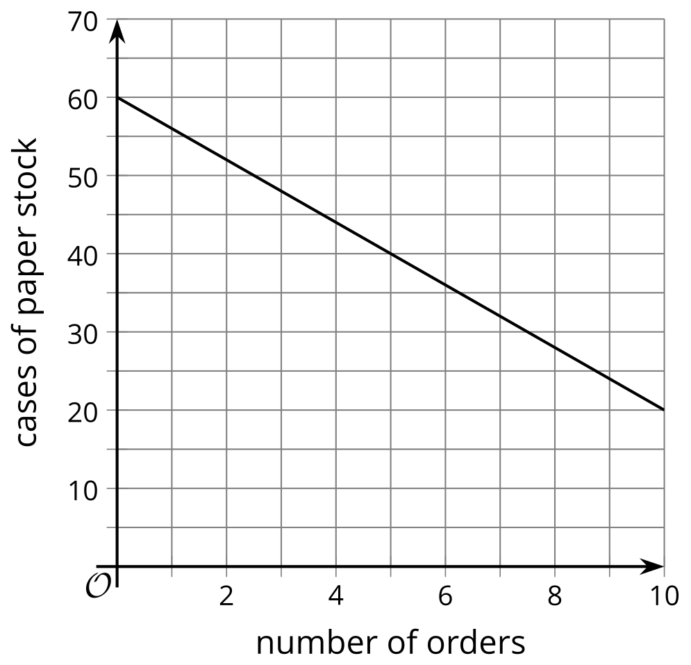
- The market value of a house is determined by the size of the house.
- 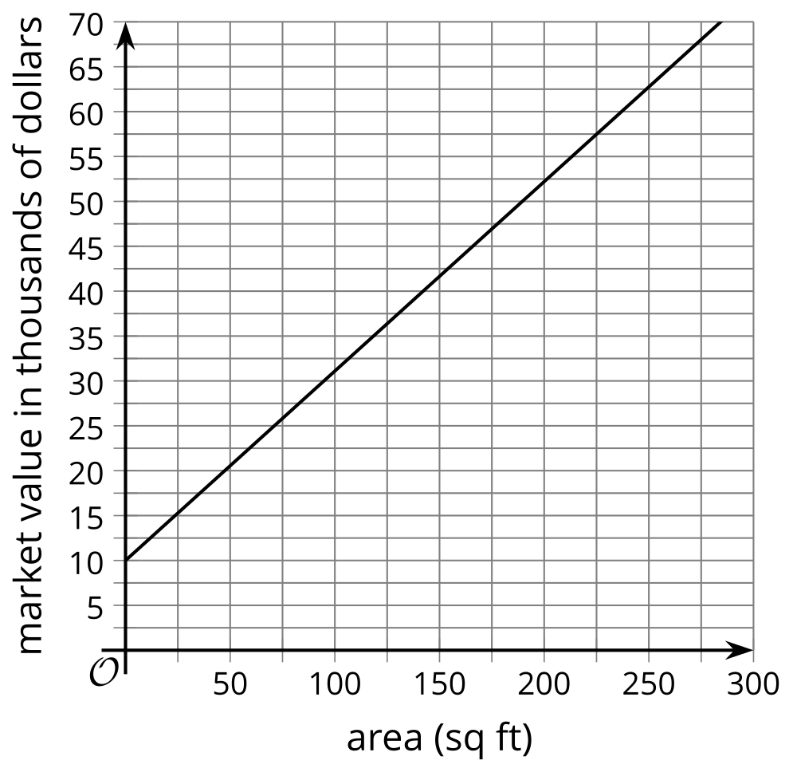
- Tyler teaches painting classes in which the amount of money he makes depends on the number of participants he has.
- 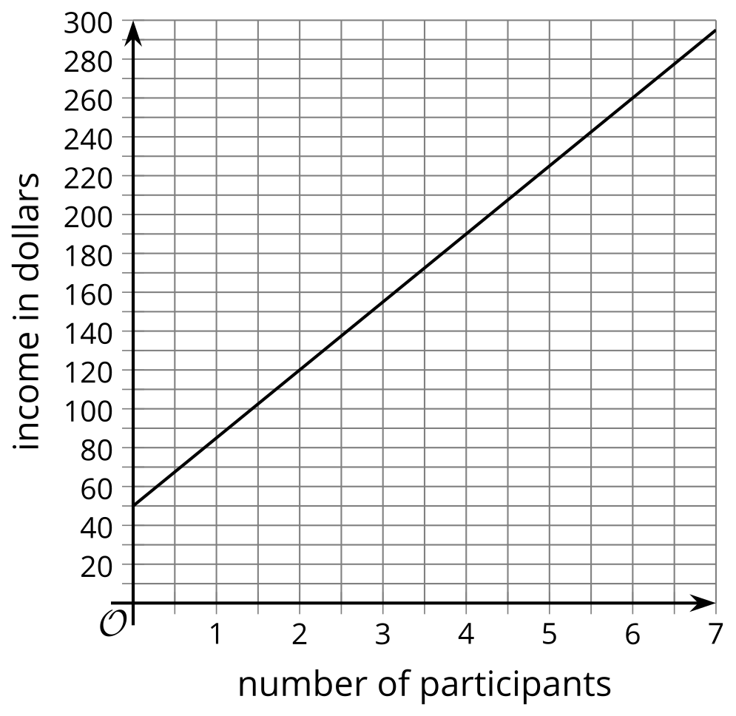
- Mai tracks the amount of money in her no-interest savings account.
- 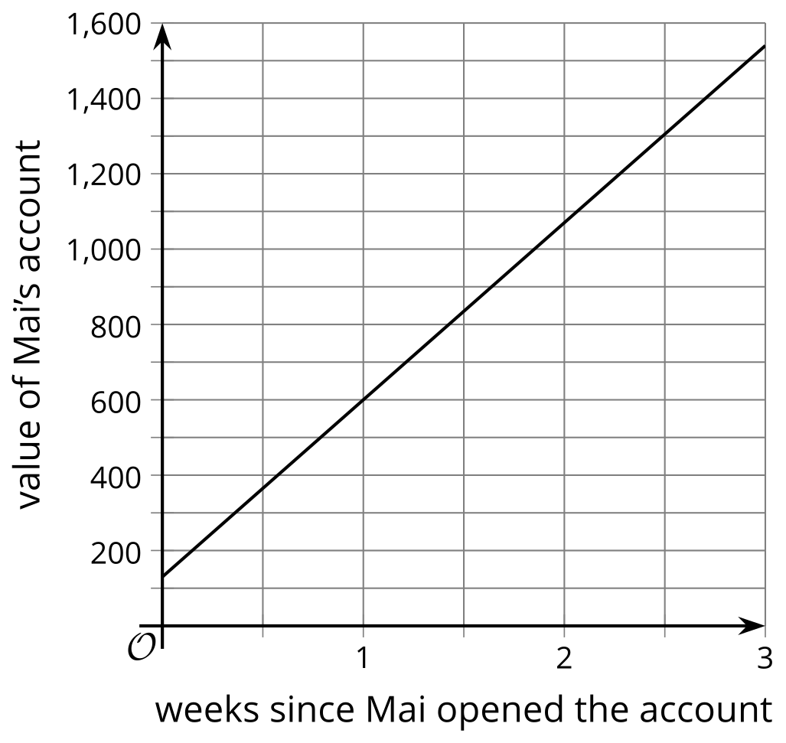
- Priya earns coins for each new level she reaches on her game.
- 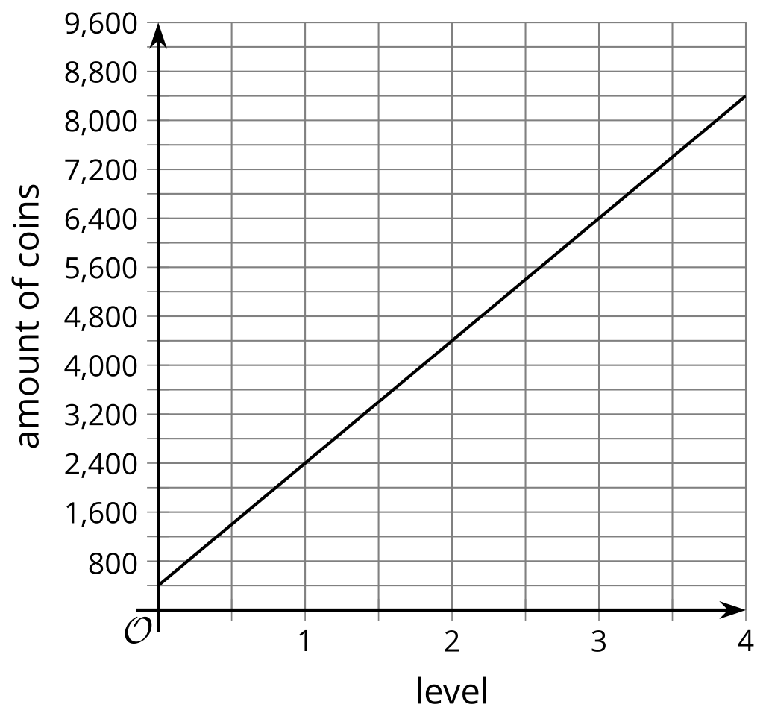
© CC BY 2019 by Illustrative Mathematics®

