Unit 5 Lesson 13: Representations of Exponential Functions

1 Which One Doesn’t Belong?: Representations of Functions (Warm up)

Student Task Statement
Which one doesn’t belong?

A
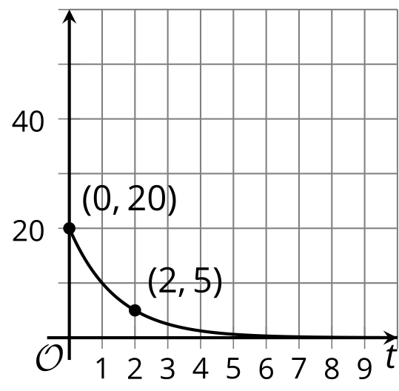

B
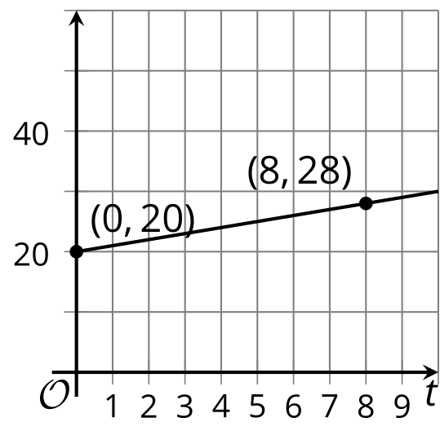
C: $f\left(t\right)=20⋅2^{t}$

D
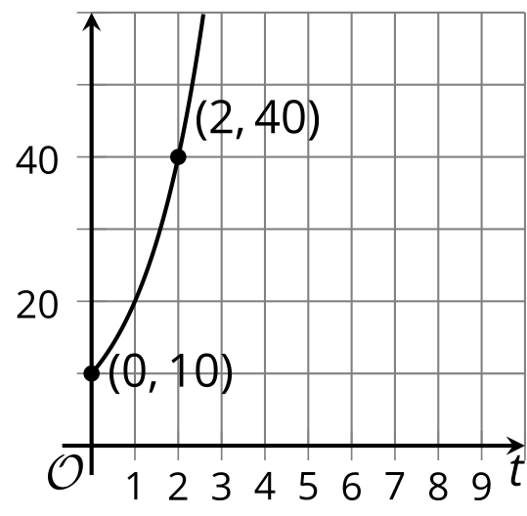

2 Interrogating Function Representations

Student Task Statement
- Consider the graph of $f\left(x\right)=3⋅2^{x}$ and corresponding table.

- 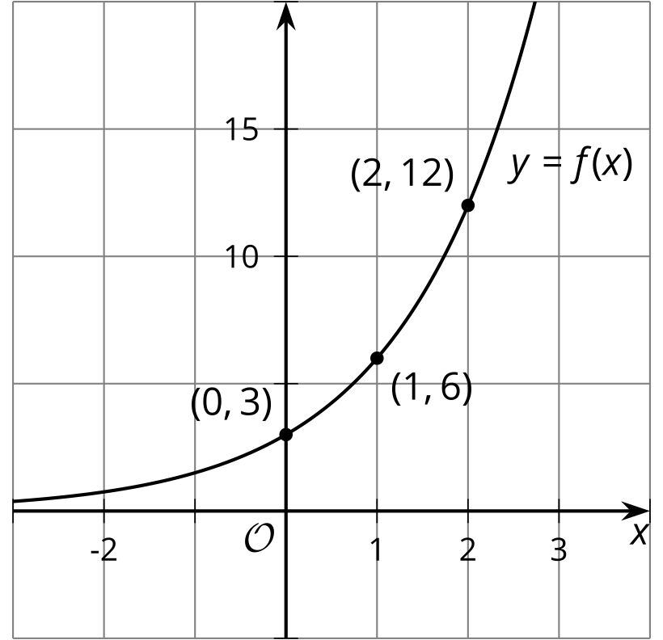
- $x$ | - $f\left(x\right)$
- 0 | - 3
- 1 | - 6
- 2 | - 12
  - Using the first two points, what is the growth factor?
  - Using the second two points, what is the growth factor?
  - Where do you see this growth factor in the equation?
  - Where do you see the growth factor on the graph?
  - What is the vertical intercept of the graph?
  - How can you tell from the equation that this is the vertical intercept?
- Consider the graph of $g\left(x\right)=8⋅{\left(\frac{1}{2}\right)}^{x}$ and corresponding table.

- 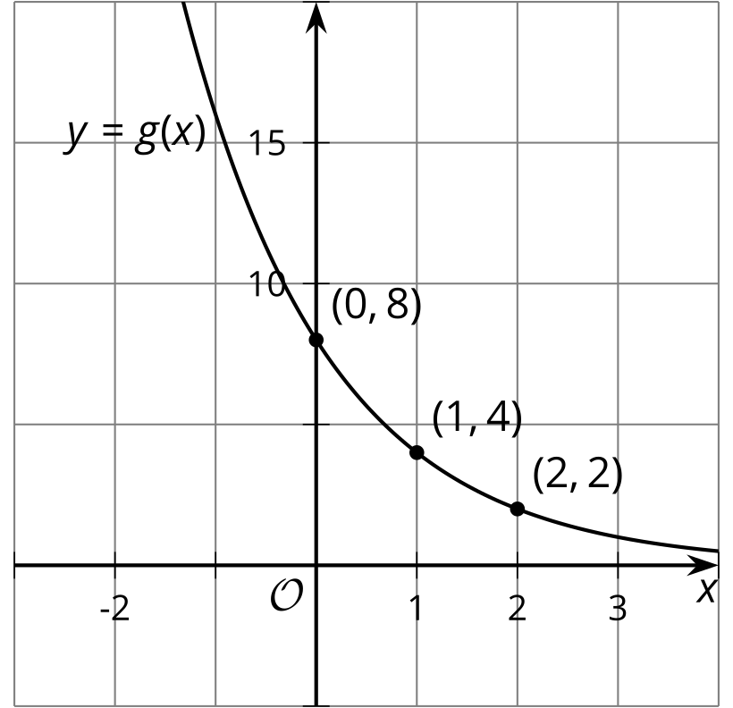
- $x$ | - $g\left(x\right)$
- 0 | - 8
- 1 | - 4
- 2 | - 2
  - Using the first two points, what is the growth factor?
  - Using the second two points, what is the growth factor?
  - Where do you see this growth factor in the equation?
  - Where do you see the growth factor on the graph?
  - What is the vertical intercept of the graph?
  - How can you tell from the equation that this is the vertical intercept?

3 Matching Representations of Exponential Functions

Student Task Statement
- Match each function with the graph that represents it.
- $a\left(t\right)=300⋅2^{t}$
- $b\left(t\right)=300⋅3^{t}$
- $c\left(t\right)=300⋅{\left(\frac{1}{2}\right)}^{t}$
- $d\left(t\right)=300⋅{\left(\frac{1}{3}\right)}^{t}$
- $e\left(t\right)=108⋅2^{t}$
- $f\left(t\right)=108⋅3^{t}$
- $g\left(t\right)=108⋅{\left(\frac{1}{2}\right)}^{t}$
- $h\left(t\right)=108⋅{\left(\frac{1}{3}\right)}^{t}$

- graph 1
- 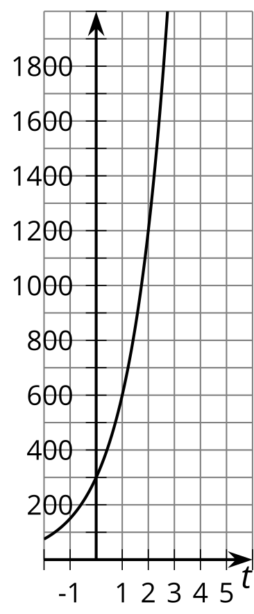

- graph 2
- 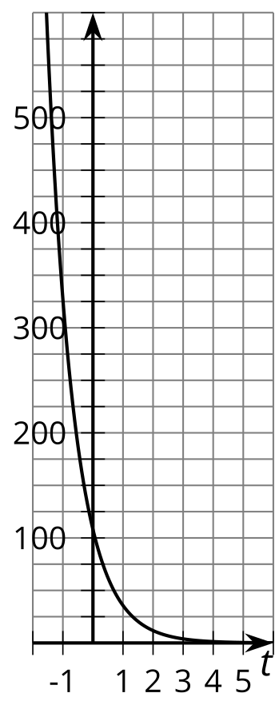

- graph 3
- 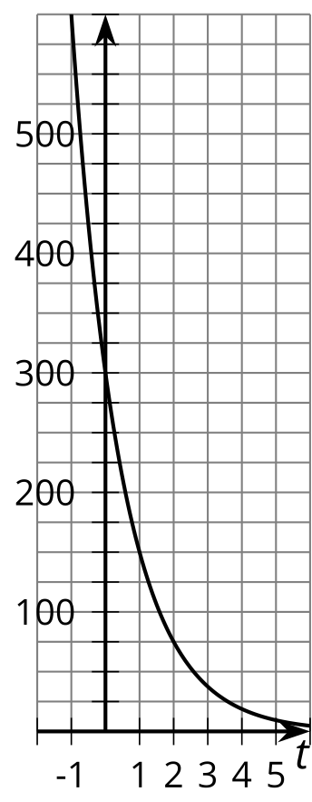

- graph 4
- 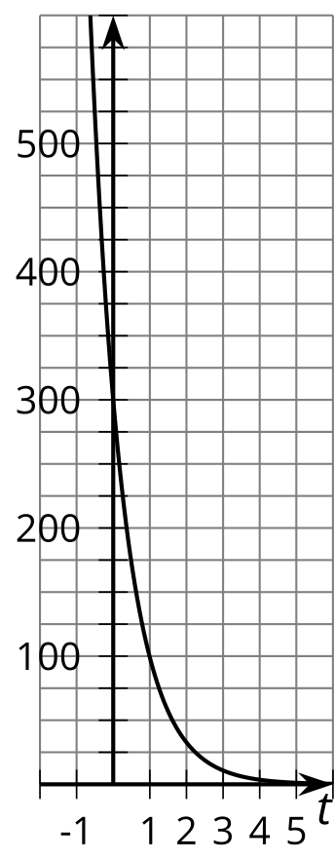

- graph 5
- 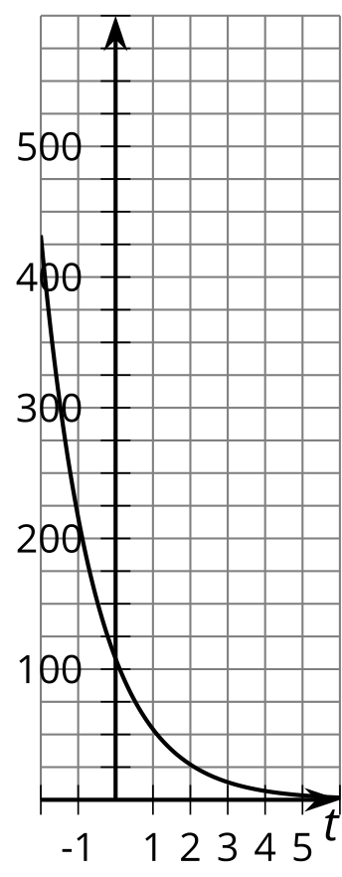

- graph 6
- 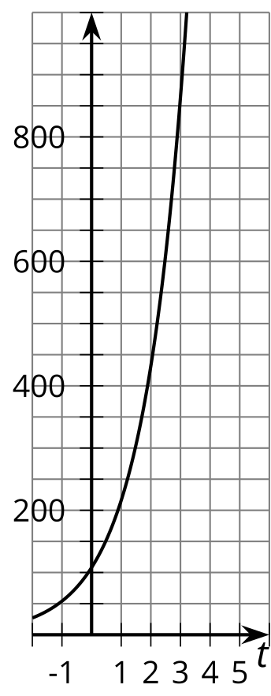

- graph 7
- 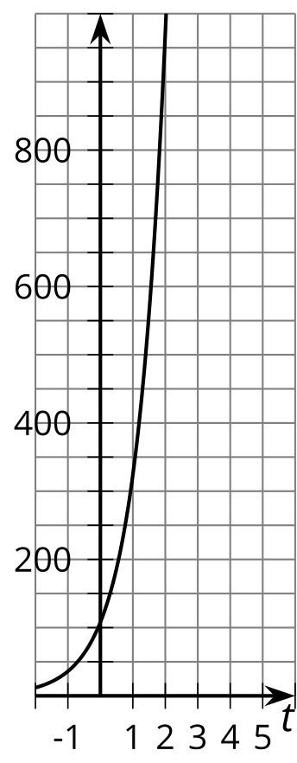

- graph 8
- 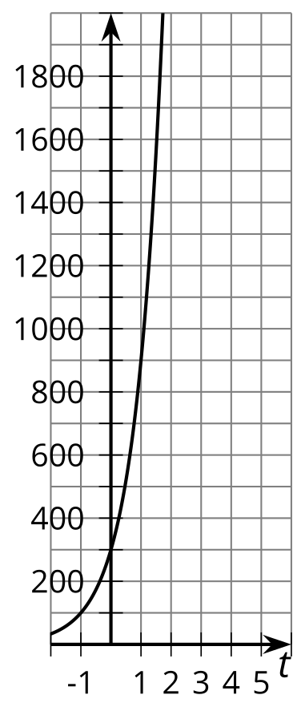
- On two of the graphs, show where you can see the vertical intercept: 108 and 300.
- On four of the graphs, show where you can see the growth factor: $\frac{1}{3}$, $\frac{1}{2}$, 2, and 3.
© CC BY 2019 by Illustrative Mathematics®

