Unit 5 Lesson 12: Reasoning about Exponential Graphs (Part 1)

1 Spending Gift Money (Warm up)

Student Task Statement
Jada received a gift of $180. In the first week, she spent a third of the gift money. She continues spending a third of what is left each week thereafter. Which equation best represents the amount of gift money $g$, in dollars, she has after $t$ weeks? Be prepared to explain your reasoning.
- $g=180−\frac{1}{3}t$
- $g=180⋅{\left(\frac{1}{3}\right)}^{t}$
- $g=\frac{1}{3}⋅{180}^{t}$
- $g=180⋅{\left(\frac{2}{3}\right)}^{t}$

2 Equations and Their Graphs

Student Task Statement
- Each of the following functions $f$, $g$$,$ $h$, and $j$ represents the amount of money in a bank account, in dollars, as a function of time $x$, in years. They are each written in form $m\left(x\right)=a⋅b^{x}$.
$f\left(x\right)=50⋅2^{x}$
$g\left(x\right)=50⋅3^{x}$
$h\left(x\right)=50⋅{\left(\frac{3}{2}\right)}^{x}$
$j\left(x\right)=50⋅{\left(0.5\right)}^{x}$
  - Use graphing technology to graph each function on the same coordinate plane.
  - Explain how changing the value of $b$ changes the graph.
- Here are equations defining functions $p$, $q$, and $r$. They are also written in the form $m\left(x\right)=a⋅b^{x}$.
$p\left(x\right)=10⋅4^{x}$
$q\left(x\right)=40⋅4^{x}$
$r\left(x\right)=100⋅4^{x}$
  - Use graphing technology to graph each function and check your prediction.
  - Explain how changing the value of $a$ changes the graph.

3 Graphs Representing Exponential Decay

Student Task Statement
$m\left(x\right)=200⋅{\left(\frac{1}{4}\right)}^{x}$
$n\left(x\right)=200⋅{\left(\frac{1}{2}\right)}^{x}$
$p\left(x\right)=200⋅{\left(\frac{3}{4}\right)}^{x}$
$q\left(x\right)=200⋅{\left(\frac{7}{8}\right)}^{x}$
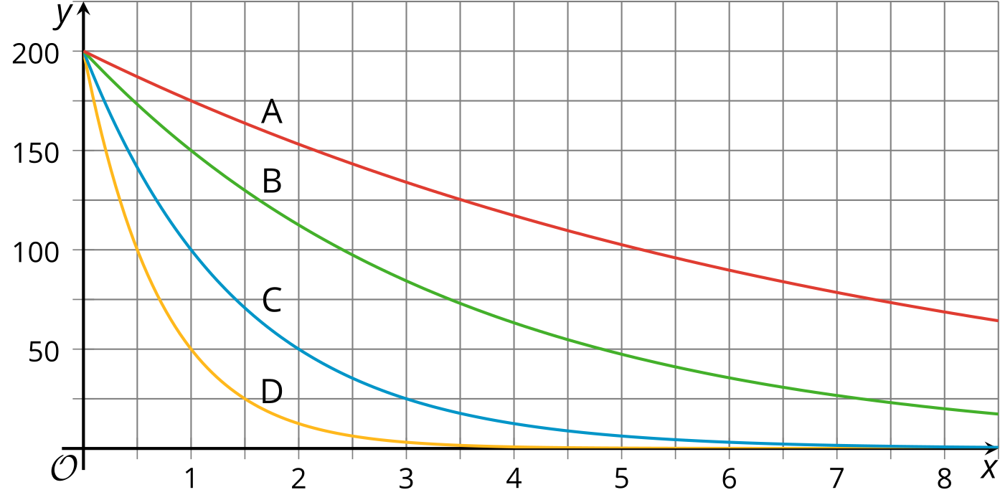
- Match each equation with a graph. Be prepared to explain your reasoning.
- Functions $f$ and $g$ are defined by these two equations: $f\left(x\right)=1,​000⋅{\left(\frac{1}{10}\right)}^{x}$ and $g\left(x\right)=1,​000⋅{\left(\frac{9}{10}\right)}^{x}$.
  - Which function is decaying more quickly? Explain your reasoning.
  - Use graphing technology to verify your response.
© CC BY 2019 by Illustrative Mathematics®

