Unit 4 Lesson 23: Two-Digit Numbers in Our World

WU Estimation Exploration: Beans (Warm up)

Student Task Statement
How many beans are there?
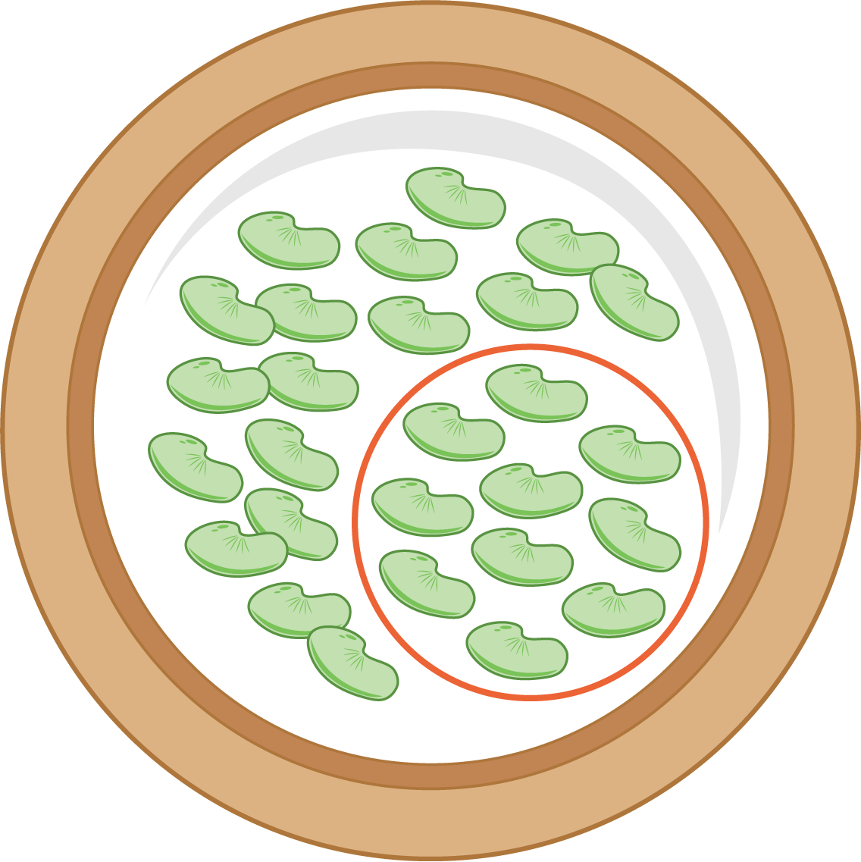
Record an estimate that is:
too low | about right | too high

1 Count the Objects

Student Task Statement
Experiment 1: How many objects are in 2 handfuls?
Record an estimate that is:
too low | about right | too high
Now find the exact number. ____________
Experiment 2: How many objects are in 2 handfuls?
Record an estimate that is:
too low | about right | too high
Now find the exact number. ____________
Experiment 3: How many objects are in 2 handfuls?
Record an estimate that is:
too low | about right | too high
Now find the exact number. ____________

2 Quantities Card Sort

Student Task Statement
- Estimate and sort the pictures based on the amount of items you see.
Sort into these groups.
  - Less than 20
  - 20 to 50
  - More than 50
- Select 1 picture from each group.
Show the number of items you think are in the picture in as many ways as you can.
- Less than 20
- 20 to 50
- More than 50
© CC BY 2021 Illustrative Mathematics®

