Unit 6 Lesson 16: Base-ten Blocks to Divide

WU What Do You Know About Base-ten Blocks? (Warm up)

Student Task Statement
What do you know about base-ten blocks?
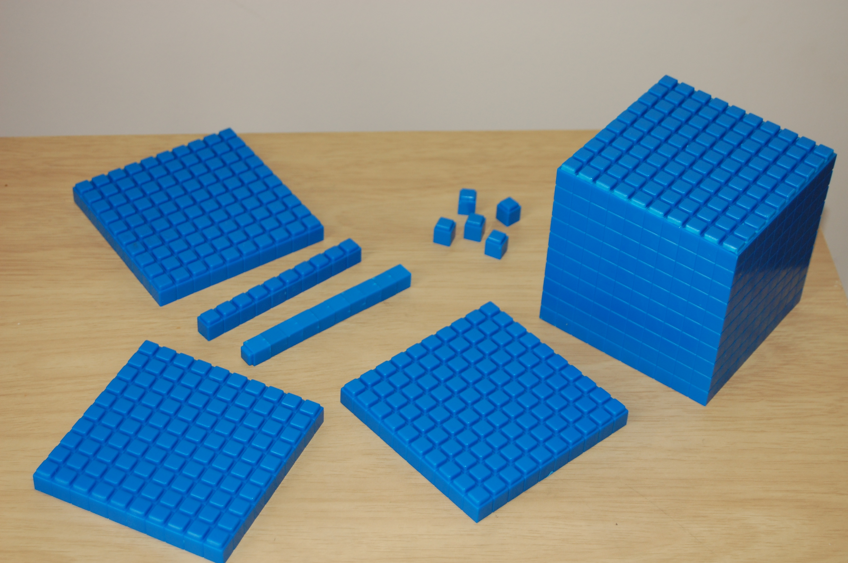

1 Blocks to Divide

Student Task Statement
Use the base-ten blocks to represent each expression. Then find the value of each expression.
- $488÷4$
- $104÷8$

2 Show Us Your Blocks

Student Task Statement
Find the value of each expression. Explain or show how you used base-ten blocks to find the value.
- $96÷4$
- $86÷2$
- $108÷9$
© CC BY 2021 Illustrative Mathematics®

