Unit 8 Lesson 13 Cumulative Practice Problems
- Find the positive solution to each equation. If the solution is irrational, write the solution using square root or cube root notation.
  - $t^{3}=216$
  - $a^{2}=15$
  - $m^{3}=8$
  - $c^{3}=343$
  - $f^{3}=181$
- For each cube root, find the two whole numbers that it lies between.
  - $\sqrt[3]{11}$
  - $\sqrt[3]{80}$
  - $\sqrt[3]{120}$
  - $\sqrt[3]{250}$
- Order the following values from least to greatest:
- $\sqrt[3]{530}, \sqrt{48}, π, \sqrt{121}, \sqrt[3]{27}, \frac{19}{2}$

- Select all the equations that have a solution of $\frac{2}{7}$:
  - $x^{2}=\frac{2}{7}$
  - $x^{2}=\frac{4}{14}$
  - $x^{2}=\frac{4}{49}$
  - $x^{3}=\frac{6}{21}$
  - $x^{3}=\frac{8}{343}$
  - $x^{3}=\frac{6}{7}$
- The equation $x^{2}=25$ has two solutions. This is because both $5⋅5=25$, and also $\text{-}5⋅\text{-}5=25$. So, 5 is a solution, and also -5 is a solution. But! The equation $x^{3}=125$ only has one solution, which is 5. This is because $5⋅5⋅5=125$, and there are no other numbers you can cube to make 125. (Think about why -5 is not a solution!)
- Find all the solutions to each equation.
  - $x^{3}=8$
  - $\sqrt[3]{x}=3$
  - $x^{2}=49$
  - $x^{3}=\frac{64}{125}$
- Find the value of each variable, to the nearest tenth.

  - 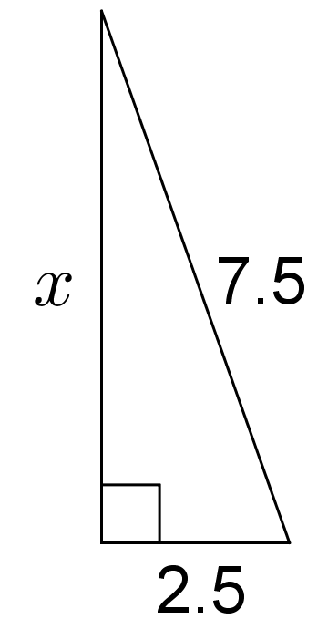

  - 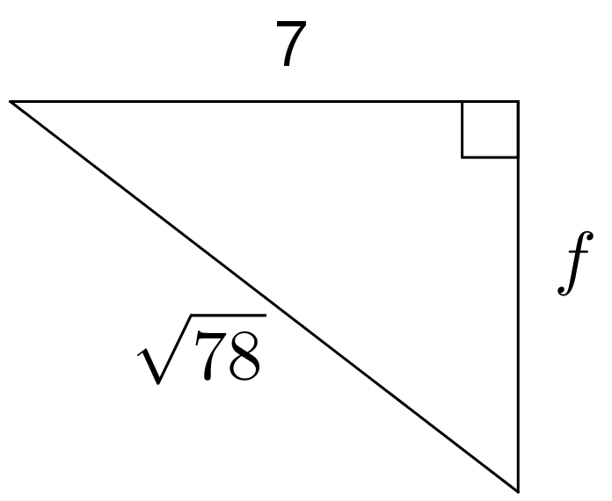

  - 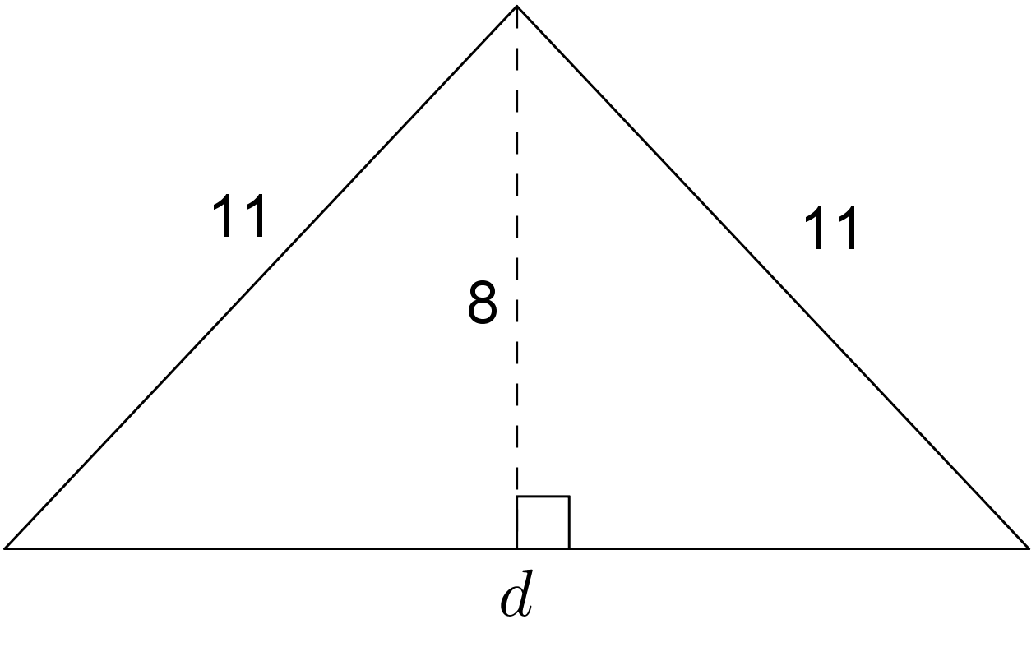
- (From Unit 8, Lesson 8.)
- A standard city block in Manhattan is a rectangle measuring 80 m by 270 m. A resident wants to get from one corner of a block to the opposite corner of a block that contains a park. She wonders about the difference between cutting across the diagonal through the park compared to going around the park, along the streets. How much shorter would her walk be going through the park? Round your answer to the nearest meter.
- (From Unit 8, Lesson 10.)
© CC BY Open Up Resources. Adaptations CC BY IM.

