Lesson 12 Practice Problems
- For each equation, is the graph of the equation parallel to the line shown, perpendicular to the line shown, or neither?
- 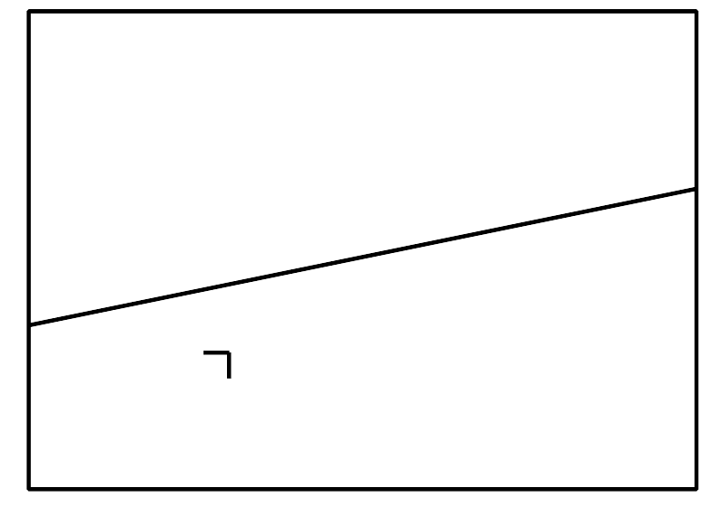
  - $y=0.2x$
  - $y=\text{-}2x+1$
  - $y=5x−3$
  - $(y−3)=\text{-}5(x−4)$
  - $(y−1)=2(x−3)$
  - $5x+y=3$
- Main Street is parallel to Park Street. Park Street is parallel to Elm Street. Elm is perpendicular to Willow. How does Willow compare to Main?
- The line which is the graph of $y=2x−4$ is transformed by the rule $(x,y)→(\text{-}x,\text{-}y)$. What is the slope of the image?
- Select all equations whose graphs are lines perpendicular to the graph of $3x+2y=6$.
  - $3x−2y=4$
  - $2x+3y=6$
  - $2x−3y=8$
  - $(y−4)=\frac{2}{3}(x−6)$
  - $(y−2)=\text{-}\frac{3}{2}(x−8)$
  - $y=\frac{2}{3}x$
  - $y=\frac{3}{2}x+3$
- (From Unit 6, Lesson 11.)
- Match each line with a perpendicular line.
  - the line through $(12,4)$ and $(9,19)$
  - $2x−5y=10$
  - $y−4=\frac{2}{3}(x+1)$
  - the line through $(3,1)$ and $(1,4)$
  - $y=\frac{1}{5}x+7$
  - $y−1=\text{-}2.5(x+3)$
- (From Unit 6, Lesson 11.)
- The graph of $y=\text{-}4x+2$ is translated by the directed line segment $AB$ shown. What is the slope of the image?
- (From Unit 6, Lesson 10.)
- Select all points on the line with a slope of $\text{-}\frac{1}{2}$ that go through the point $(4,\text{-}1)$.
  - $(\text{-}2,2)$
  - $(0,2)$
  - $(4,\text{-}1)$
  - $(0,1)$
  - $(\text{-}3,8)$
- (From Unit 6, Lesson 9.)
- One way to define a circle is that it is the set of all points that are the same distance from a given center. How does the equation $(x−h)^{2}+(y−k)^{2}=r^{2}$ relate to this definition? Draw a diagram if it helps you explain.
- (From Unit 6, Lesson 4.)
© CC BY 2019 by Illustrative Mathematics®

