Unit 6 Lesson 16 Cumulative Practice Problems
- Here is a graph that shows some values for the number of cups of sugar, $s$, required to make $x$ batches of brownies.
- 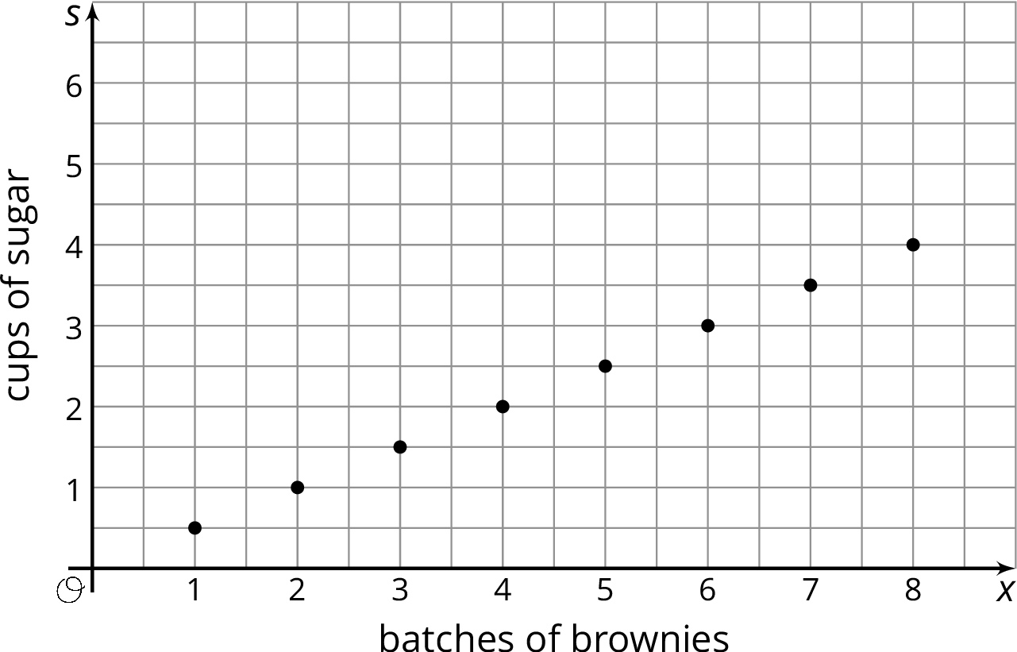
  - Complete the table so that the pair of numbers in each column represents the coordinates of a point on the graph.
- $x$ | - 1 | - 2 | - 3 | - 4 | - 5 | - 6 | - 7
  - $s$
  - What does the point $(8,4)$ mean in terms of the amount of sugar and number of batches of brownies?
  - Write an equation that shows the amount of sugar in terms of the number of batches.
- Each serving of a certain fruit snack contains 90 calories.
  - Han wants to know how many calories he gets from the fruit snacks. Write an equation that shows the number of calories, $c$, in terms of the number of servings, $n$.
  - Tyler needs some extra calories each day during his sports season. He wants to know how many servings he can have each day if all the extra calories come from the fruit snack. Write an equation that shows the number of servings, $n$, in terms of the number of calories, $c$.
- Kiran shops for books during a 20% off sale.
  - What percent of the original price of a book does Kiran pay during the sale?
  - Complete the table to show how much Kiran pays for books during the sale.
  - Write an equation that relates the sale price, $s$, to the original price $p$.
  - On graph paper, create a graph showing the relationship between the sale price and the original price by plotting the points from the table.
- original price  in dollars $(p)$ | - sale price  in dollars $(s)$
- 1
- 2
- 3
- 4
- 5
- 6
- 7
- 8
- 9
- 10
- Evaluate each expression when $x$ is 4 and $y$ is 6.
  - $(6−x)^{3}+y$
  - $2+x^{3}$
  - $2^{x}−2y$
  - ${\left(\frac{1}{2}\right)}^{x}$
  - $1^{x}+2^{x}$
  - $\frac{2^{x}}{x^{2}}$
- (From Unit 6, Lesson 15.)
- Find $(12.34)⋅(0.7)$. Show your reasoning.
- (From Unit 5, Lesson 8.)
- For each expression, write another division expression that has the same value and that can be used to help find the quotient. Then, find each quotient.
  - $302.1÷0.5$
  - $12.15÷0.02$
  - $1.375÷0.11$
- (From Unit 5, Lesson 13.)
© CC BY Open Up Resources. Adaptations CC BY IM.

