Unit 4 Lesson 9: Using Trigonometric Ratios to Find Angles

1 Once More with the Table (Warm up)

Student Task Statement
A triangle with side lengths 3, 4, and 5 is a right triangle by the converse of the Pythagorean Theorem. What are the measures of the acute angles?

Activity Synthesis

2 From Ratios to Angles

Student Task Statement
Find all missing side and angle measures.

3 Leaning Ladders

Student Task Statement
A good rule of thumb for a safe angle to use when leaning a ladder is the angle formed by your body when you stand on the ground and hold your arms out parallel to the ground.
- What are the angles in the triangle formed by your body and the ladder?
- What are the angles in the triangle formed by the ladder, the ground, and the railing? Explain or show your reasoning.
- You have a 13 foot long ladder and need to climb to a 12 foot tall roof.
  - If you put the top of the ladder at the top of the wall, what angle is formed between the ladder and the ground?
  - Is it possible to adjust the ladder to a safe angle? If so, give someone instructions to do so. If not, explain why not.
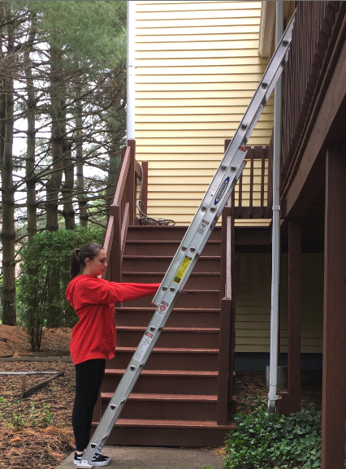

Images for Activity Synthesis

$\text{arccos}\left(\frac{\text{adjacent}}{\text{hypotenuse}}\right)=θ$

$\text{arcsin}\left(\frac{\text{opposite}}{\text{hypotenuse}}\right)=θ$

$\text{arctan}\left(\frac{\text{opposite}}{\text{adjacent}}\right)=θ$
© CC BY 2019 by Illustrative Mathematics®

