Unit 2 Lesson 8: Compare Matching Images

WU Questions About Us: Dogs or Cats? (Part 2) (Warm up)

Student Task Statement

1 Are There Enough?

Images for Launch
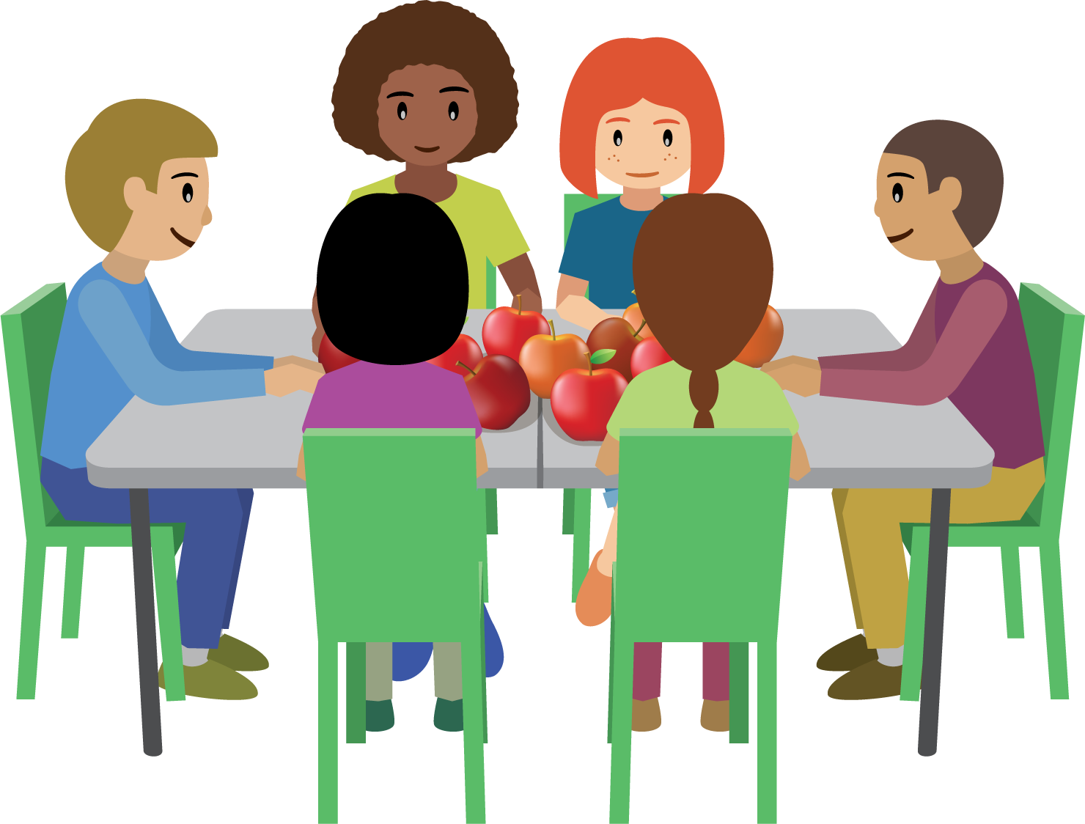

Student Task Statement

- 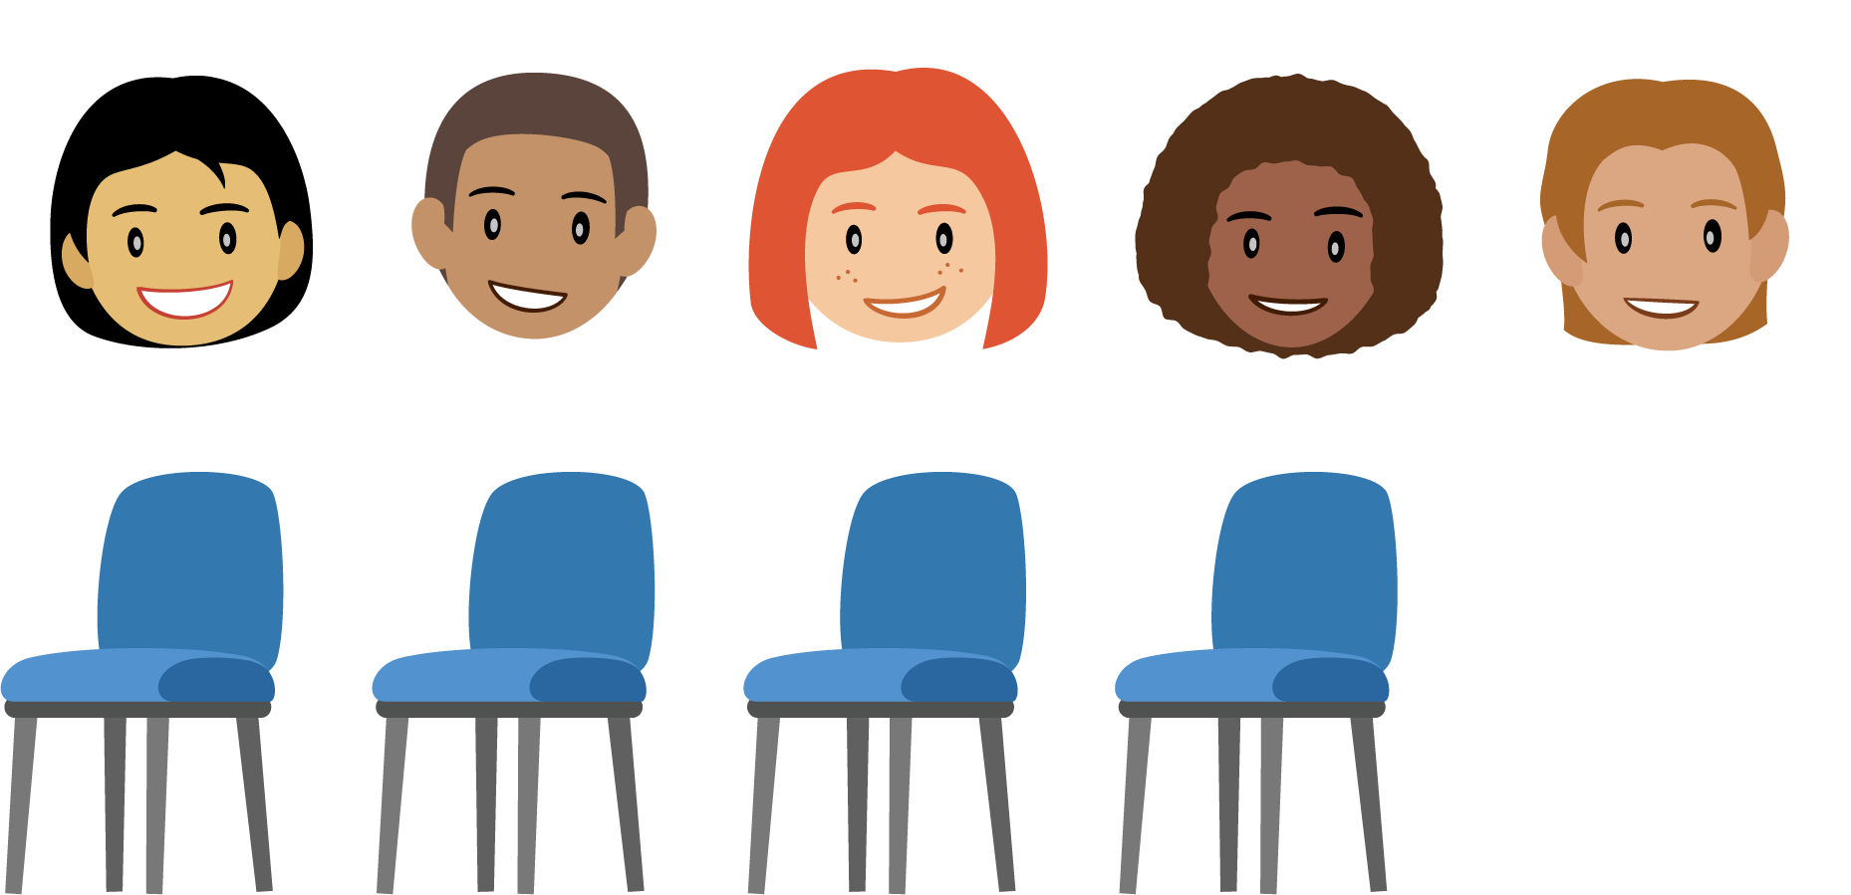

- 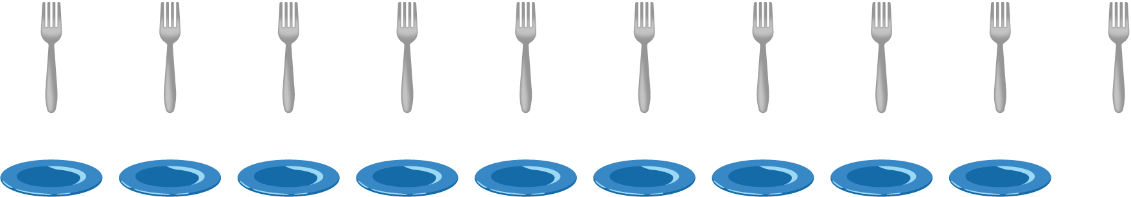

- 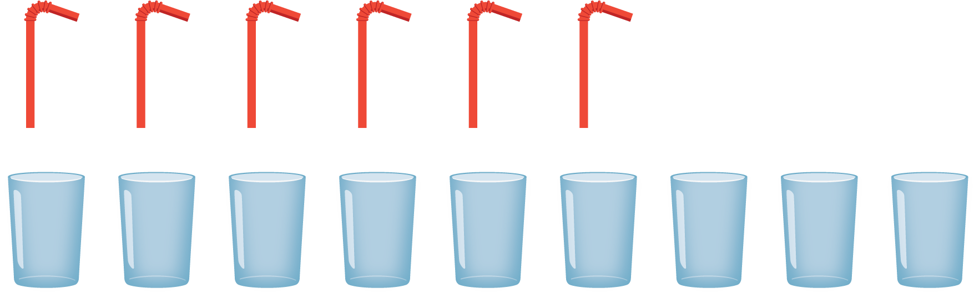

2 Comparing Images That Aren’t Matched

Student Task Statement

- 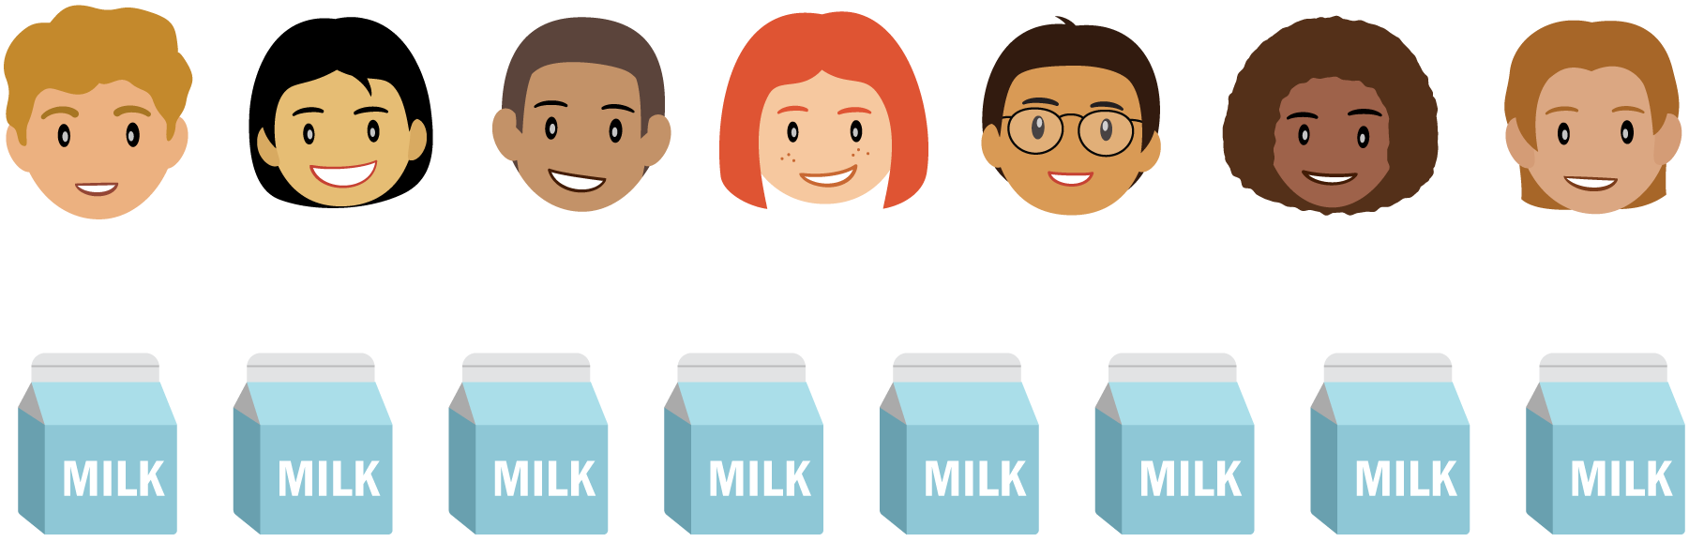

- 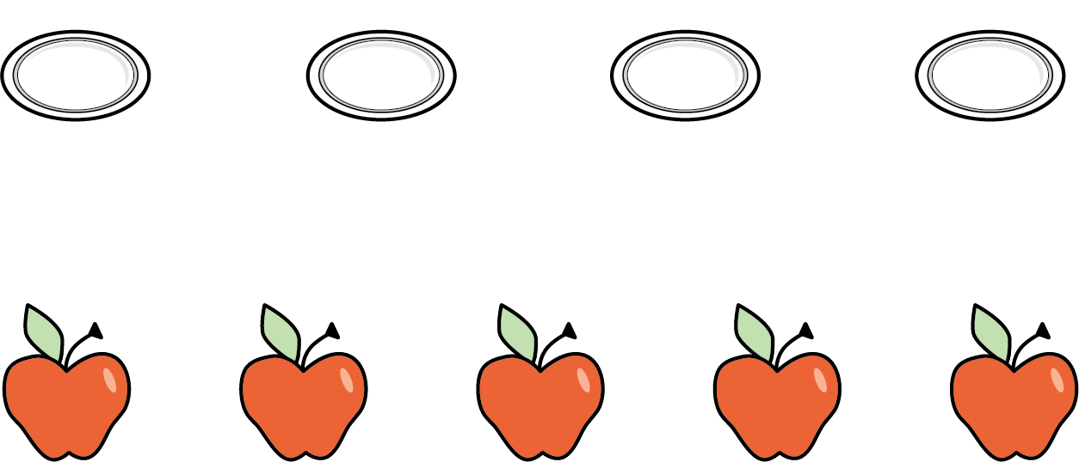

- 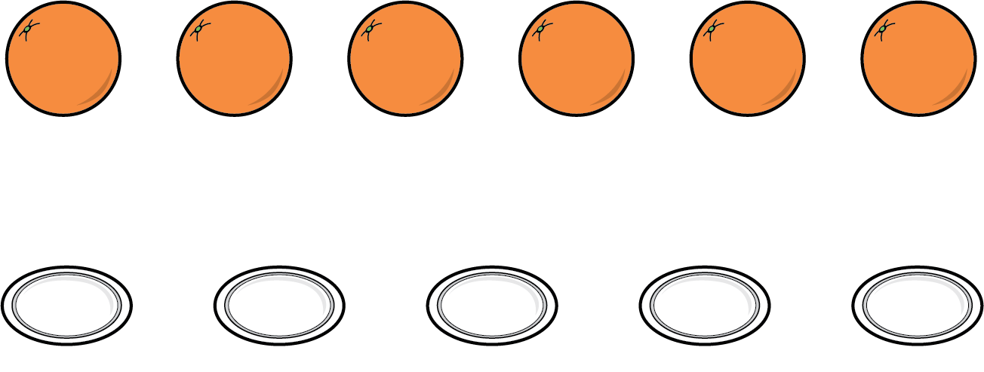

3 Centers: Choice Time

Student Task Statement
Choose a center.
Math Stories
Connecting Cubes
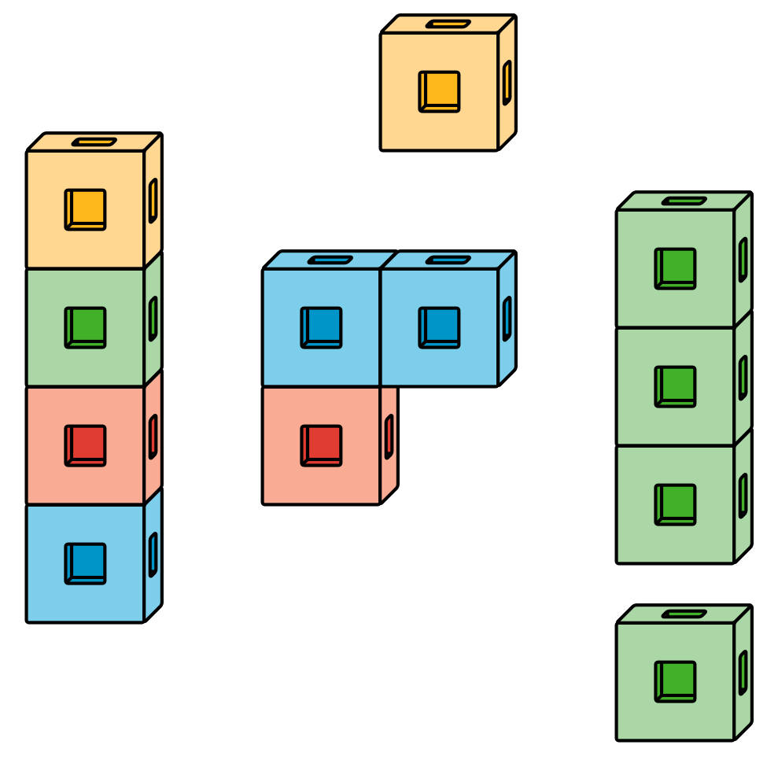
Number Race
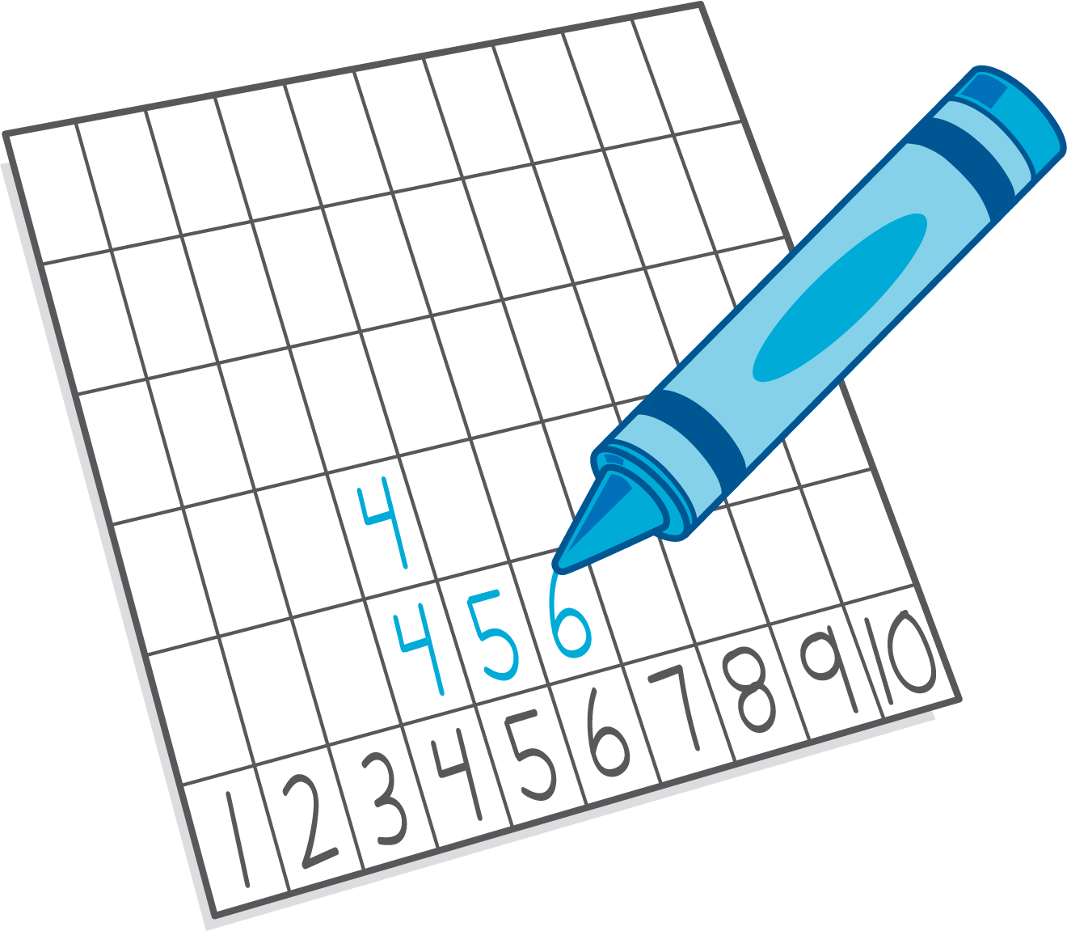

Images for Activity Synthesis
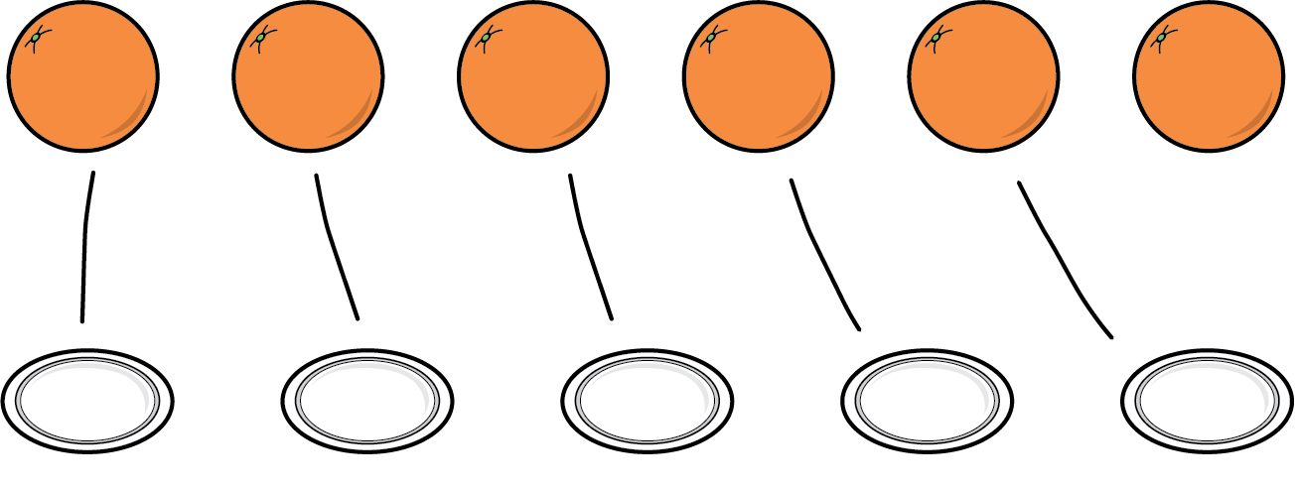
© CC BY 2021 Illustrative Mathematics®

