Unit 6 Lesson 15: Features of Trigonometric Graphs (Part 1)

1 Notice and Wonder: Musical Notes (Warm up)

Student Task Statement
Here are pictures of sound waves for two different musical notes:
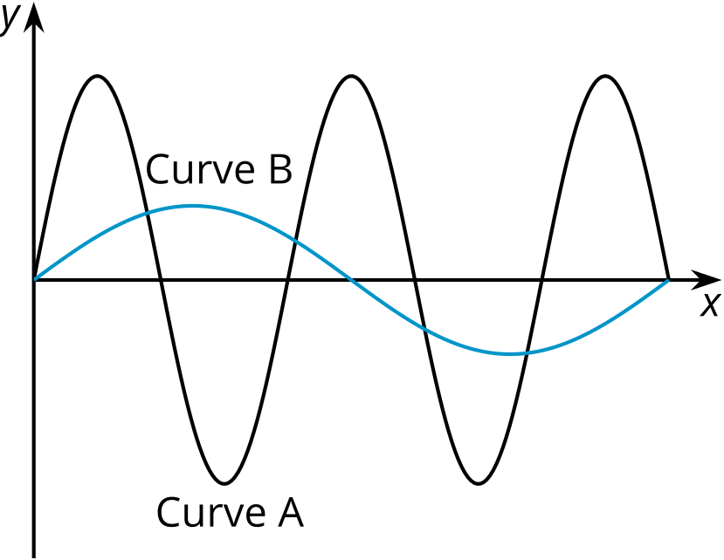
What do you notice? What do you wonder?

2 Equations and Graphs

Student Task Statement
Match each equation with its graph. More than 1 equation can match the same graph.
Equations:
- $y=\text{-}cos\left(θ\right)$
- $y=2sin\left(θ\right)−3$
- $y=cos\left(θ+\frac{π}{2}\right)$
- $y=3sin\left(θ\right)−2$
- $y=sin\left(θ−\frac{π}{2}\right)$
- $y=sin\left(θ+π\right)$

A
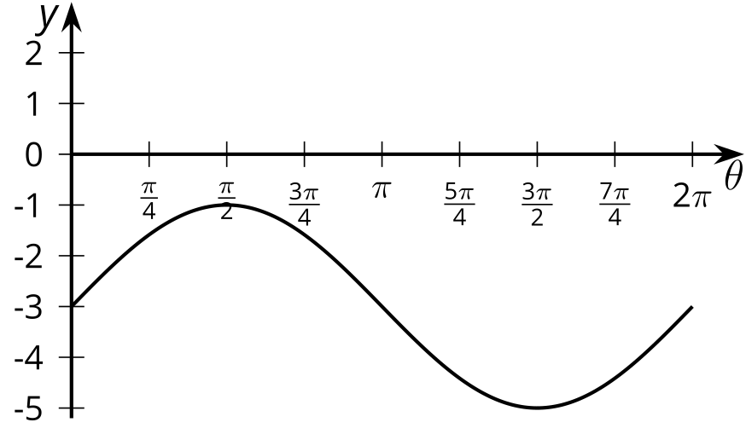

B
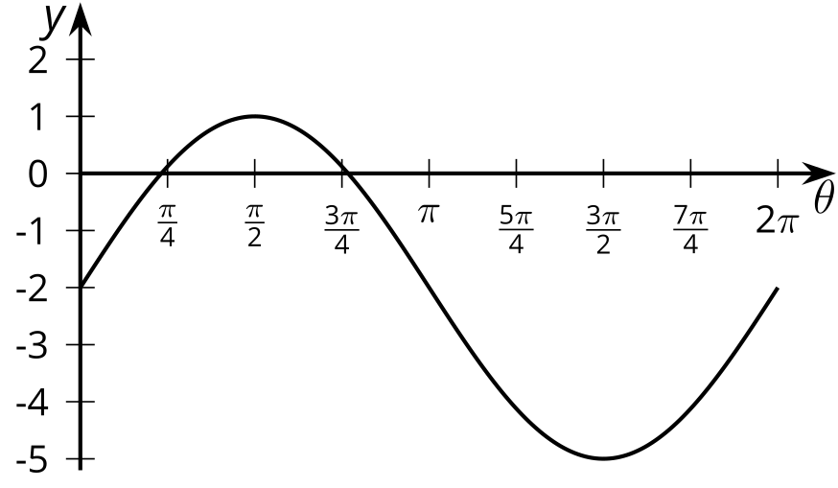

C
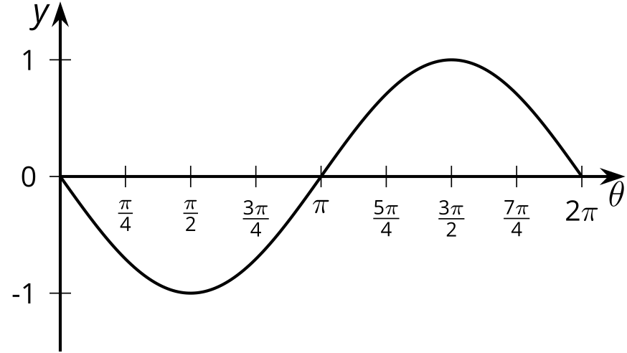

D
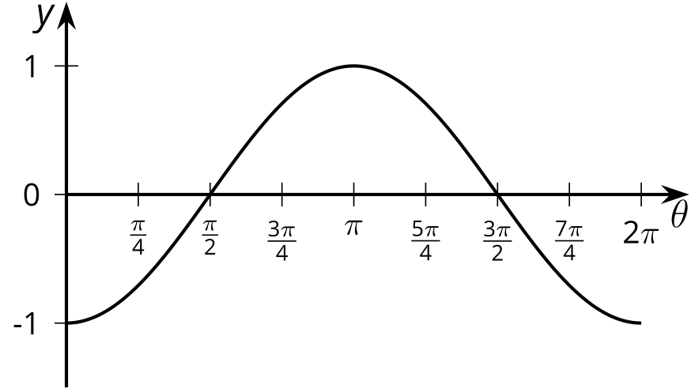

3 Double the Sine

Student Task Statement
- Complete the table of values for the expression $sin\left(2θ\right)$
- $θ$ | - 0 | - $\frac{π}{12}$ | - $\frac{π}{6}$ | - $\frac{π}{4}$ | - $\frac{π}{2}$ | - $\frac{3π}{4}$ | - $π$ | - $\frac{5π}{4}$ | - $\frac{3π}{2}$ | - $\frac{7π}{4}$ | - $2π$
- $sin\left(2θ\right)$
- Plot the values and sketch a graph of the equation $y=sin\left(2θ\right)$. How does the graph of $y=sin\left(2θ\right)$ compare to the graph of $y=sin\left(θ\right)$?
- 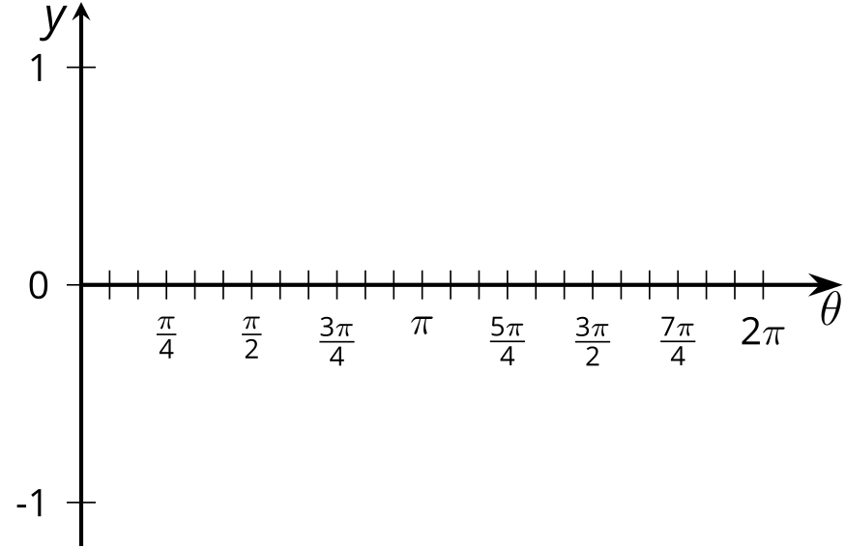
- Predict what the graph of $y=cos\left(4θ\right)$ will look like and make a sketch. Explain your reasoning.

Activity Synthesis
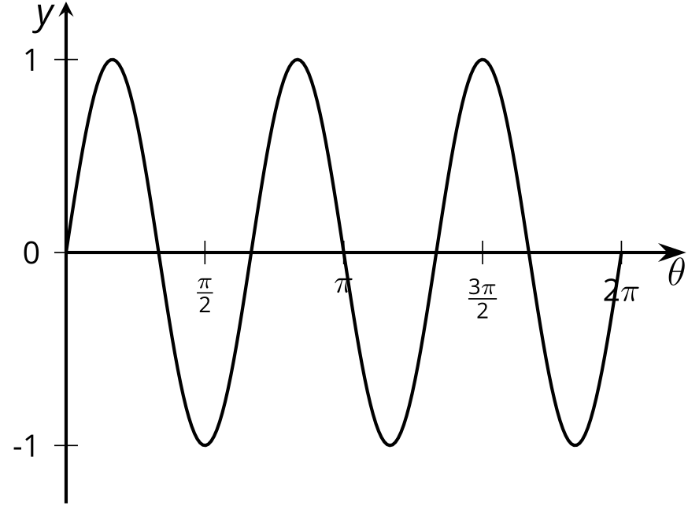

Images for Activity Synthesis
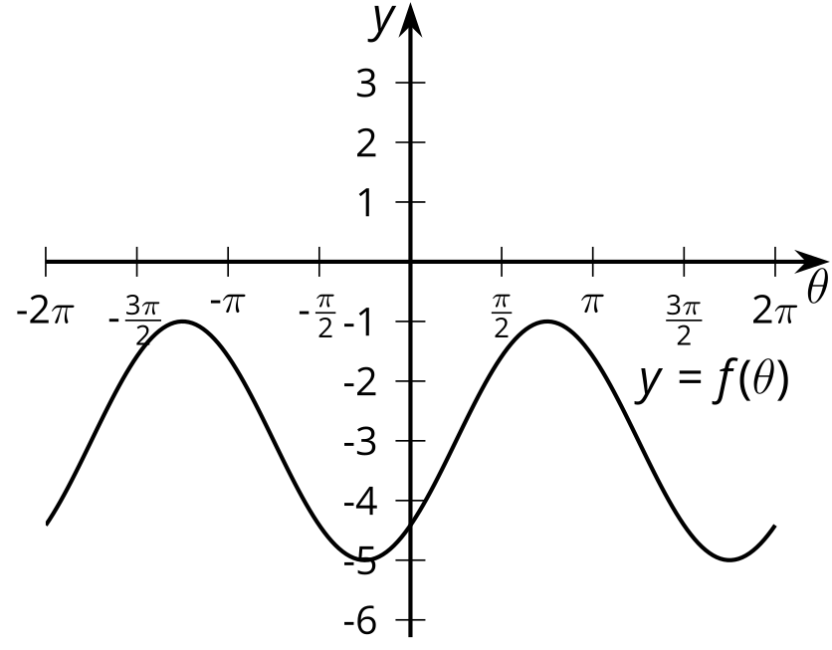
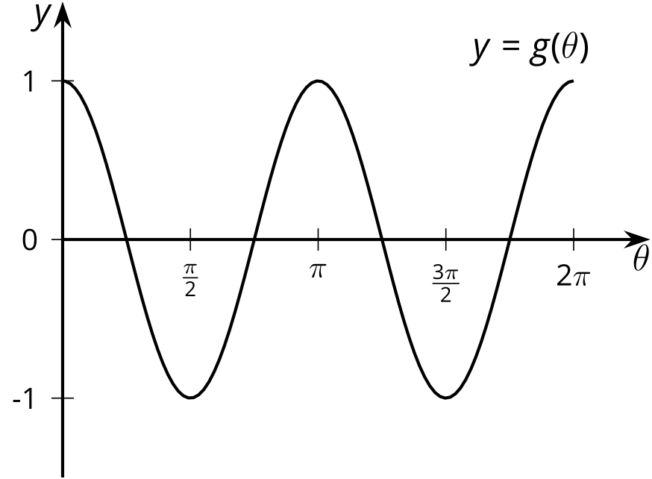
© CC BY 2019 by Illustrative Mathematics®

