Lesson 9: How Much in Each Group? (Part 2)
Let’s practice dividing fractions in different situations.

9.1: Number Talk: Greater Than 1 or Less Than 1?
Decide whether each quotient is greater than 1 or less than 1.
$\frac{1}{2}÷\frac{1}{4}$
$1÷\frac{3}{4}$
$\frac{2}{3}÷\frac{7}{8}$
$2\frac{7}{8}÷2\frac{3}{5}$

9.2: Two Water Containers
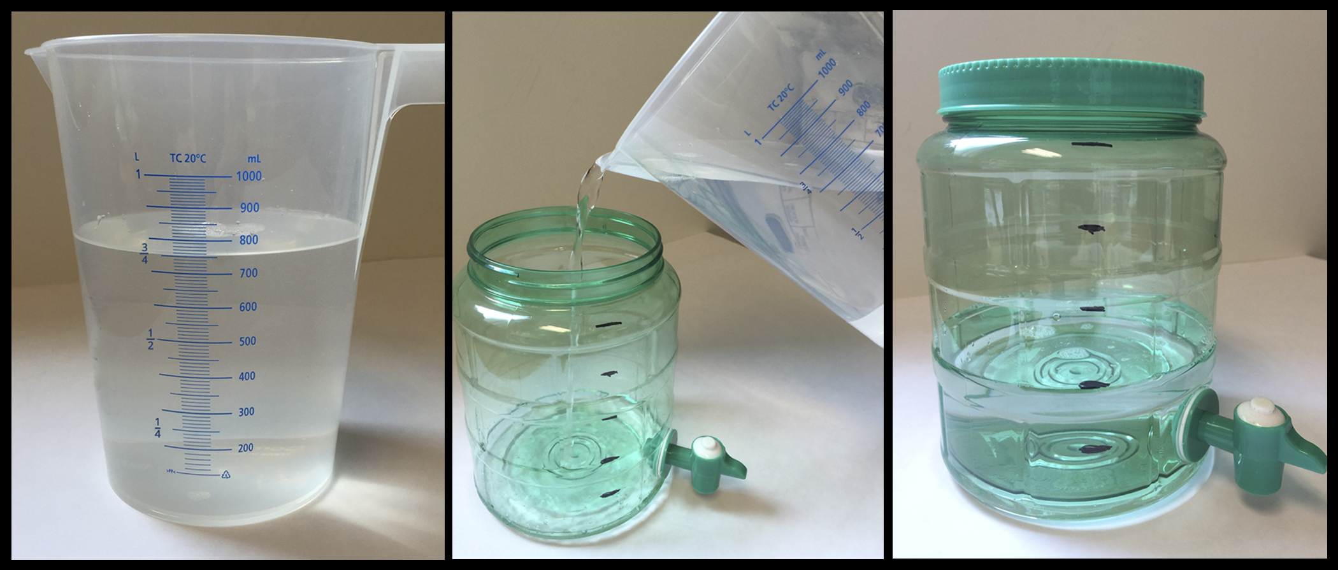
- After looking at these pictures, Lin says, “I see the fraction $\frac{2}{5}$.” Jada says, “I see the fraction $\frac{3}{4}$.” What quantities are Lin and Jada referring to?
- Consider the problem: How many liters of water fit in the water dispenser?
  - Write a multiplication equation and a division equation for the question.
  - Find the answer and explain your reasoning. If you get stuck, consider drawing a diagram.
  - Check your answer using the multiplication equation.

9.3: Amount in One Group
Write a multiplication equation and a division equation and draw a diagram to represent each situation. Then, find the answer and explain your reasoning.
- Jada bought $3\frac{1}{2}$ yards of fabric for $21. How much did each yard cost?
- $\frac{4}{9}$ kilogram of baking soda costs $2. How much does 1 kilogram of baking soda cost?
- Diego can fill $1\frac{1}{5}$ bottles with 3 liters of water. How many liters of water fill 1 bottle?
- $\frac{5}{4}$ gallons of water fill $\frac{5}{6}$ of a bucket. How many gallons of water fill the entire bucket?

Are you ready for more?
The largest sandwich ever made weighed 5,440 pounds. If everyone on Earth shares the sandwich equally, how much would you get? What fraction of a regular sandwich does this represent?

9.4: Inventing Another Situation
- Think of a situation with a question that can be represented by $\frac{1}{3}÷\frac{1}{4}=?$. Describe the situation and the question.
- Trade descriptions with a partner.
  - Review each other’s description and discuss whether each question matches the equation.
  - Revise your description based on the feedback from your partner.
- Find the answer to your question. Explain or show your reasoning. If you get stuck, consider drawing a diagram.

Lesson 9 Summary
Sometimes we have to think carefully about how to solve a problem that involves multiplication and division. Diagrams and equations can help us.
For example, $\frac{3}{4}$ of a pound of rice fills $\frac{2}{5}$ of a container. There are two whole amounts to keep track of here: 1 whole pound and 1 whole container. The equations we write and the diagram we draw depend on what question we are trying to answer.
- How many pounds fill 1 container?
- $\frac{2}{5}⋅?=\frac{3}{4}$
- $\frac{3}{4}÷\frac{2}{5}=?$
- 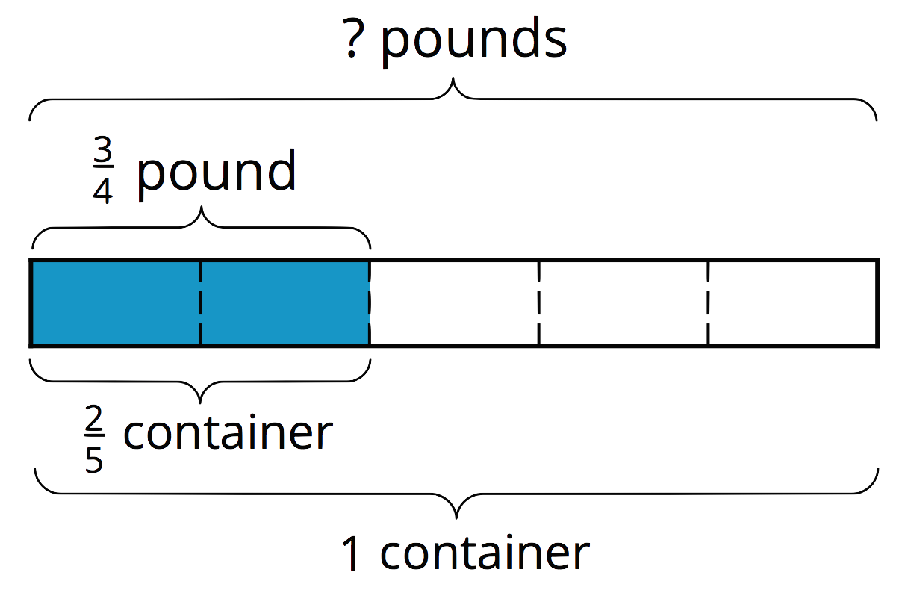
- If $\frac{2}{5}$ of a container is filled with $\frac{3}{4}$ pound, then $\frac{1}{5}$ of a container is filled with half of $\frac{3}{4}$, or $\frac{3}{8}$, pound. One whole container then has $5⋅\frac{3}{8}$ (or $\frac{15}{8}$) pounds.
- What fraction of a container does 1 pound fill?
- $\frac{3}{4}⋅?=\frac{2}{5}$
- $\frac{2}{5}÷\frac{3}{4}=?$
- 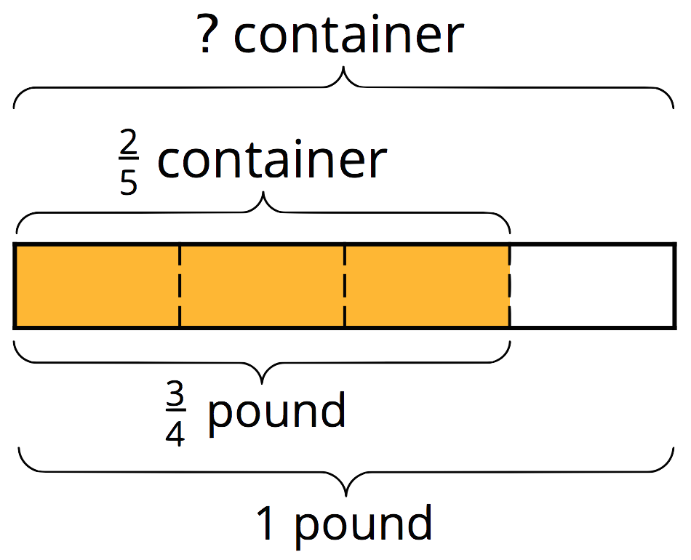
- If $\frac{3}{4}$ pound fills $\frac{2}{5}$ of a container, then $\frac{1}{4}$ pound fills a third of $\frac{2}{5}$, or $\frac{2}{15}$, of a container. One whole pound then fills $4⋅\frac{2}{15}$ (or $\frac{8}{15}$) of a container.
© CC BY Open Up Resources. Adaptations CC BY IM.

