Lesson 14: Use Diagrams to Compare

Standards Alignments
Addressing | 2.MD.D.10
Building Towards | 2.OA.A.1

Teacher-facing Learning Goals
- Solve Compare problems with an unknown difference within 20.
- Use understanding of bar graphs to make sense of tape diagrams.

Student-facing Learning Goals
- Let’s use bar graphs and diagrams to solve Compare problems.

Lesson Purpose
The purpose of this lesson is for students to use their understanding of bar graphs to interpret tape diagrams and solve Compare problems with the difference unknown within 20.
In this lesson, students use their understanding of bar graphs to make sense of a new representation, the tape diagram. The tape diagram is a representation that can be used by students to represent story problems. Students will use tape diagrams in grade 2 and throughout elementary, middle, and high school.

Access for:

Students with Disabilities
- Action and Expression (Activity 1)

English Learners
- MLR2 (Activity 1)

Instructional Routines
Notice and Wonder (Warm-up)

Materials to Gather
- Glue or tape: Activity 1
- Scissors: Activity 1

Materials to Copy
- Party Time (groups of 1): Activity 1

Lesson Timeline
Warm-up | 10 min
Activity 1 | 20 min
Activity 2 | 15 min
Lesson Synthesis | 10 min
Cool-down | 5 min

Teacher Reflection Question
The relationship between addition and subtraction is important as students develop fluency within 20 in grade 2. How did you use the tape diagram to help students build this understanding?

Cool-down
(to be completed at the end of the lesson) 5min
Dogs at the Pet Shop

Standards Alignments
Addressing | 2.MD.D.10

Student-facing Task Statement
These two representations show the same data about dogs at a pet store.
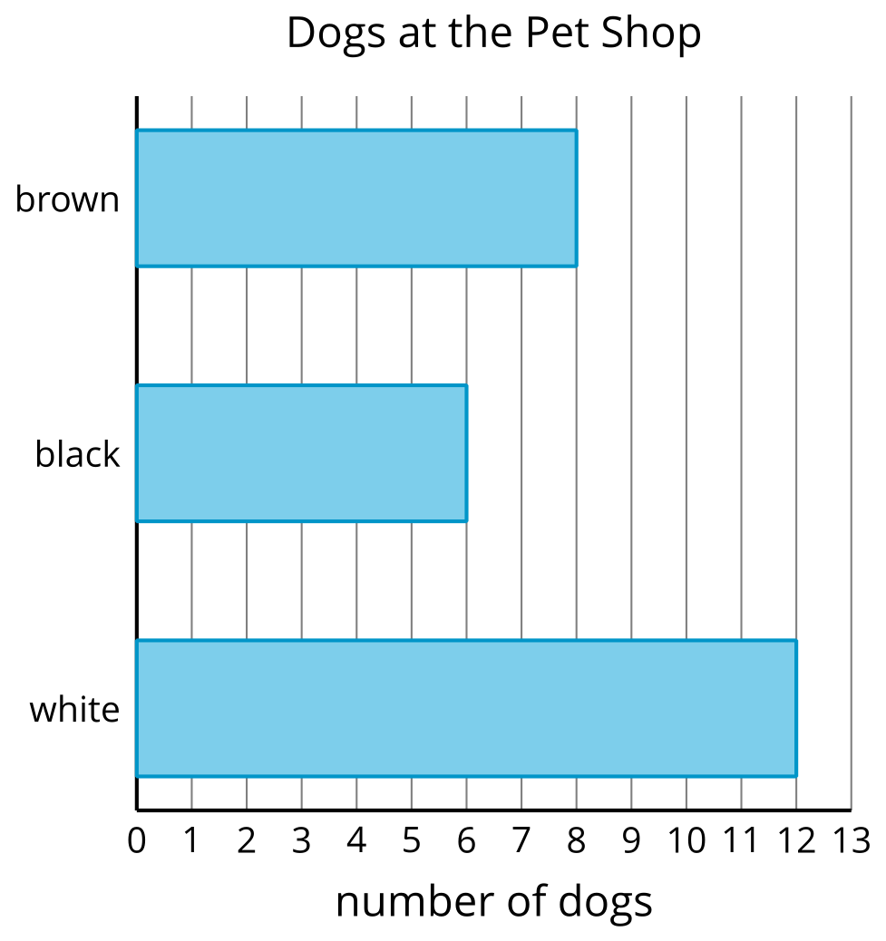
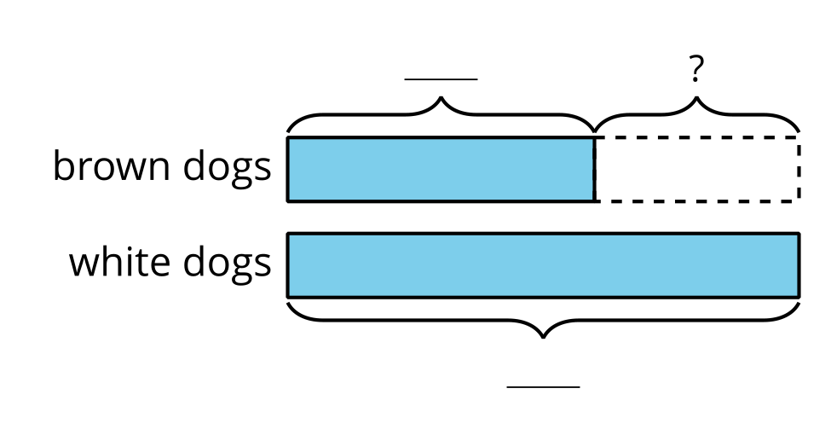
- Use the bar graph to fill in the boxes on the diagram.
- How many more white dogs than brown dogs are there? Show your thinking using drawings, numbers, or words.

Student Responses
- 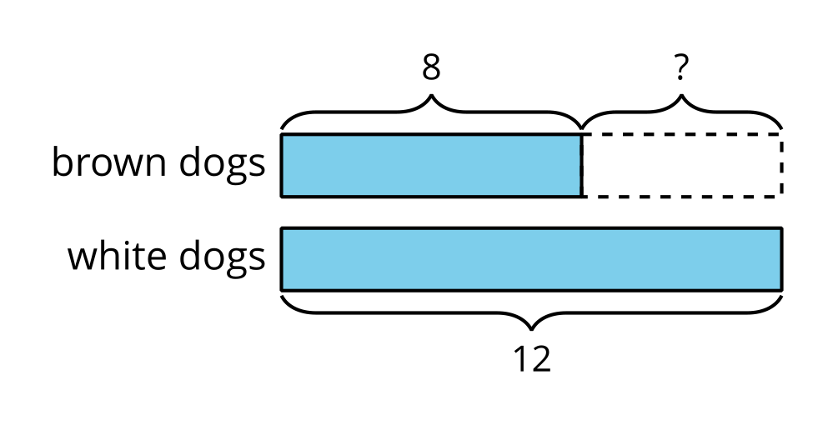
- Sample response: There are 4 more white dogs than brown dogs. $8+4=12$

