Lesson 4: Introduction to Addition Algorithms
- Let’s learn new ways to add.

Warm-up: Which One Doesn’t Belong: 247
Which one doesn’t belong?
A. $200+30+17$
B. 247
C. $200+47+10$
D. $100+140+7$

4.1: What is an Algorithm?
Three students found the value of $362+354$. Their work is shown. Explain how each method works.
- Tyler’s drawing
- 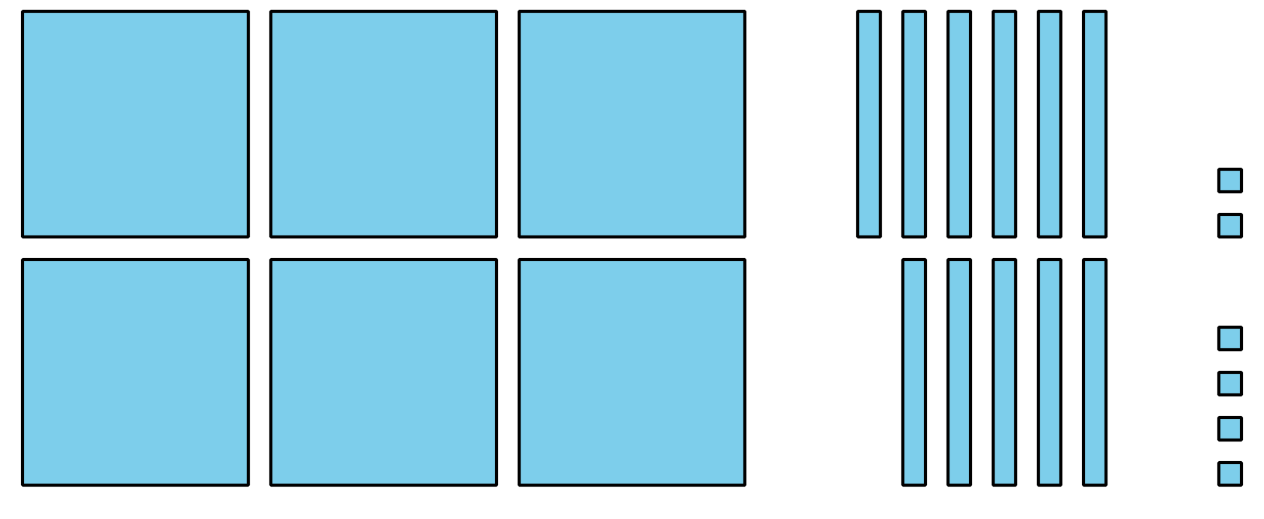
- Lin’s method
- 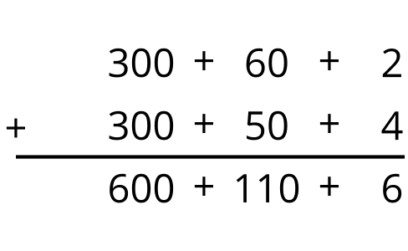
- Han’s method
- 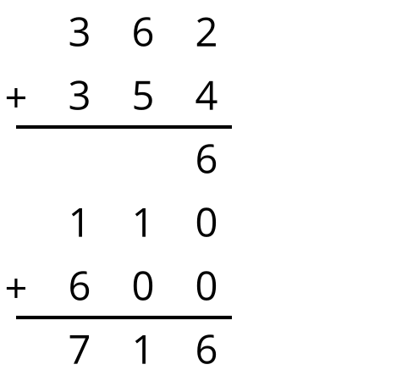
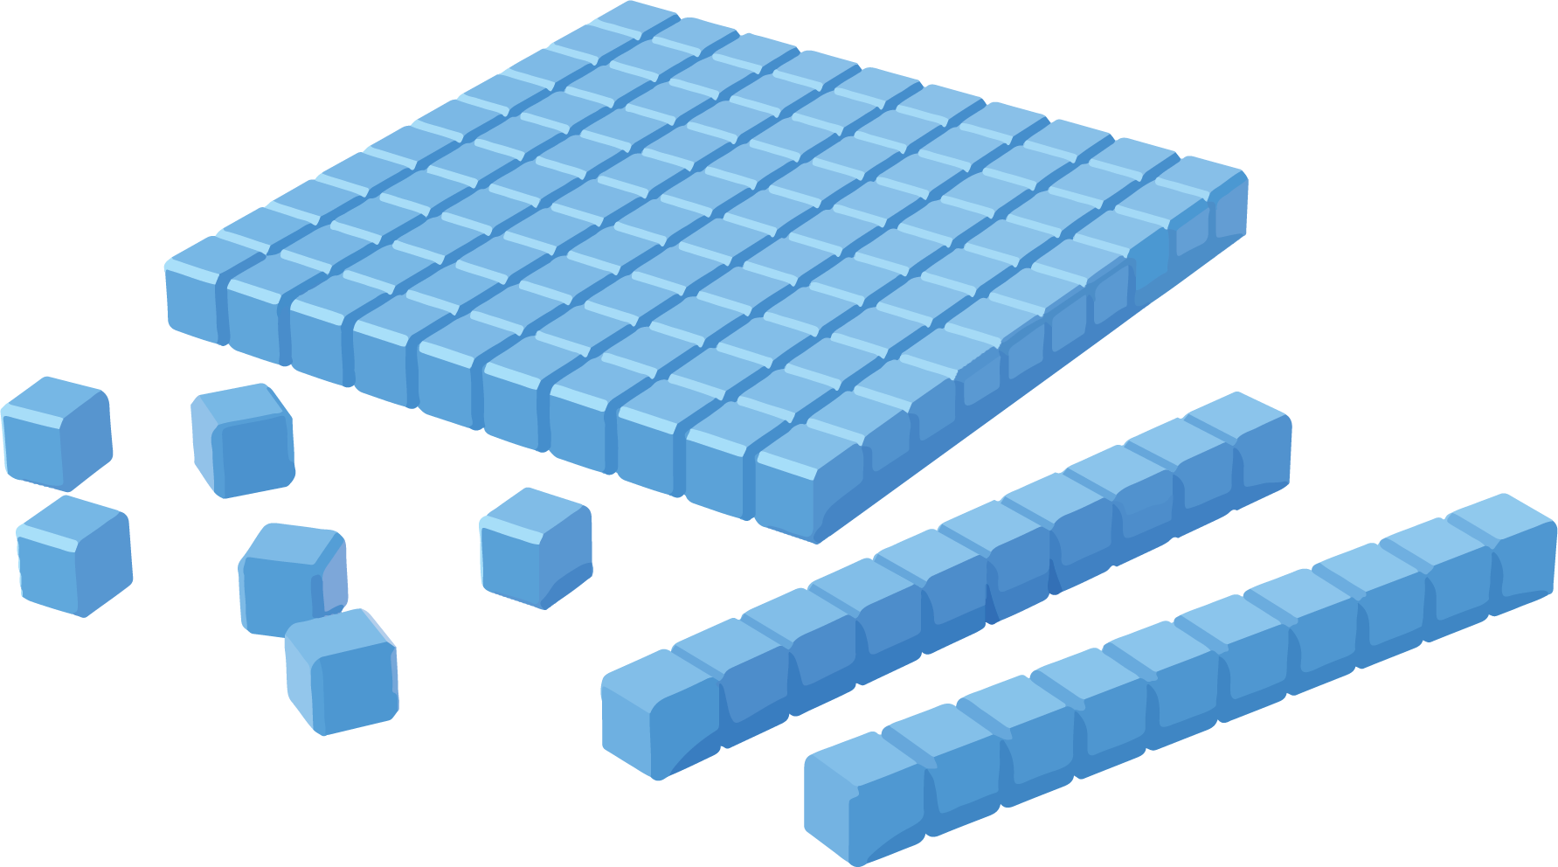

4.2: Try an Algorithm
Try using an algorithm to find the value of each sum. Show your thinking. Organize it so it can be followed by others.
- $475+231$
- $136+389$
- $670+257$
© CC BY 2021 Illustrative Mathematics®

