Lesson 8 Practice Problems
- To find the area of this right triangle, Diego and Jada used different strategies. Diego drew a line through the midpoints of the two longer sides, which decomposes the triangle into a trapezoid and a smaller triangle. He then rearranged the two shapes into a parallelogram.
- 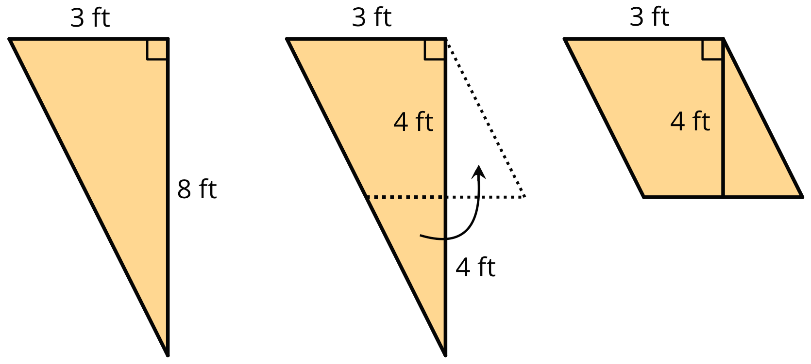
- Jada made a copy of the triangle, rotated it, and lined it up against one side of the original triangle so that the two triangles make a parallelogram.
- 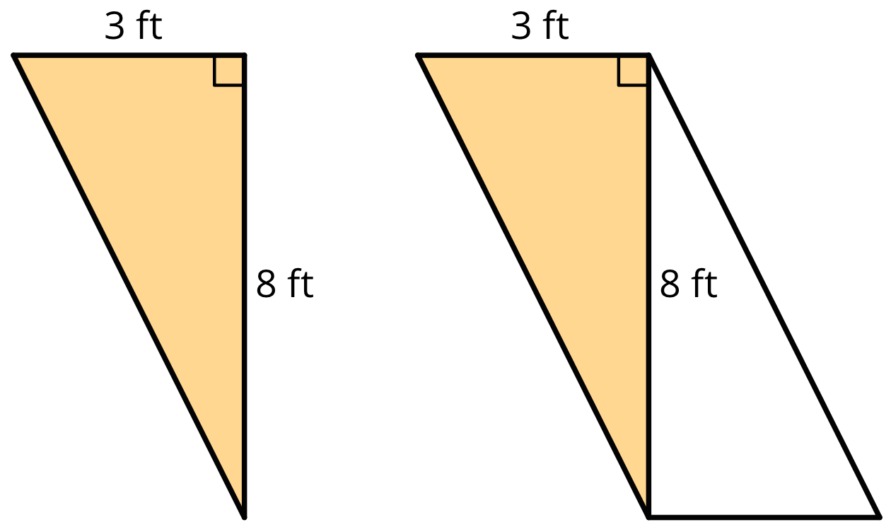
  - Explain how Diego might use his parallelogram to find the area of the triangle.
  - Explain how Jada might use her parallelogram to find the area of the triangle.
- Find the area of the triangle. Explain or show your reasoning.
- a.
- 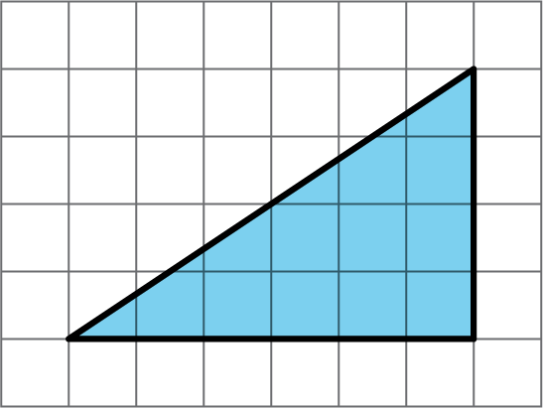
- b.
- 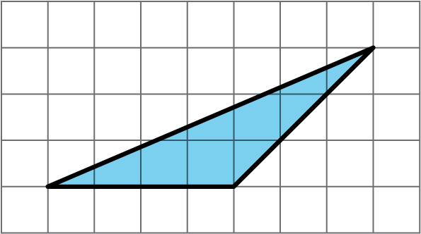

- Which of the three triangles has the greatest area? Show your reasoning. If you get stuck, try using what you know about the area of parallelograms.
- 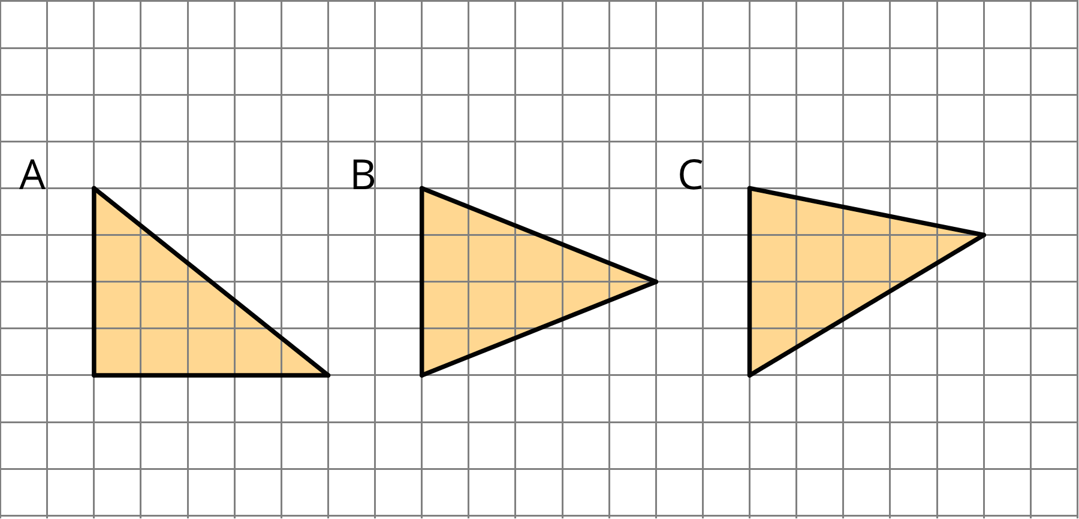
- Draw an identical copy of each triangle such that the two copies together form a parallelogram. If you get stuck, consider using tracing paper.
- 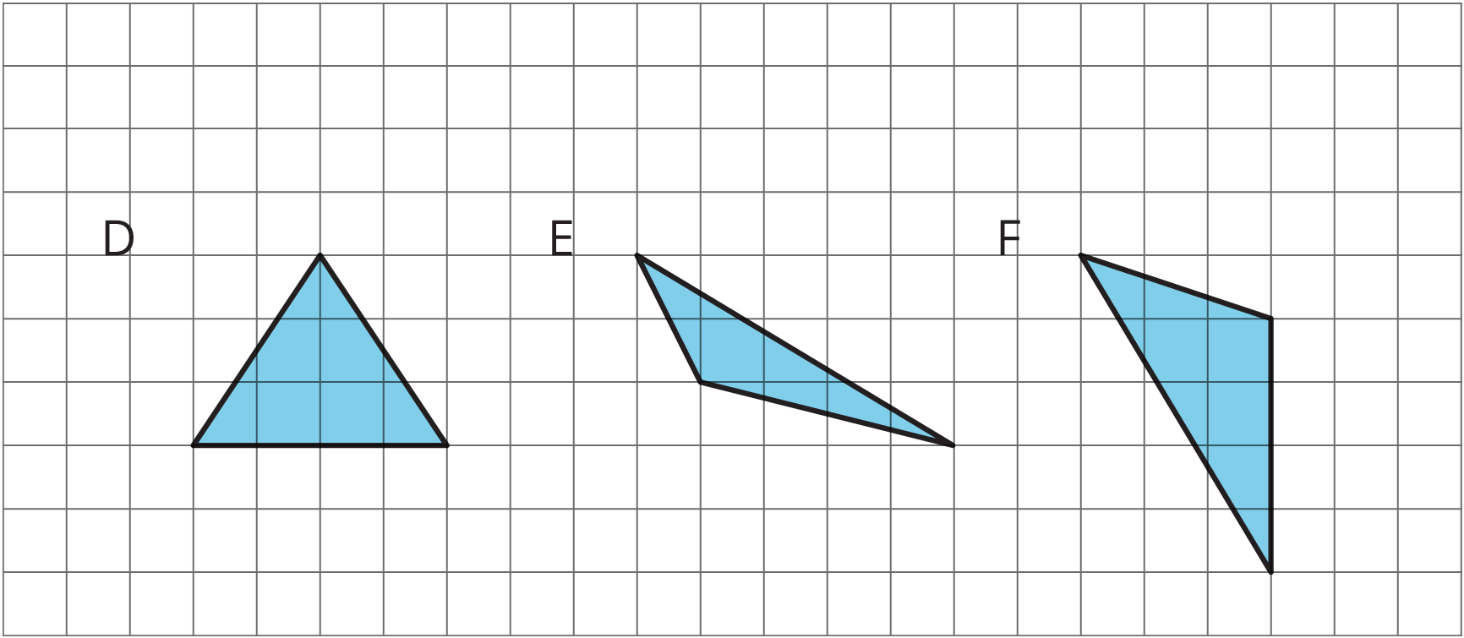
- (From Unit 1, Lesson 7.)

  - A parallelogram has a base of 3.5 units and a corresponding height of 2 units. What is its area?
  - A parallelogram has a base of 3 units and an area of 1.8 square units. What is the corresponding height for that base?
  - A parallelogram has an area of 20.4 square units. If the height that corresponds to a base is 4 units, what is the base?
- (From Unit 1, Lesson 6.)
© CC BY Open Up Resources. Adaptations CC BY IM.

