Lesson 15: Diagrams with All Kinds of Compare Problems

Standards Alignments
Addressing | 2.OA.A.1, 2.OA.B.2

Teacher-facing Learning Goals
- Interpret tape diagrams that represent Compare problems, with unknowns in all positions within 100.

Student-facing Learning Goals
- Let’s connect Compare problems to diagrams.

Lesson Purpose
The purpose of this lesson is for students to connect Compare problems with unknowns in all positions to tape diagrams.
In this lesson, students continue to make sense of tape diagrams as they connect them to story problems. The story problems in this lesson include Compare problems with an unknown difference, an unknown larger number, or an unknown smaller number. Because these problem types are familiar from grade 1, students also begin to work with numbers within 100 in this lesson. This gives students an opportunity to notice how the tape diagram can be used to quickly visualize story problems with larger quantities. Students use tape diagrams to make sense of Compare problems. When students connect situations, tape diagrams, and equations, they deepen their understanding of the problem type and develop strategies they can use to make sense of and persevere in solving these problems in future lessons (MP1, MP2).

Access for:

Students with Disabilities
- Action and Expression (Activity 1)

English Learners
- MLR8 (Activity 2)

Instructional Routines
Card Sort (Activity 2), Number Talk (Warm-up)

Materials to Copy
- Card Sort: At the Beach (groups of 2): Activity 2

Lesson Timeline
Warm-up | 10 min
Activity 1 | 15 min
Activity 2 | 20 min
Lesson Synthesis | 10 min
Cool-down | 5 min

Teacher Reflection Question
As students worked in their small groups today, whose ideas were heard, valued, and accepted? How can you adjust the group structure in future lessons to ensure each student’s ideas are a part of the collective learning?

Cool-down
(to be completed at the end of the lesson) 5min
At the Beach

Standards Alignments
Addressing | 2.OA.A.1

Student-facing Task Statement
Children found shells and rocks at the beach. They found 8 more shells than rocks. They found 19 rocks. How many shells did the children find?
- Circle the diagram that matches the story problem.
- 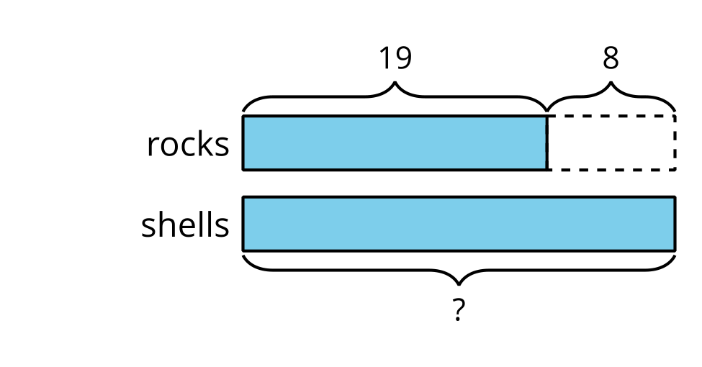
- 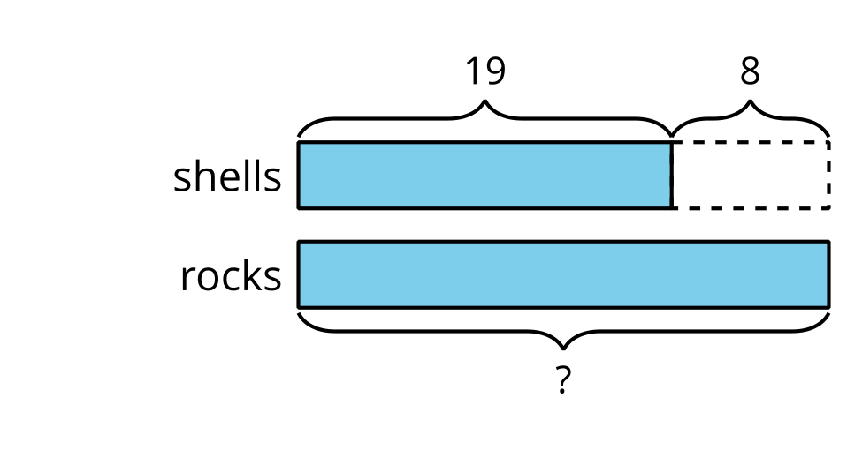
- Explain how you know the diagram matches the story.

Student Responses
- Circles left choice.
- Sample response: The diagram matches because it shows that there will be more shells than rocks. It doesn’t tell how many shells so that’s why it has a ?

