Lesson 5: Another Addition Algorithm
- Let’s learn another algorithm to add.

Warm-up: Notice and Wonder: Another Curious Table
What do you notice? What do you wonder?
+ | 98 | 99 | 100 | 101 | 102
98 |  | 197 |  | 199
99 | 197 |  | 199 |  | 201
100 |  | ? |  | ?
101 | 199 |  | 201 |  | 203
102 |  | 201 |  | 203

5.1: A New Addition Algorithm
Here are two algorithms for adding $367+231$.
Han’s algorithm
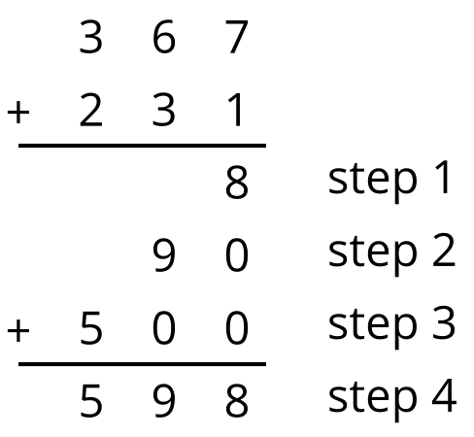
Elena’s algorithm
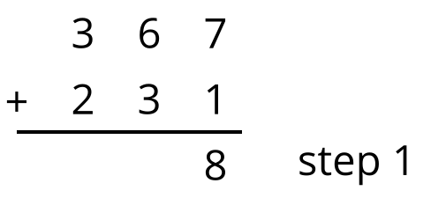
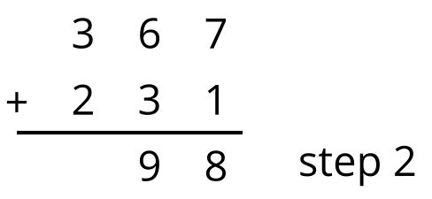
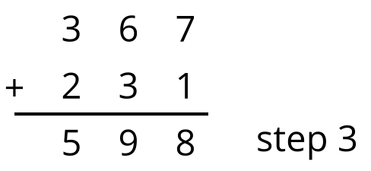
Discuss with your partner:
- How is Elena’s algorithm different from Han’s algorithm?
- Why do both algorithms work?

5.2: Compose New Units
Here are two algorithms for adding $365+182$.
Han’s algorithm
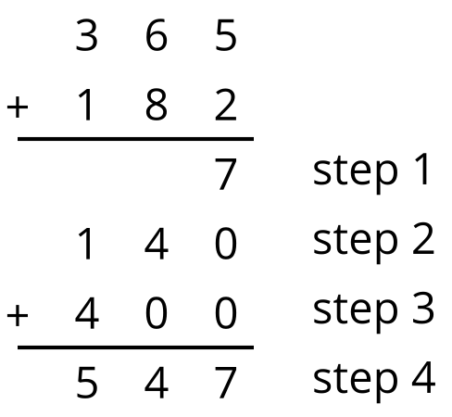
Elena's algorithm
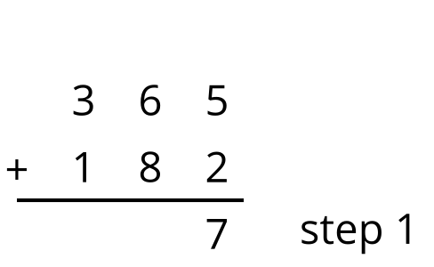
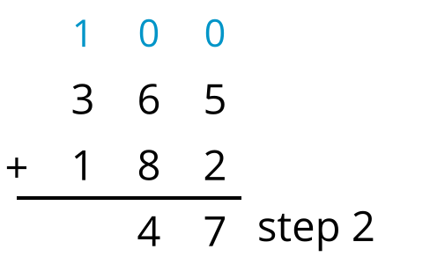
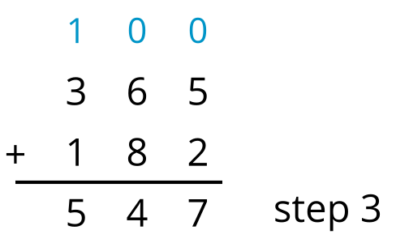
- How do the algorithms show the 14 tens differently?
- Try Elena’s algorithm to find the value of each sum.
  - $174+352$
  - $273+619$
  - $354+198$
  - $525+376$
© CC BY 2021 Illustrative Mathematics®

