Unit 6 Lesson 18: Divide with Partial Quotients

WU Number Talk: Divide by 3 (Warm up)

Student Task Statement
Find the value of each expression mentally.
- $90÷3$
- $96÷3$
- $960÷3$
- $954÷3$

1 Decompose Dividends

Student Task Statement
- Find the value of $465÷5$. Show your reasoning. You may use base-blocks if you find them helpful.
- Here’s how Priya finds the value of $465÷5$.
- 400÷5=8060÷5=125÷5=01 465÷5¯ =93000¯
  - What has Priya done? Describe her steps.
  - How is Priya’s method similar to your method?
  - Use Priya’s method to find the value of $428÷4$.

2 Tyler’s Method

Student Task Statement
Tyler uses a different method to find the value of $465÷5$. Let’s compare Priya’s and Tyler’s work.
Priya's method
400÷5=8060÷5=125÷5=01 465÷5¯ =93000¯
Tyler's method
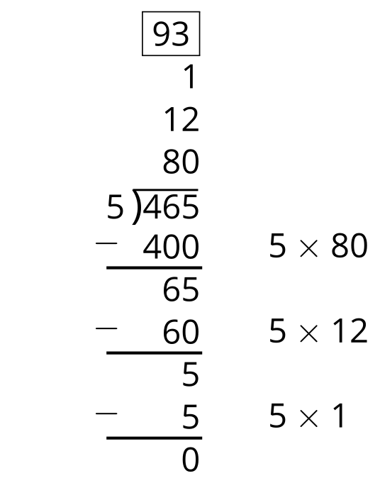
- How are Priya and Tyler’s methods alike? How are they different? List as many similarities and differences as you can find.
- Why do you think Tyler uses subtraction in his method?
- Show how Tyler might record the process of finding the value of $428÷4$.

Images for Activity Synthesis
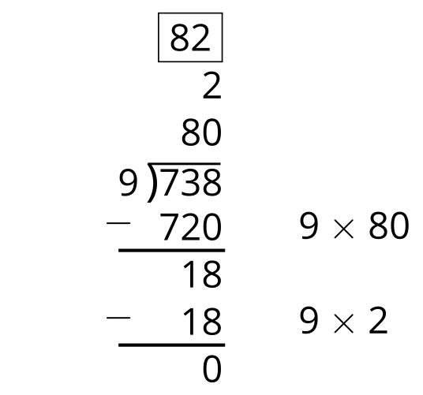
© CC BY 2021 Illustrative Mathematics®

