Unit 6 Lesson 9: Introduction to Trigonometric Functions

1 An Angle and a Circle (Warm up)

Student Task Statement
Suppose there is a point $P$ on the unit circle at $(1,0)$.
- Describe how the $x$-coordinate of $P$ changes as it rotates once counterclockwise around the circle.
- Describe how the $y$-coordinate of $P$ changes as it rotates once counterclockwise around the circle.

2 Do the Wave

Student Task Statement
- For each tick mark on the horizontal axis, plot the value of $y=\text{cos}(θ)$, where $θ$ is the measure of an angle in radians. Use the class display of the unit circle, the unit circle from an earlier lesson, or technology to estimate the value of $\text{cos}(θ)$.
- 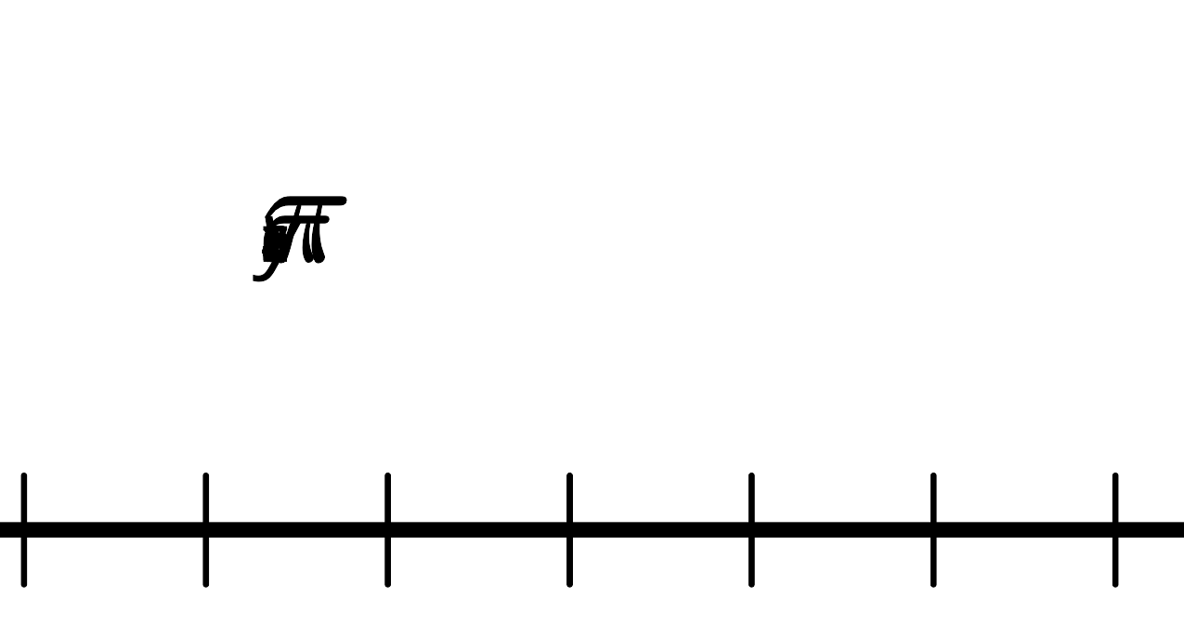
- For each tick mark on the horizontal axis, plot the value of $y=\text{sin}(θ)$. Use the class display of the unit circle, the unit circle from an earlier lesson, or technology to estimate the value of $\text{sin}(θ)$.
- 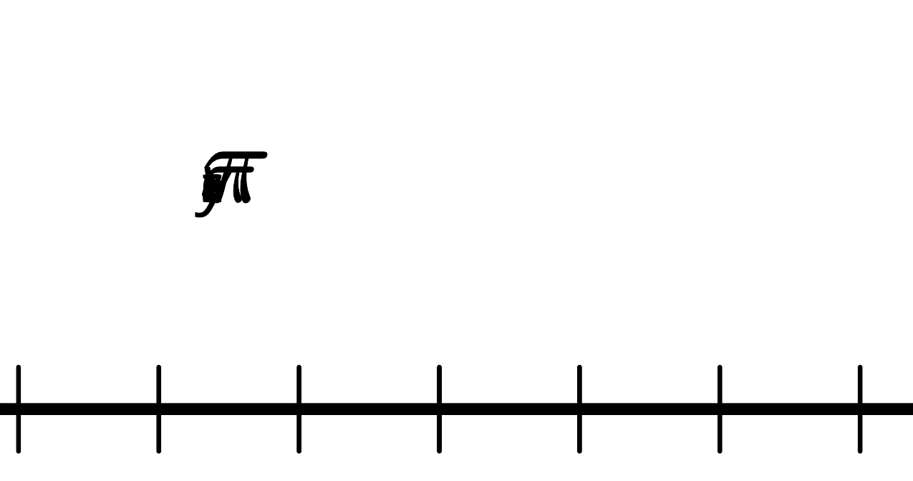
- What do you notice about the two graphs?
- Explain why any angle measure between 0 and $2π$ gives a point on each graph.
- Could these graphs represent functions? Explain your reasoning.

3 Graphs of Cosine and Sine

Student Task Statement
- Looking at the graphs of $y=\text{cos}(θ)$ and $y=\text{sin}(θ)$, at what values of $θ$ do $\text{cos}(θ)=\text{sin}(θ)$? Where on the unit circle do these points correspond to?
- For each of these equations, first predict what the graph looks like, and then check your prediction using technology.
  - $y=\text{cos}(θ)+\text{sin}(θ)$
  - $y={\text{cos}}^{2}(θ)$
  - $y={\text{sin}}^{2}(θ)$
  - $y={\text{cos}}^{2}(θ)+{\text{sin}}^{2}(θ)$

Images for Activity Synthesis
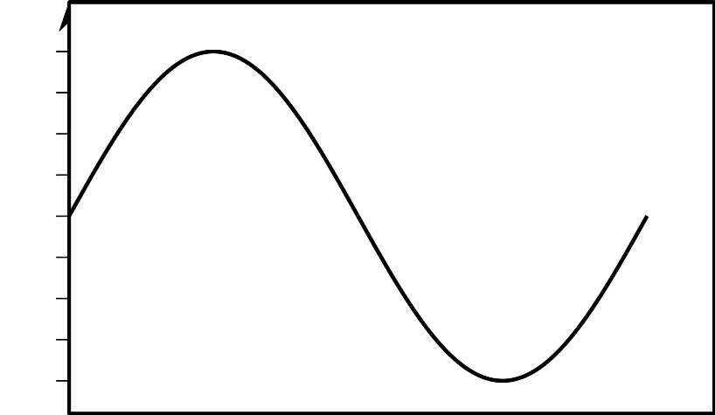
© CC BY 2019 by Illustrative Mathematics®

