Unit 4 Lesson 16 Cumulative Practice Problems
- Lin was looking at the equation $2x−32+4(3x−2462)=14x$. She said, “I can tell right away there are no solutions, because on the left side, you will have $2x+12x$ and a bunch of constants, but you have just $14x$ on the right side.” Do you agree with Lin? Explain your reasoning.
- Han was looking at the equation $6x−4+2(5x+2)=16x$. He said, “I can tell right away there are no solutions, because on the left side, you will have $6x+10x$ and a bunch of constants, but you have just $16x$ on the right side.” Do you agree with Han? Explain your reasoning.
- Decide whether each equation is true for all, one, or no values of $x$.
  - $6x−4=\text{-}4+6x$
  - $4x−6=4x+3$
  - $\text{-}2x+4=\text{-}3x+4$
- Solve each of these equations. Explain or show your reasoning.
  - $3(x−5)=6$
  - $2\left(x−\frac{2}{3}\right)=0$
  - $4x−5=2−x$
- (From Unit 4, Lesson 13.)
- In the picture triangle $A^{′}B^{′}C^{′}$ is an image of triangle $ABC$ after a rotation. The center of rotation is $E$.
- 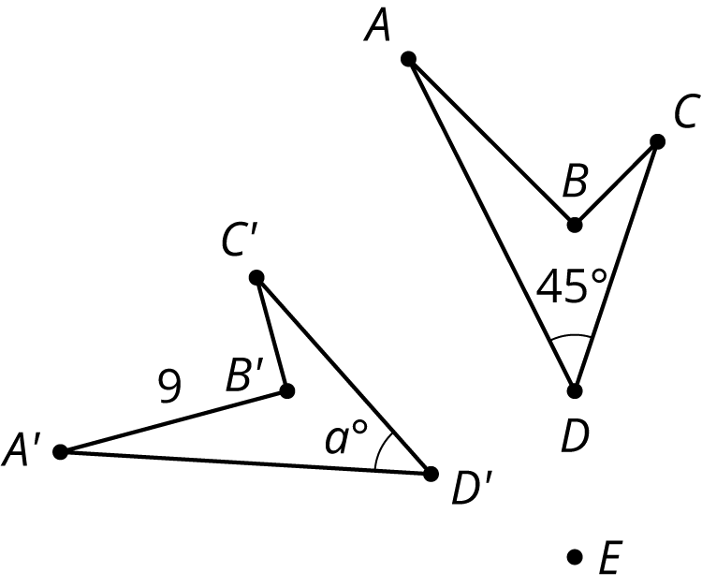
  - What is the length of side $AB$? Explain how you know.
  - What is the measure of angle $D^{′}$? Explain how you know.
- (From Unit 1, Lesson 6.)
- Solve each of these equations. Explain or show your reasoning.
- $2(x+5)=3x+1$
- $3y−4=6−2y$
- $3(n+2)=9(6−n)$

- (From Unit 4, Lesson 13.)
© CC BY Open Up Resources. Adaptations CC BY IM.

