Unit 6 Lesson 17 Cumulative Practice Problems
- A car is traveling down a road at a constant speed of 50 miles per hour.
  - Complete the table with the amounts of time it takes the car to travel certain distances, or the distances traveled for certain amounts of time.
  - Write an equation that represents the distance traveled by the car, $d$, for an amount of time, $t$.
  - In your equation, which is the dependent variable and which is the independent variable?
- time (hours) | - distance (miles)
- 2
- 1.5
- $t$
 | - 50
 | - 300
 | - $d$
- The graph represents the amount of time in hours it takes a ship to travel various distances in miles.
- 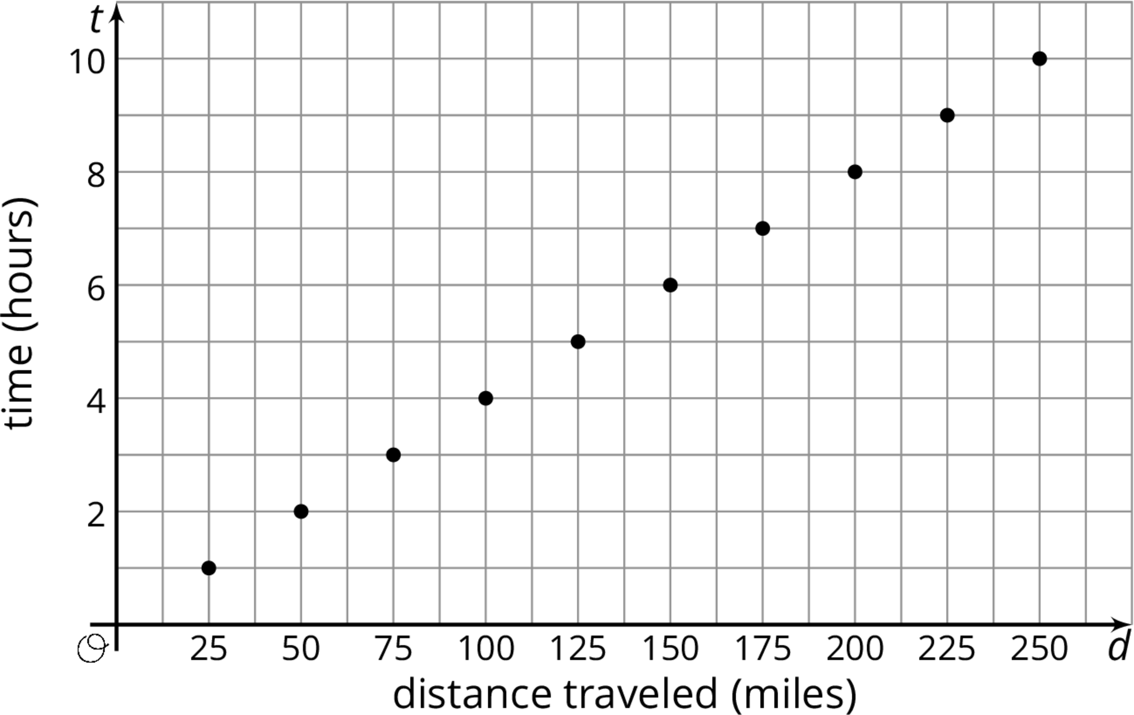
  - Write the coordinates of one of point on the graph. What does the point represent?
  - What is the speed of the ship in miles per hour?
  - Write an equation that relates the time, $t$, it takes to travel a given distance, $d$.
- Find a solution to each equation in the list that follows (not all numbers will be used):
  - $2^{x}=8$
  - $2^{x}=2$
  - $x^{2}=100$
  - $x^{2}=\frac{1}{100}$
  - $x^{1}=7$
  - $2^{x}⋅2^{3}=2^{7}$
  - $\frac{2^{x}}{2^{3}}=2^{5}$
- List:
- $\frac{1}{10}$
- $\frac{1}{3}$
- 1
- 2
- 3
- 4
- 5
- 7
- 8
- 10
- 16
- (From Unit 6, Lesson 15.)
- Select all the expressions that are equivalent to $5x+30x−15x$.
  - $5(x+6x−3x)$
  - $(5+30−15)\text{\backslash boldcdot}x$
  - $x(5+30x−15x)$
  - $5x(1+6−3)$
  - $5(x+30x−15x)$
- (From Unit 6, Lesson 11.)
- Evaluate each expression if $x$ is 1, $y$ is 2, and $z$ is 3.
  - $7x^{2}−z$
  - $(x+4)^{3}−y$
  - $y(x+3^{3})$
  - $(7−y+z)^{2}$
  - $0.241x+x^{3}$
- (From Unit 6, Lesson 15.)
© CC BY Open Up Resources. Adaptations CC BY IM.

