Lesson 3: Scaled Relationships
Let’s find relationships between scaled copies.

3.1: Three Quadrilaterals (Part 1)
Each of these polygons is a scaled copy of the others.
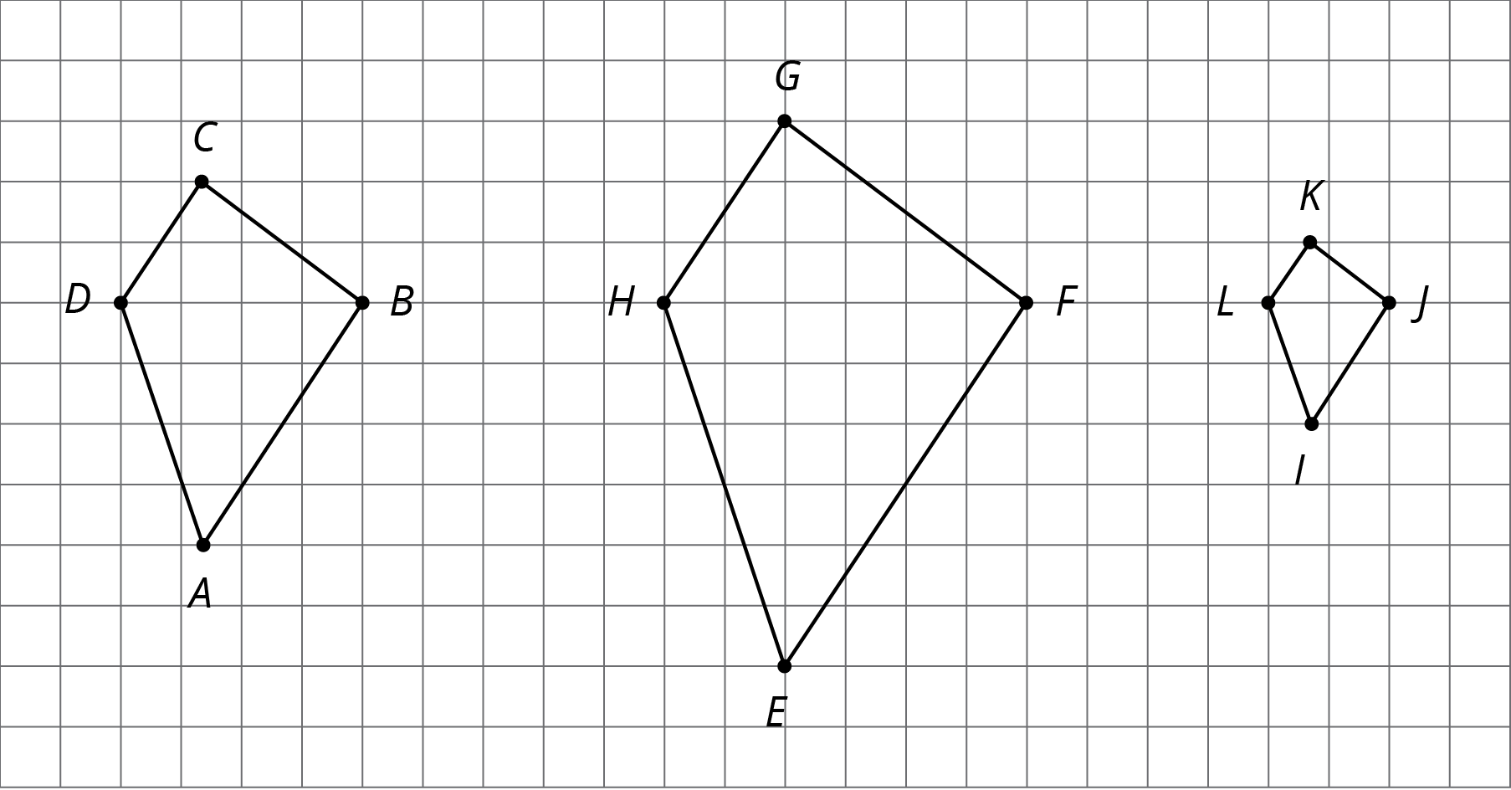
- Name two pairs of corresponding angles. What can you say about the sizes of these angles?
- Check your prediction by measuring at least one pair of corresponding angles using a protractor. Record your measurements to the nearest $5^{∘}$.

3.2: Three Quadrilaterals (Part 2)
Each of these polygons is a scaled copy of the others. You already checked their corresponding angles.
- The side lengths of the polygons are hard to tell from the grid, but there are other corresponding distances that are easier to compare. Identify the distances in the other two polygons that correspond to $DB$ and $AC$, and record them in the table.
- quadrilateral | - distance that  corresponds to $DB$ | - distance that  corresponds to $AC$
- $ABCD$ | - $DB=4$ | - $AC=6$
- $EFGH$
- $IJKL$
- Look at the values in the table. What do you notice?
- Pause here so your teacher can review your work.
- The larger figure is a scaled copy of the smaller figure.
- 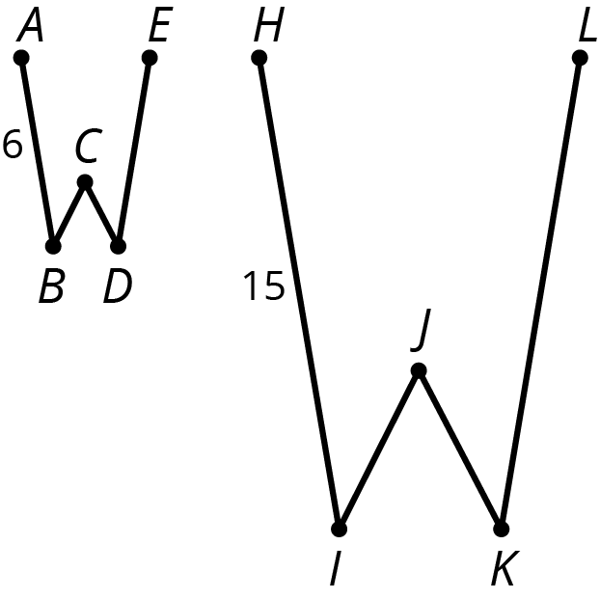
  - If $AE=4$, how long is the corresponding distance in the second figure? Explain or show your reasoning.
  - If $IK=5$, how long is the corresponding distance in the first figure? Explain or show your reasoning.

3.3: Card Sort: Scaled Copies
Your teacher will give you a set of cards. On each card, Figure A is the original and Figure B is a scaled copy.
- Sort the cards based on their scale factors. Be prepared to explain your reasoning.
- Examine cards 10 and 13 more closely. What do you notice about the shapes and sizes of the figures? What do you notice about the scale factors?
- Examine cards 8 and 12 more closely. What do you notice about the figures? What do you notice about the scale factors?

Are you ready for more?
Triangle B is a scaled copy of Triangle A with scale factor $\frac{1}{2}$.
- How many times bigger are the side lengths of Triangle B when compared with Triangle A?
- Imagine you scale Triangle B by a scale factor of $\frac{1}{2}$ to get Triangle C. How many times bigger will the side lengths of Triangle C be when compared with Triangle A?
- Triangle B has been scaled once. Triangle C has been scaled twice. Imagine you scale triangle A $n$ times to get Triangle N, always using a scale factor of $\frac{1}{2}$. How many times bigger will the side lengths of Triangle N be when compared with Triangle A?

3.4: Scaling A Puzzle
Your teacher will give you 2 pieces of a 6-piece puzzle.
- If you drew scaled copies of your puzzle pieces using a scale factor of $\frac{1}{2}$, would they be larger or smaller than the original pieces? How do you know?
- Create a scaled copy of each puzzle piece on a blank square, with a scale factor of $\frac{1}{2}$.
- When everyone in your group is finished, put all 6 of the original puzzle pieces together like this:
- 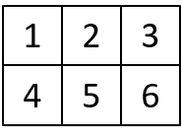
- Next, put all 6 of your scaled copies together. Compare your scaled puzzle with the original puzzle. Which parts seem to be scaled correctly and which seem off? What might have caused those parts to be off?
- Revise any of the scaled copies that may have been drawn incorrectly.
- If you were to lose one of the pieces of the original puzzle, but still had the scaled copy, how could you recreate the lost piece?

Lesson 3 Summary
When a figure is a scaled copy of another figure, we know that:
- All distances in the copy can be found by multiplying the corresponding distances in the original figure by the same scale factor, whether or not the endpoints are connected by a segment.
- For example, Polygon $STUVWX$ is a scaled copy of Polygon $ABCDEF$. The scale factor is 3. The distance from $T$ to $X$ is 6, which is three times the distance from $B$ to $F$.
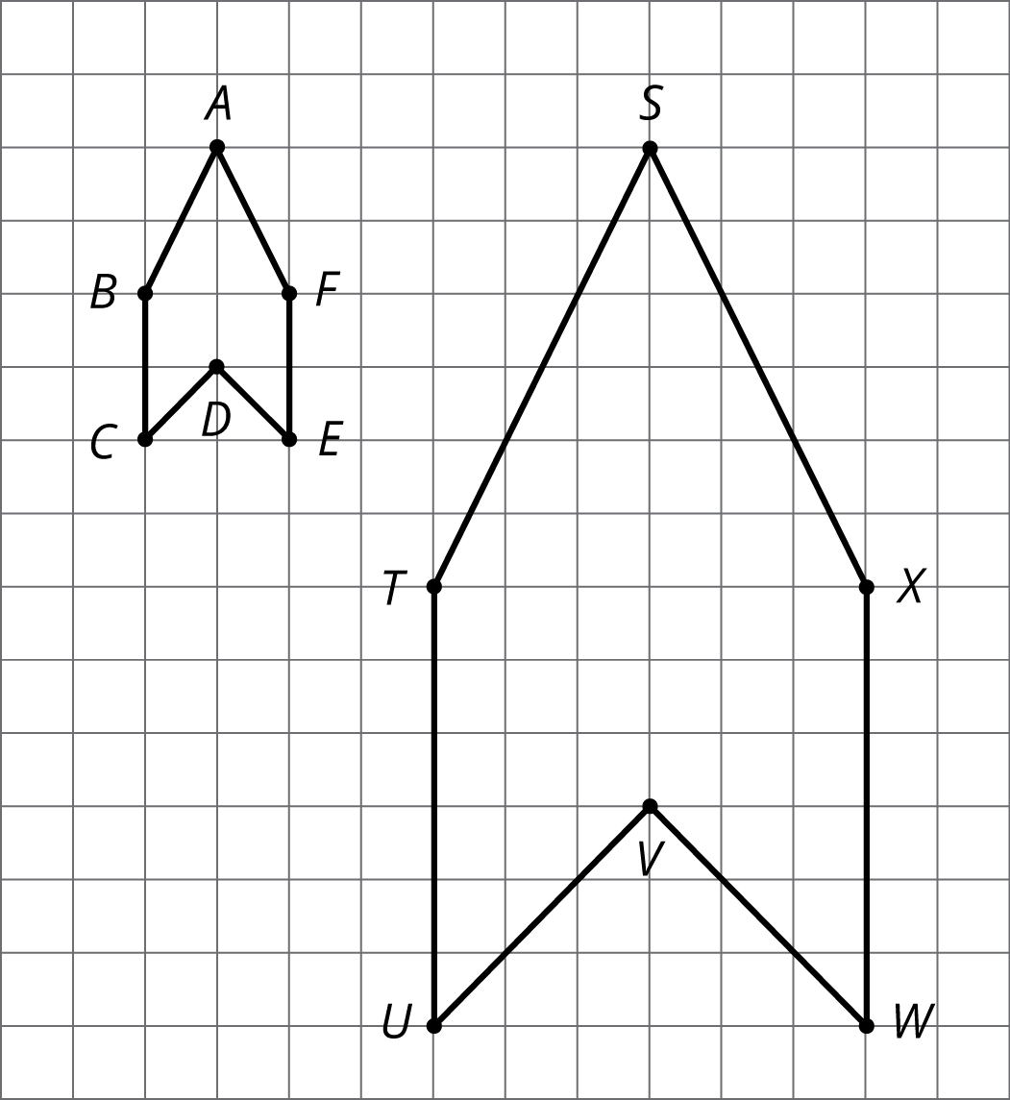
- All angles in the copy have the same measure as the corresponding angles in the original figure, as in these triangles.
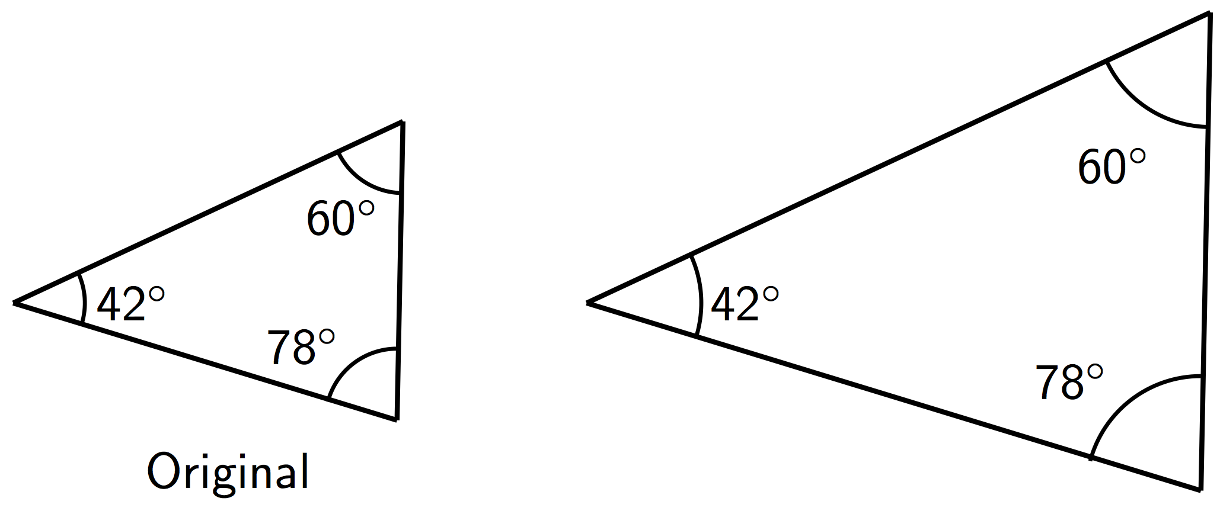
These observations can help explain why one figure is not a scaled copy of another.
For example, even though their corresponding angles have the same measure, the second rectangle is not a scaled copy of the first rectangle, because different pairs of corresponding lengths have different scale factors, $2⋅\frac{1}{2}=1$ but $3⋅\frac{2}{3}=2$.
When one figure is a scaled copy of another, the size of the scale factor affects the size of the copy. When a figure is scaled by a scale factor greater than 1, the copy is larger than the original. When the scale factor is less than 1, the copy is smaller. When the scale factor is exactly 1, the copy is the same size as the original.
Triangle $DEF$ is a larger scaled copy of triangle $ABC$, because the scale factor from $ABC$ to $DEF$ is $\frac{3}{2}$. Triangle $ABC$ is a smaller scaled copy of triangle $DEF$, because the scale factor from $DEF$ to $ABC$ is $\frac{2}{3}$.
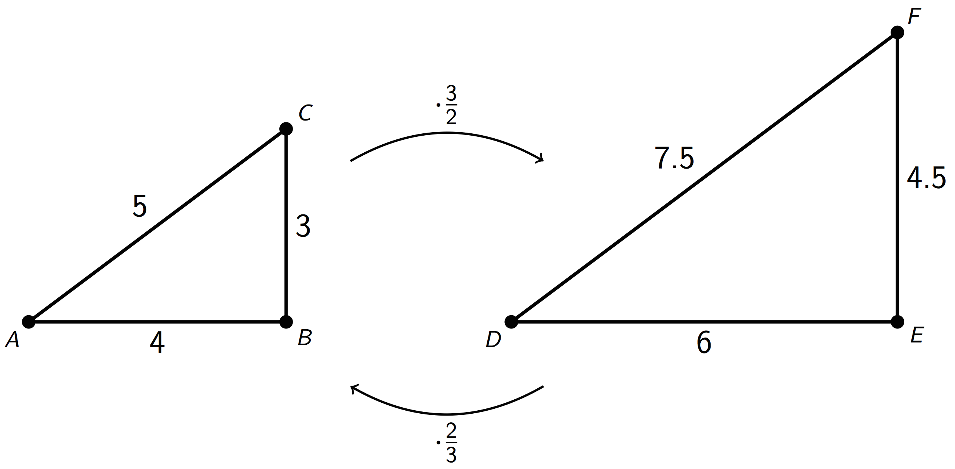
This means that triangles $ABC$ and $DEF$ are scaled copies of each other. It also shows that scaling can be reversed using reciprocal scale factors, such as $\frac{2}{3}$ and $\frac{3}{2}$.
In other words, if we scale Figure A using a scale factor of 4 to create Figure B, we can scale Figure B using the reciprocal scale factor, $\frac{1}{4}$, to create Figure A.
© CC BY Open Up Resources. Adaptations CC BY IM.

