Unit 2 Lesson 10: Find More or Fewer

WU Questions About Us: Apples or Bananas? (Part 2) (Warm up)

Student Task Statement

1 Circle More, Circle Fewer

Student Task Statement

- 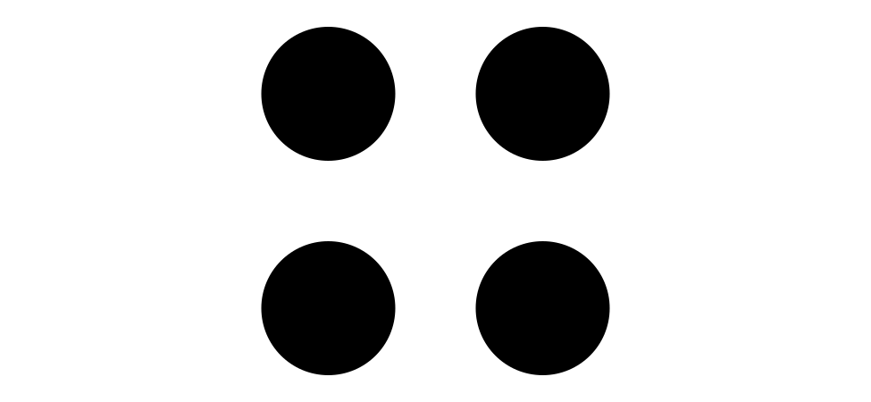

- 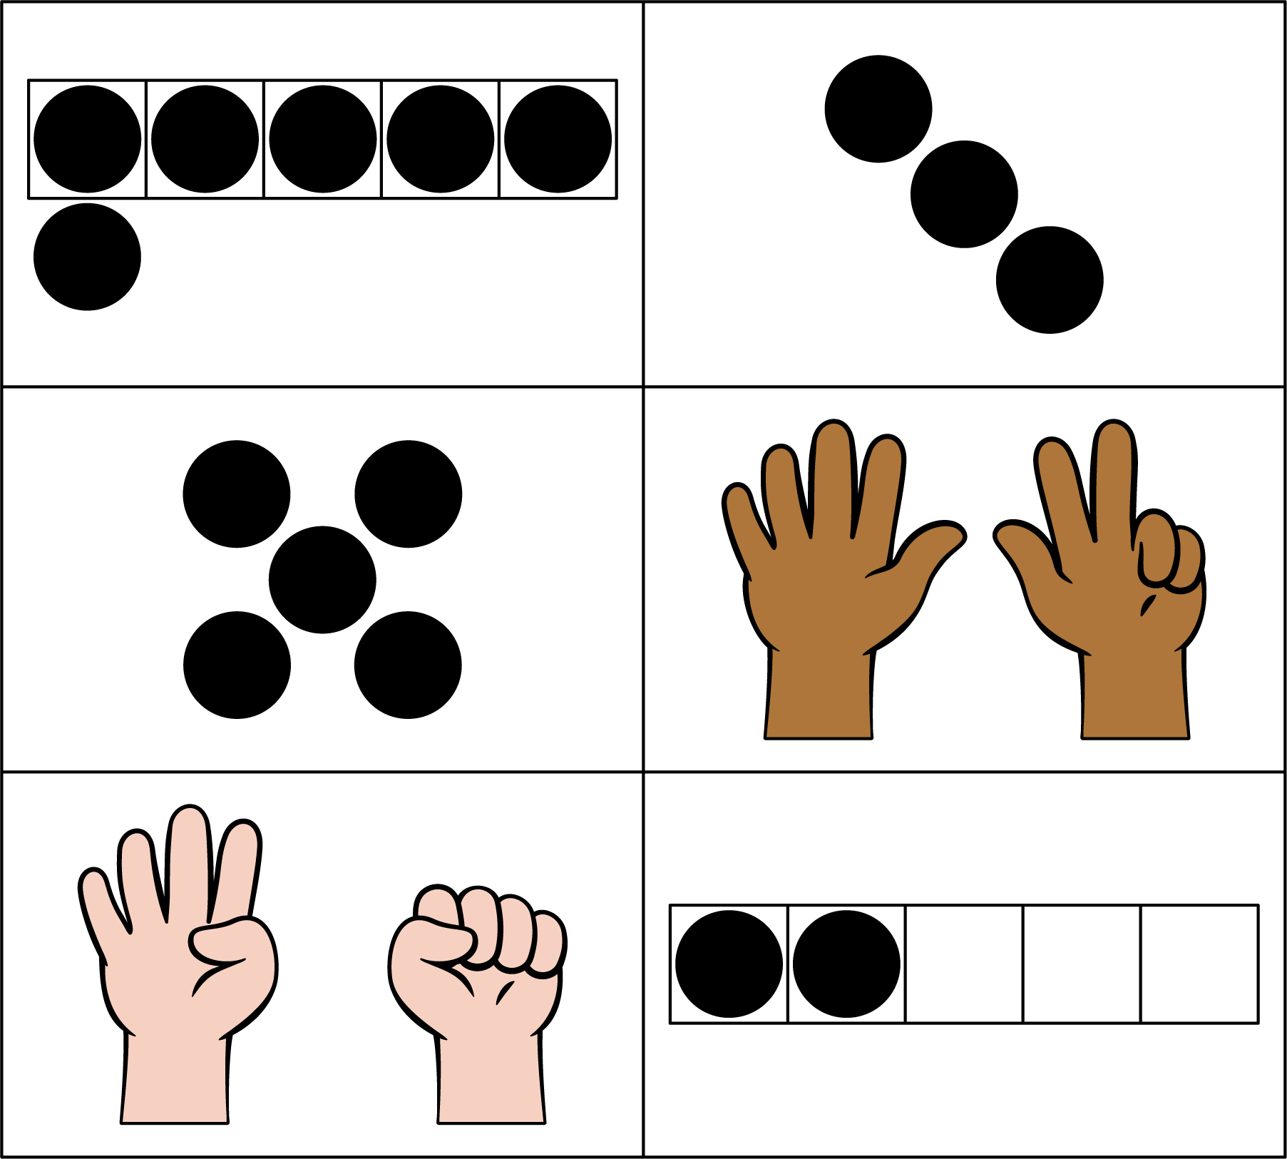

- 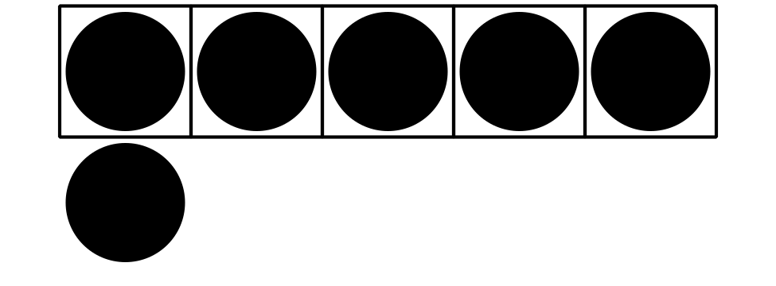

- 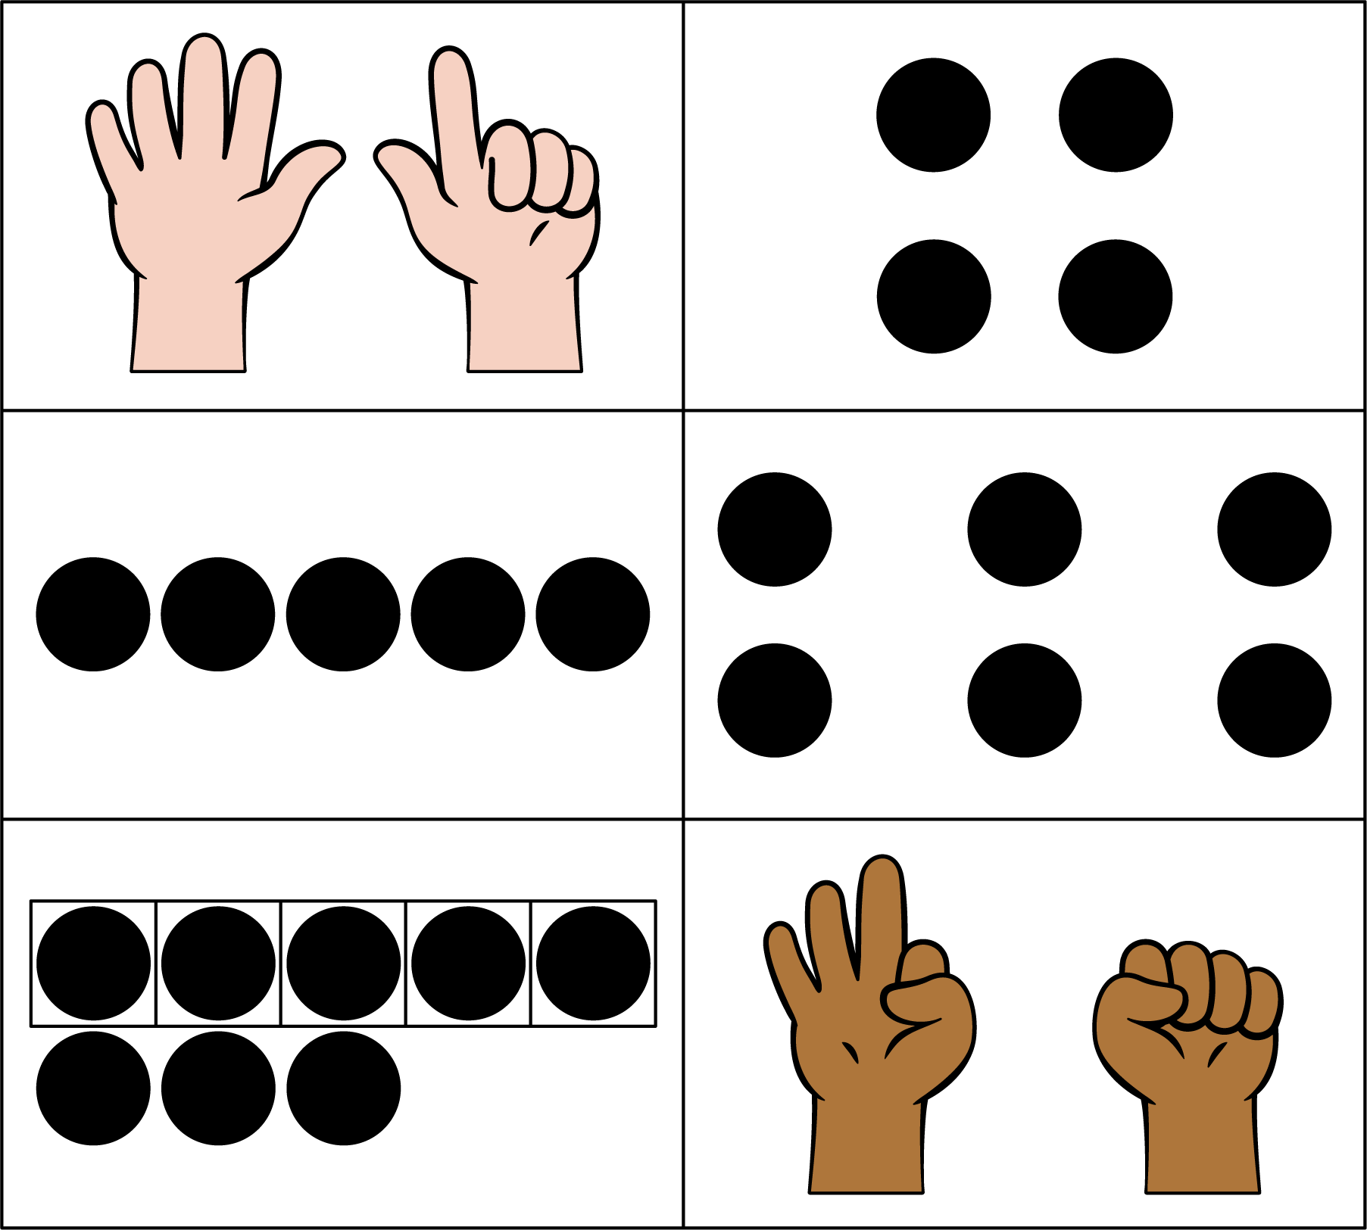

2 Introduce Less, Same, More, Images

Student Task Statement
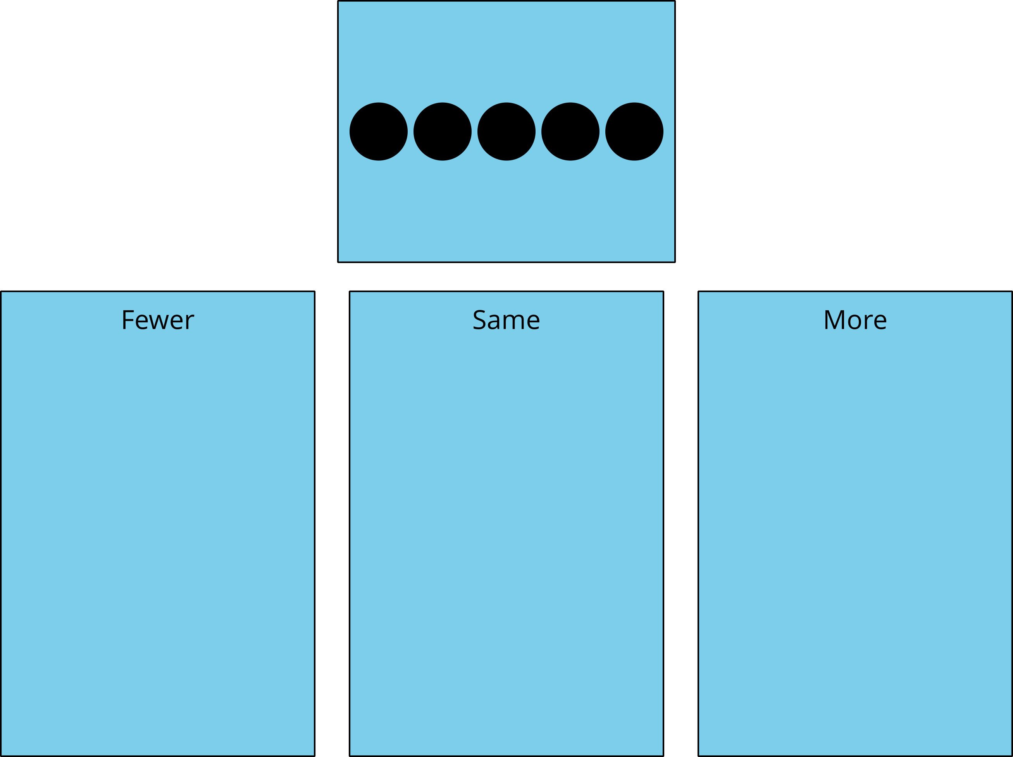

3 Centers: Choice Time

Student Task Statement
Choose a center.
Less, Same, More
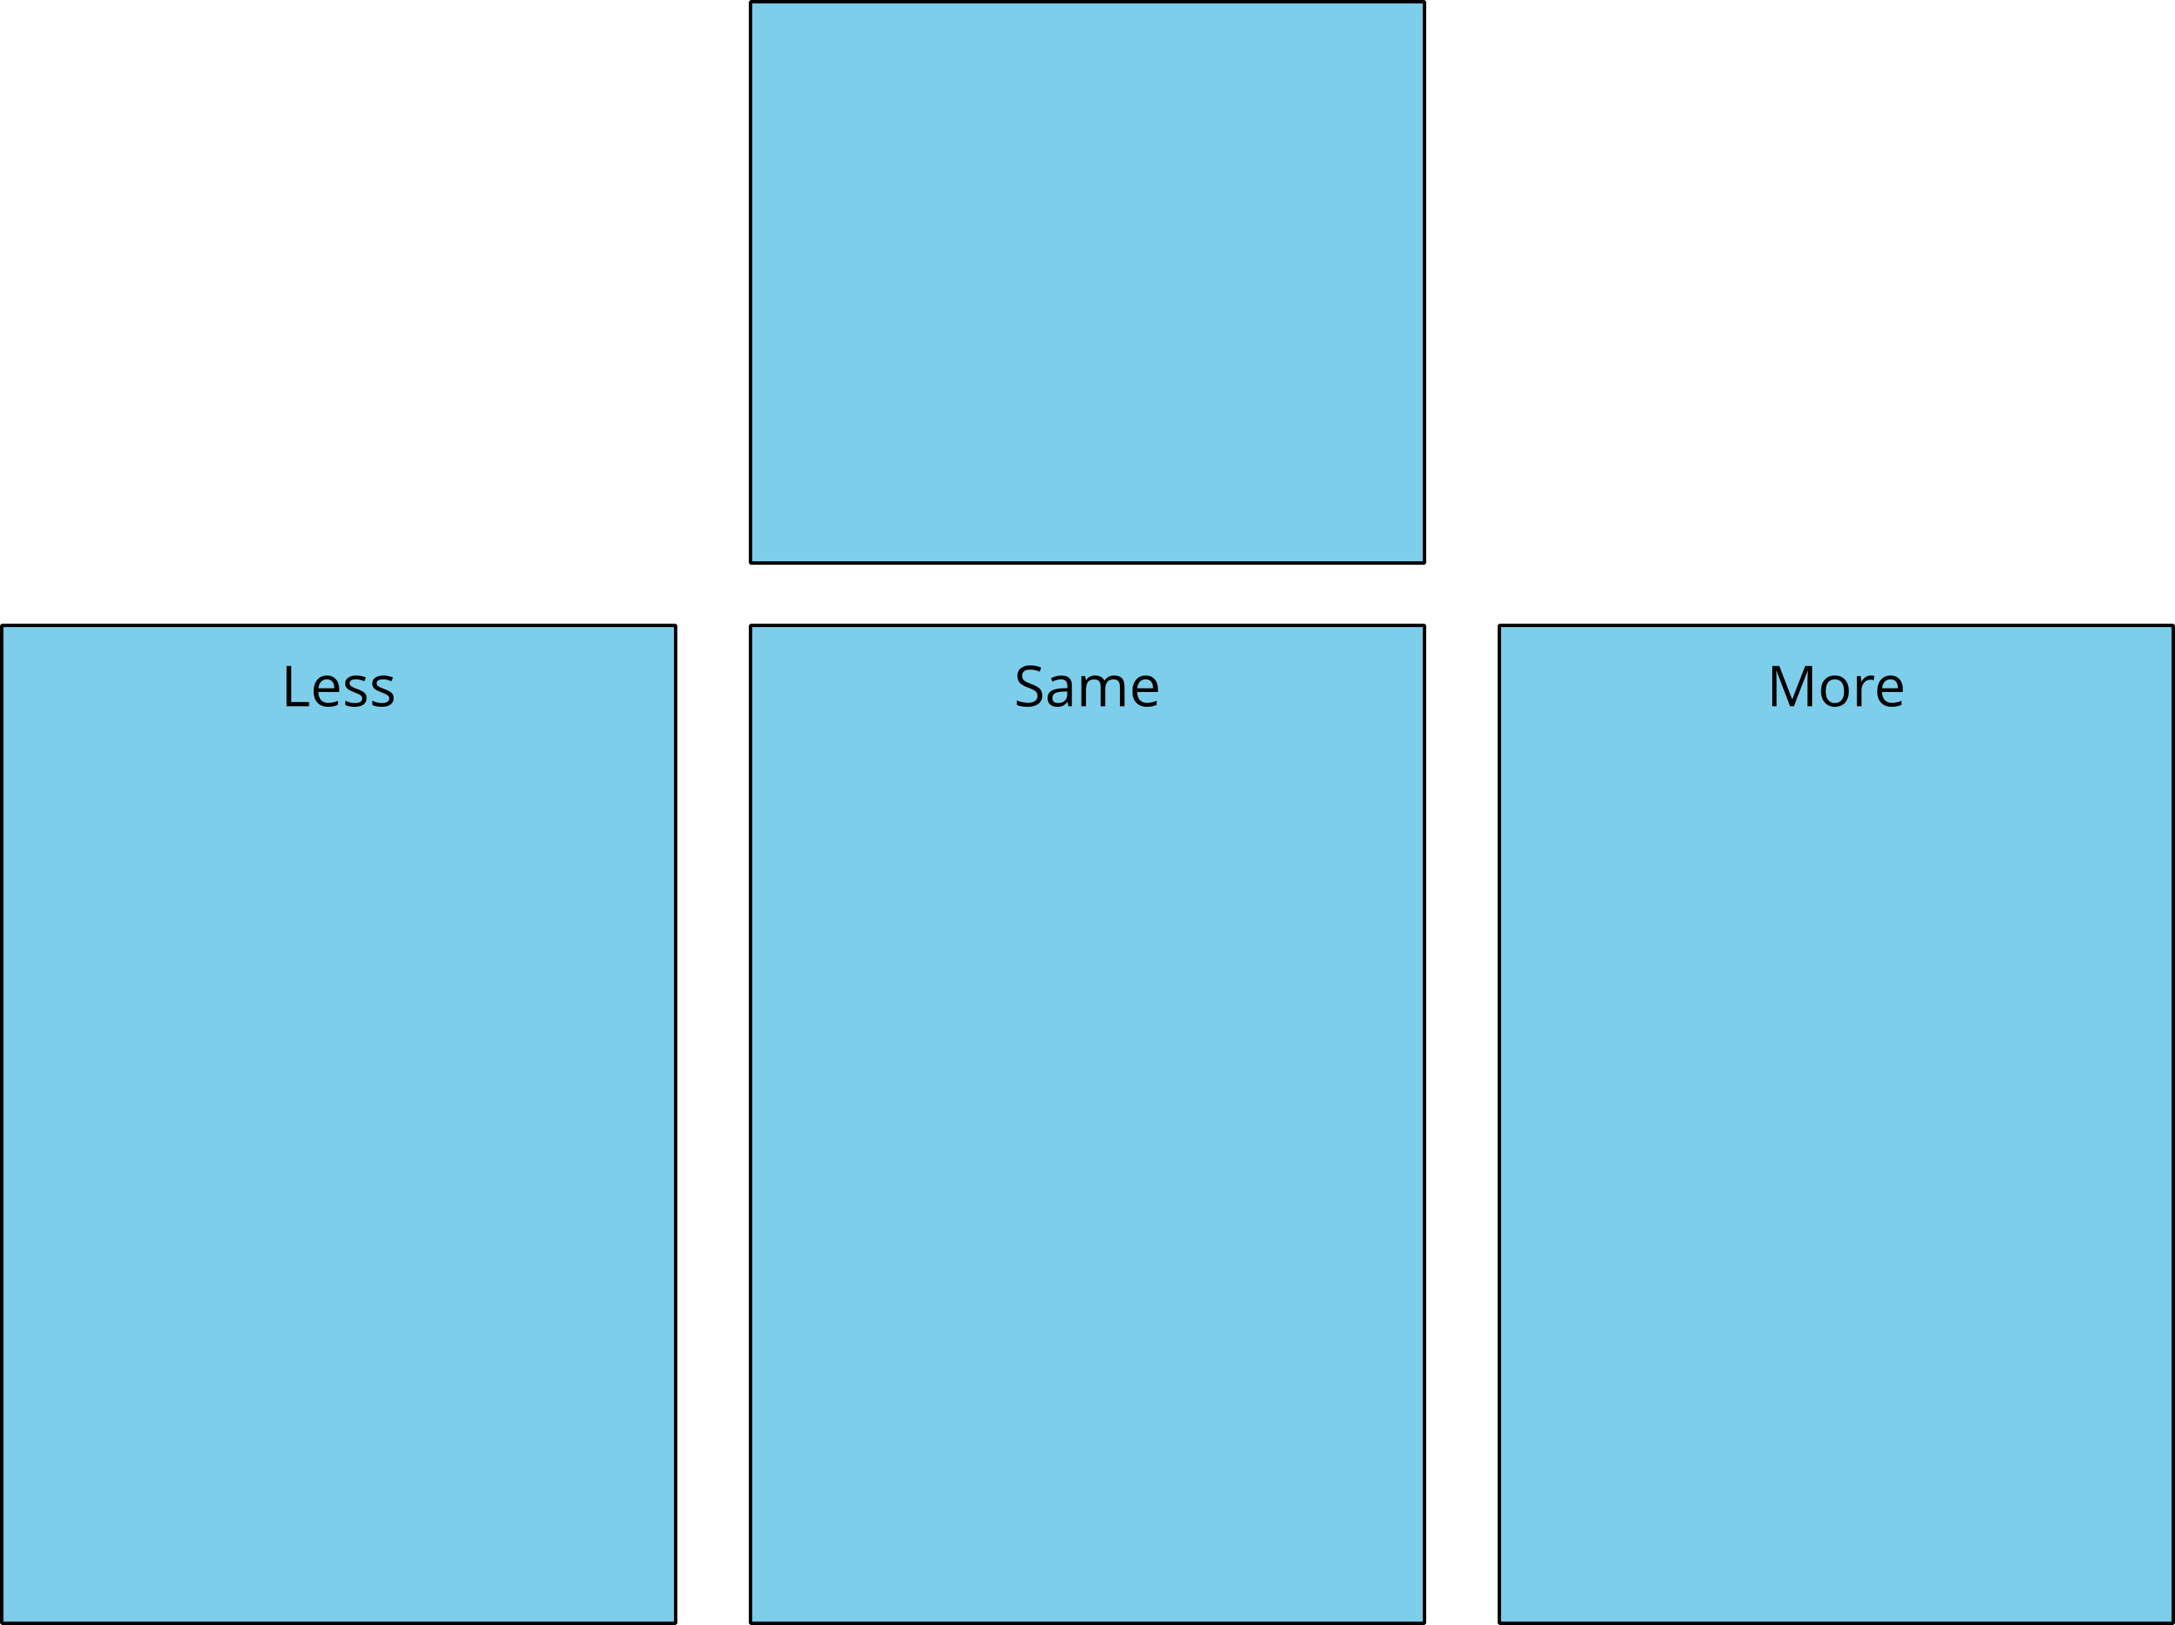
Bingo
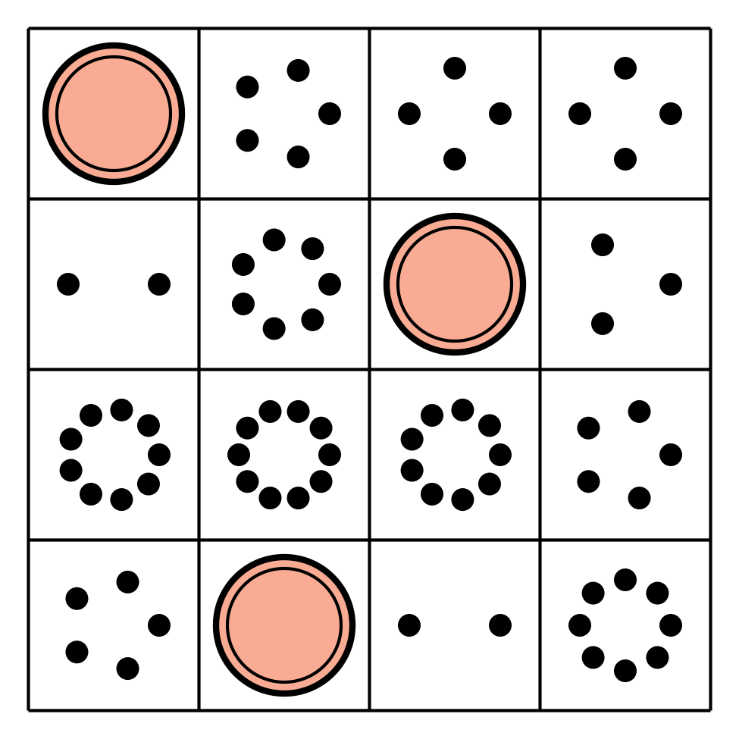
Math Stories
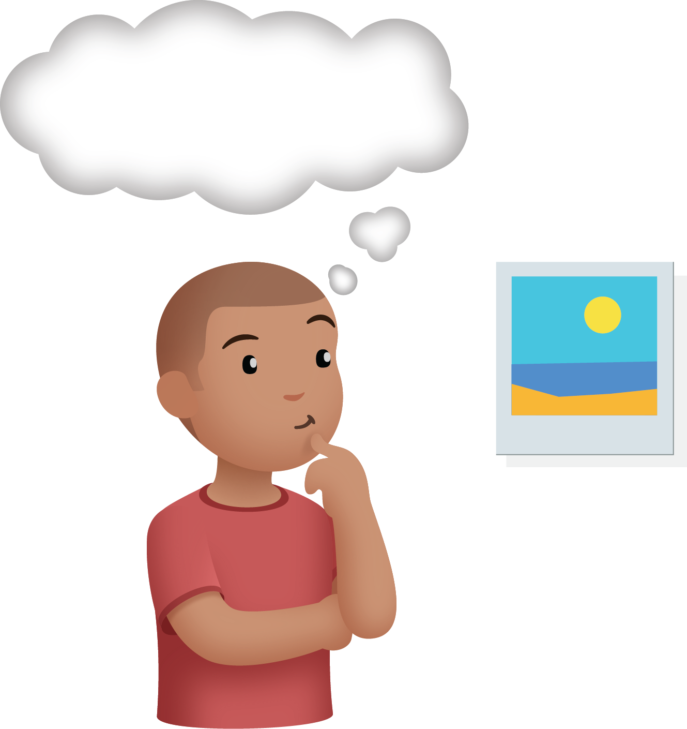
Connecting Cubes
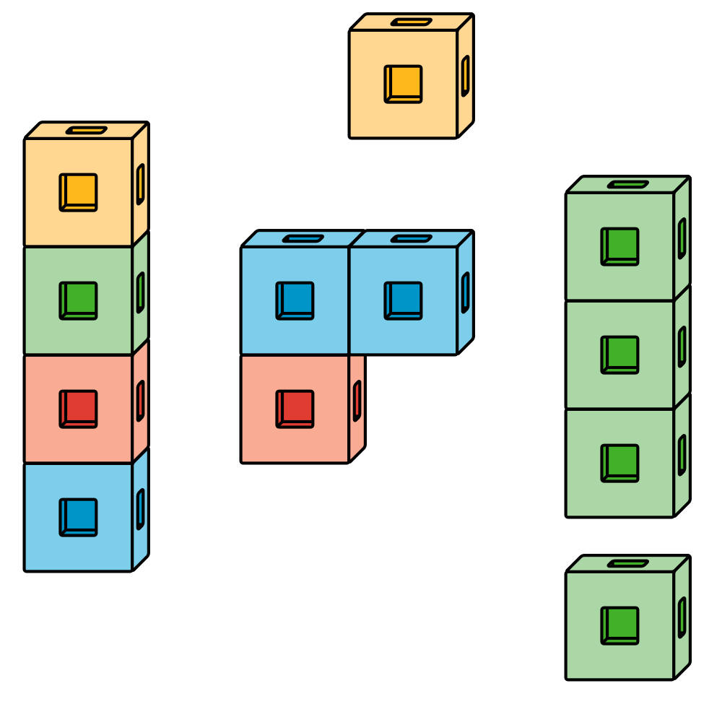
Number Race
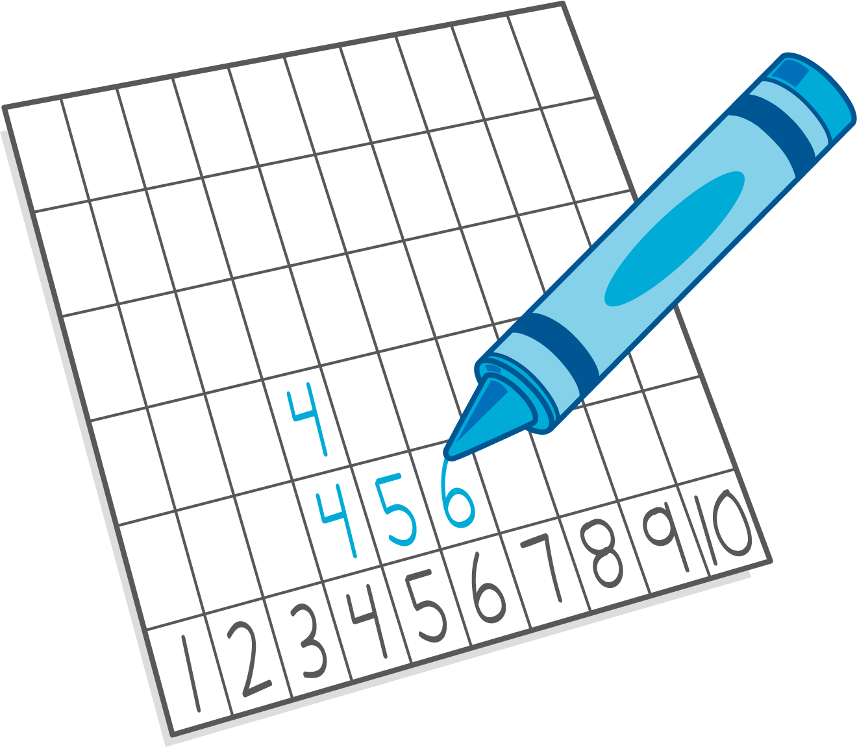

Images for Activity Synthesis
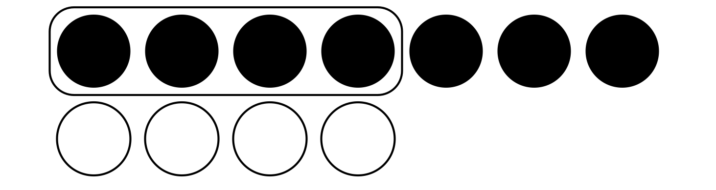
© CC BY 2021 Illustrative Mathematics®

