Lesson 9 Practice Problems
- Select all drawings in which a corresponding height $h$ for a given base $b$ is correctly identified.
- 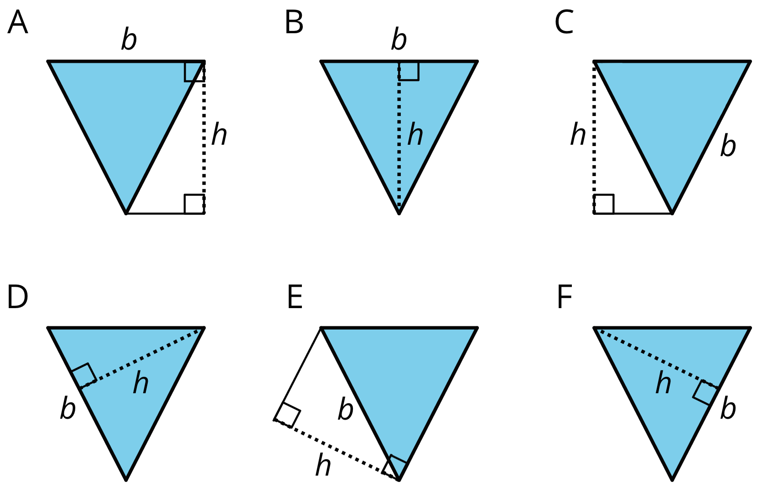
  - A
  - B
  - C
  - D
  - E
  - F
- For each triangle, a base and its corresponding height are labeled.
- 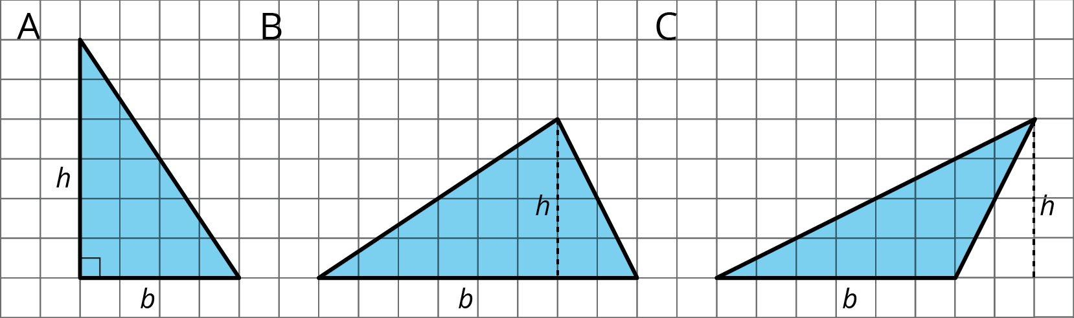
  - Find the area of each triangle.
  - How is the area related to the base and its corresponding height?
- Here is a right triangle. Name a corresponding height for each base.
- 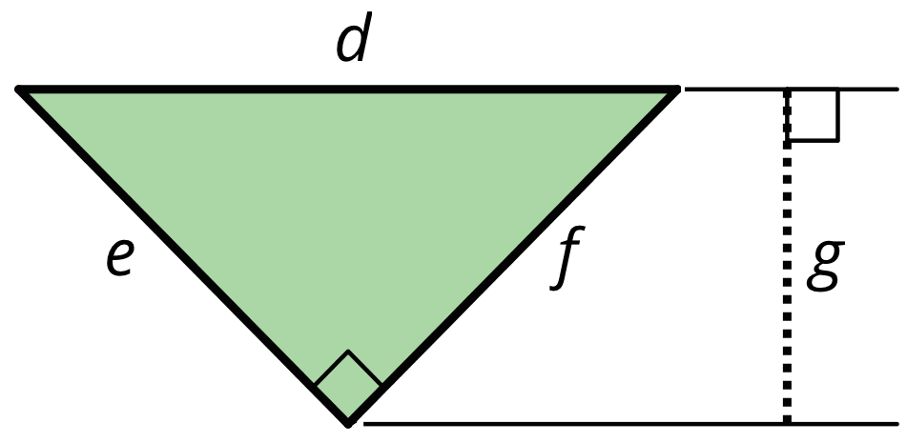
  - Side $d$
  - Side $e$
  - Side $f$
- Find the area of the shaded triangle. Show your reasoning.
- 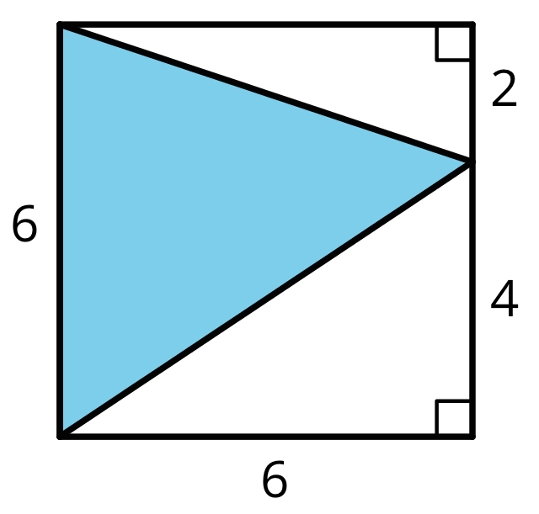
- (From Unit 1, Lesson 8.)
- Andre drew a line connecting two opposite corners of a parallelogram. Select all true statements about the triangles created by the line Andre drew.
- 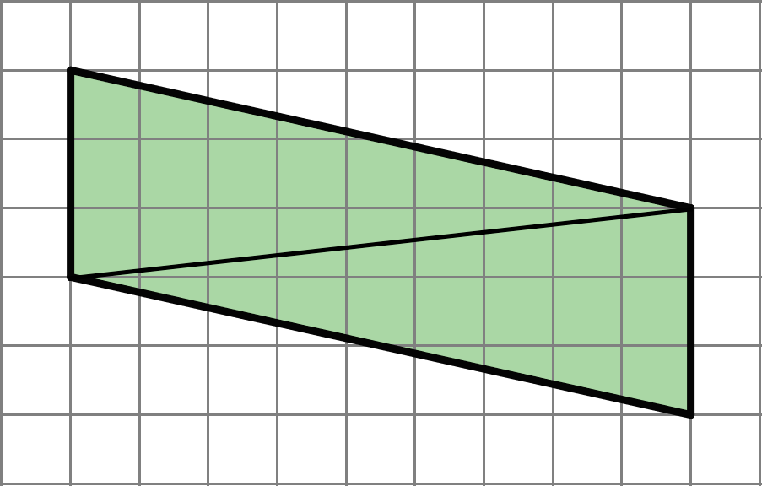
  - Each triangle has two sides that are 3 units long.
  - Each triangle has a side that is the same length as the diagonal line.
  - Each triangle has one side that is 3 units long.
  - When one triangle is placed on top of the other and their sides are aligned, we will see that one triangle is larger than the other.
  - The two triangles have the same area as each other.
- (From Unit 1, Lesson 7.)
- Here is an octagon. (Note: The diagonal sides of the octagon are not 4 inches long.)
- 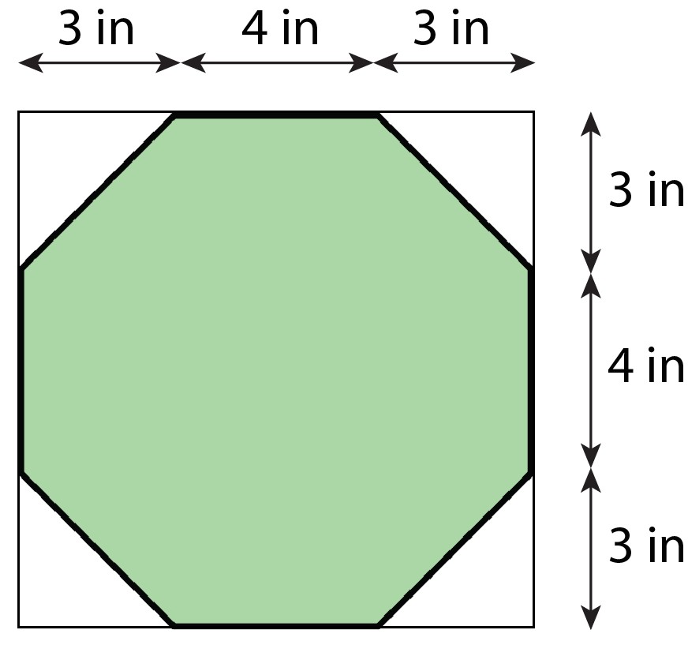
  - While estimating the area of the octagon, Lin reasoned that it must be less than 100 square inches. Do you agree? Explain your reasoning.
  - Find the exact area of the octagon. Show your reasoning.
- (From Unit 1, Lesson 3.)
© CC BY Open Up Resources. Adaptations CC BY IM.

