Lesson 14: Nets and Surface Area

14.1: Matching Nets
Each of the nets can be assembled into a polyhedron. Match each net with its corresponding polyhedron, and name the polyhedron. Be prepared to explain how you know the net and polyhedron go together.
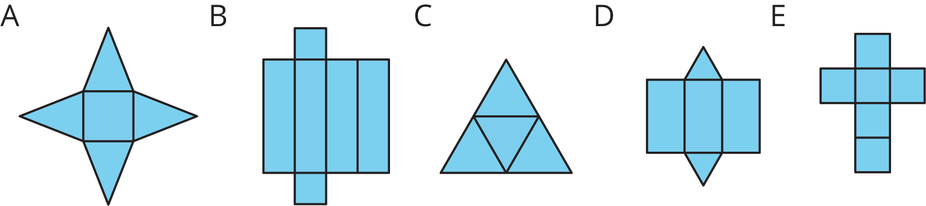
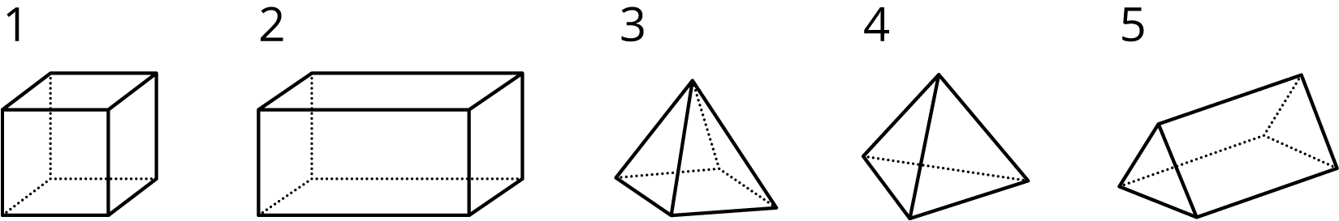

14.2: Using Nets to Find Surface Area
- Name the polyhedron that each net would form when assembled.
- 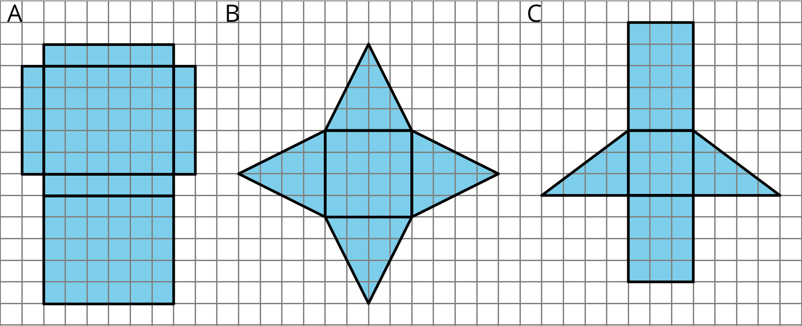
- Your teacher will give you the nets of three polyhedra. Cut out the nets and assemble the three-dimensional shapes.
- Find the surface area of each polyhedron. Explain your reasoning clearly.

Are you ready for more?
- For each net, decide if it can be assembled into a rectangular prism.
- 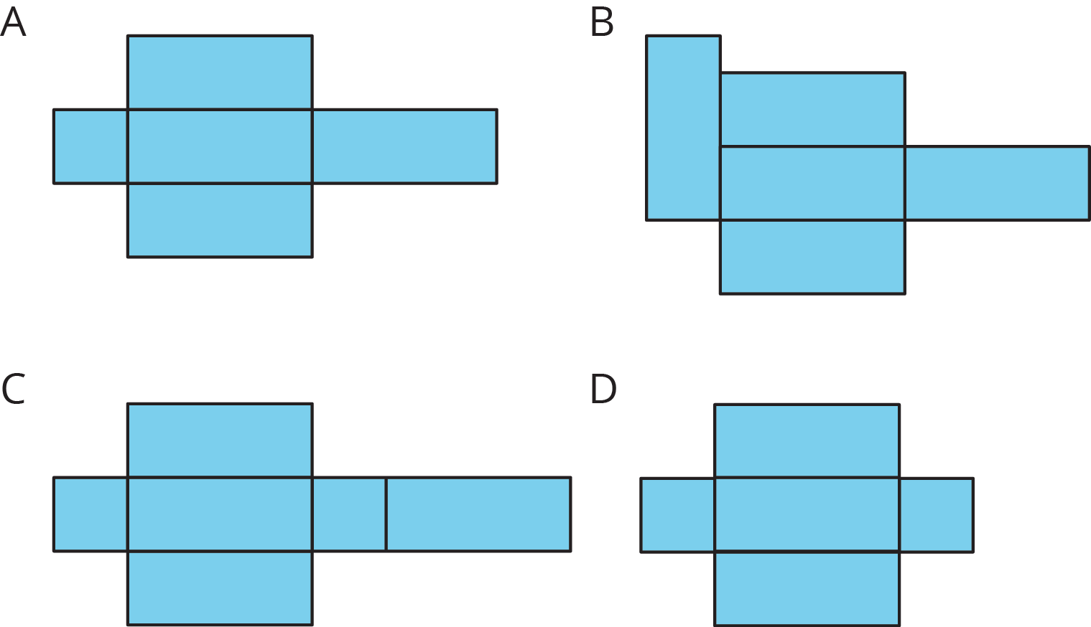
- For each net, decide if it can be folded into a triangular prism.
- 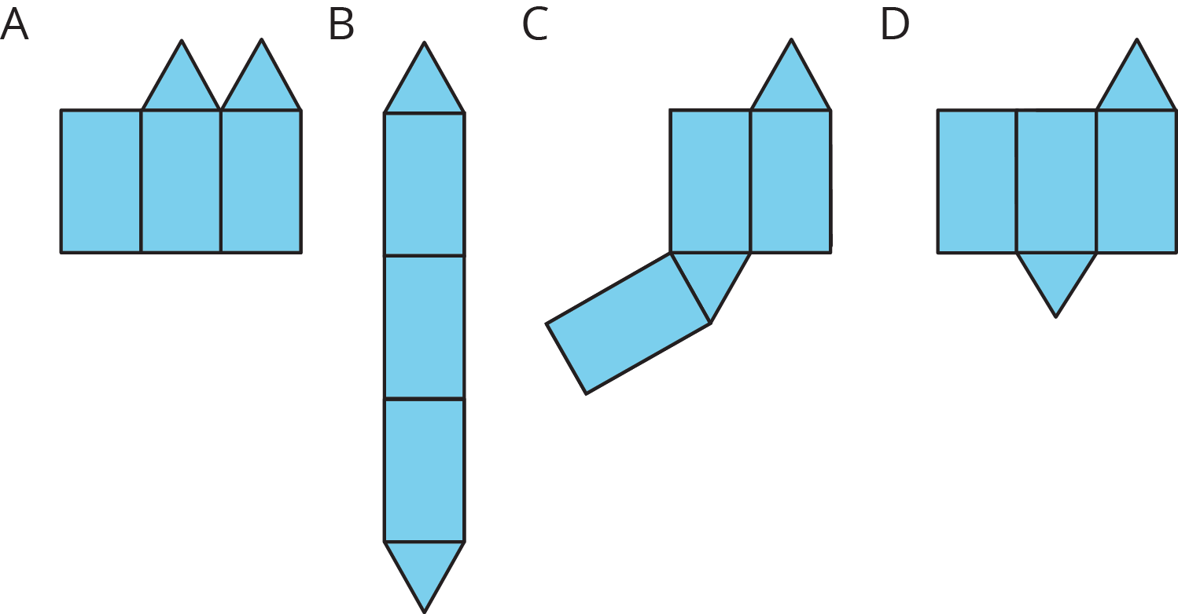

Lesson 14 Summary
A net of a pyramid has one polygon that is the base. The rest of the polygons are triangles. A pentagonal pyramid and its net are shown here.
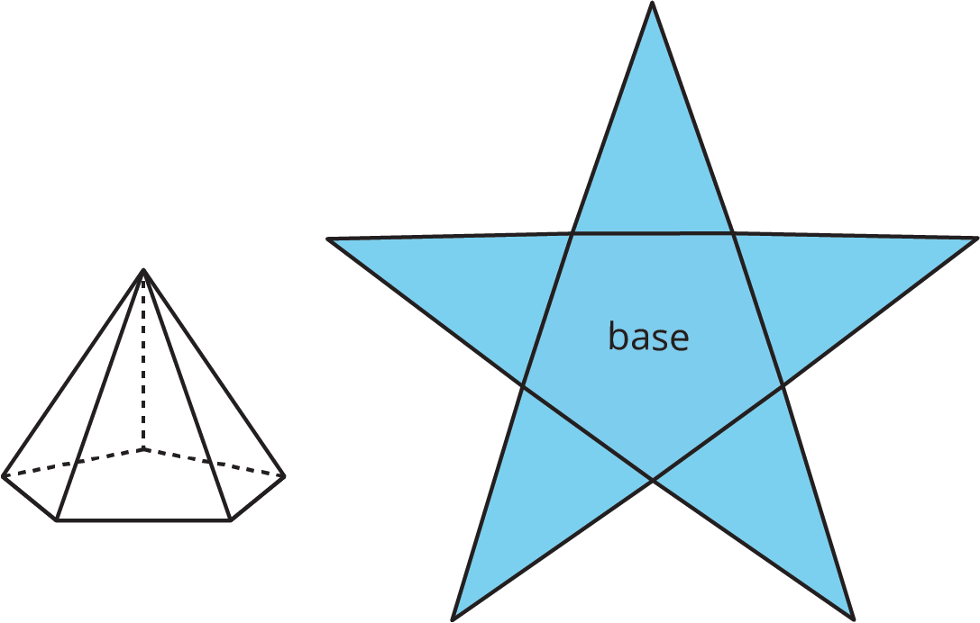
A net of a prism has two copies of the polygon that is the base. The rest of the polygons are rectangles. A pentagonal prism and its net are shown here.
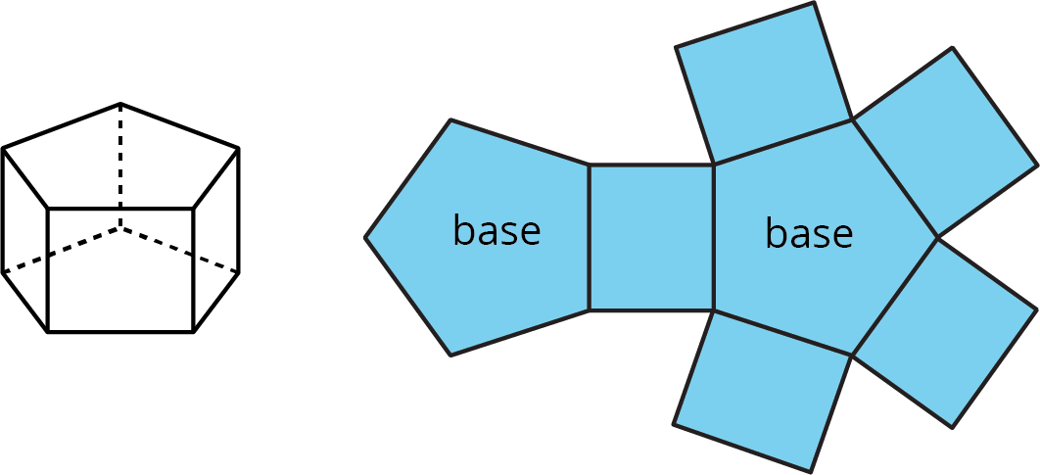
In a rectangular prism, there are three pairs of parallel and identical rectangles. Any pair of these identical rectangles can be the bases.
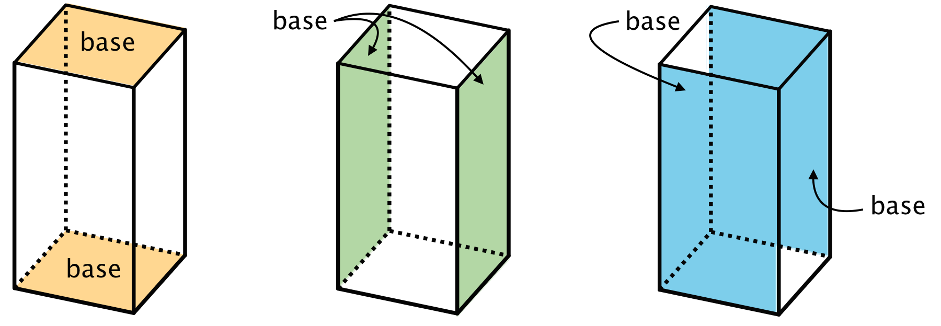
Because a net shows all the faces of a polyhedron, we can use it to find its surface area. For instance, the net of a rectangular prism shows three pairs of rectangles: 4 units by 2 units, 3 units by 2 units, and 4 units by 3 units.
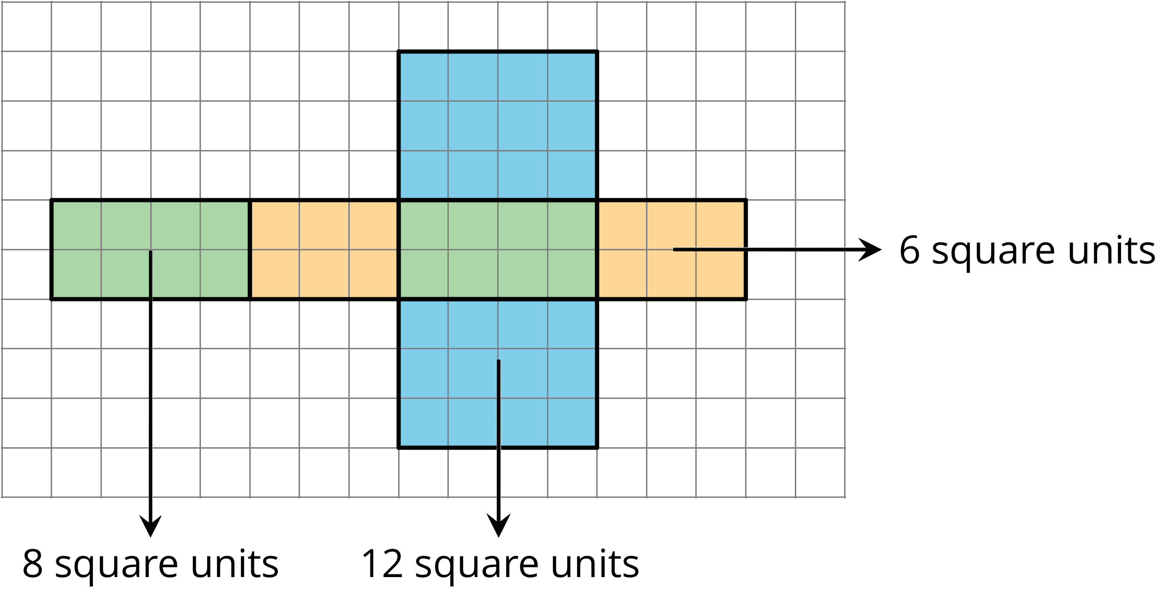
The surface area of the rectangular prism is 52 square units because $8+8+6+6+12+12=52$.
© CC BY Open Up Resources. Adaptations CC BY IM.

