Lesson 15 Practice Problems
- Consider the parallelogram with vertices at $(0,0),(4,0),(2,3),$ and $(6,3)$. Where do the diagonals of this parallelogram intersect?
  - $(3,1.5)$
  - $(4,2)$
  - $(2,4)$
  - $(3.5,3)$
- What is the midpoint of the line segment with endpoints $(1,\text{-}2)$ and $(9,8)$?
  - $(3,5)$
  - $(4,3)$
  - $(5,3)$
  - $(5,5)$
- Graph the image of triangle $ABC$ under a dilation with center $A$ and scale factor $\frac{2}{3}$.
- 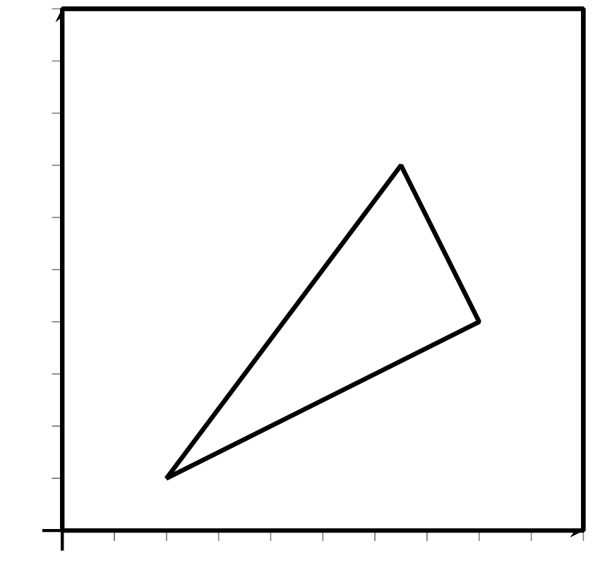
- A quadrilateral has vertices $A=(0,0),B=(2,4),C=(0,5),$ and $D=(\text{-}2,1)$. Prove that $ABCD$ is a rectangle.
- (From Unit 6, Lesson 14.)
- A quadrilateral has vertices $A=(0,0),B=(1,3),C=(0,4),$ and $D=(\text{-}1,1)$. Select the most precise classification for quadrilateral $ABCD$.
  - quadrilateral
  - parallelogram
  - rectangle
  - square
- (From Unit 6, Lesson 14.)
- Write an equation whose graph is a line perpendicular to the graph of $x=\text{-}7$ and which passes through the point $(\text{-}7,1)$.
- (From Unit 6, Lesson 12.)
- Graph the equations $(x+1)^{2}+(y−1)^{2}=64$ and $y=1$. Where do they intersect?
- 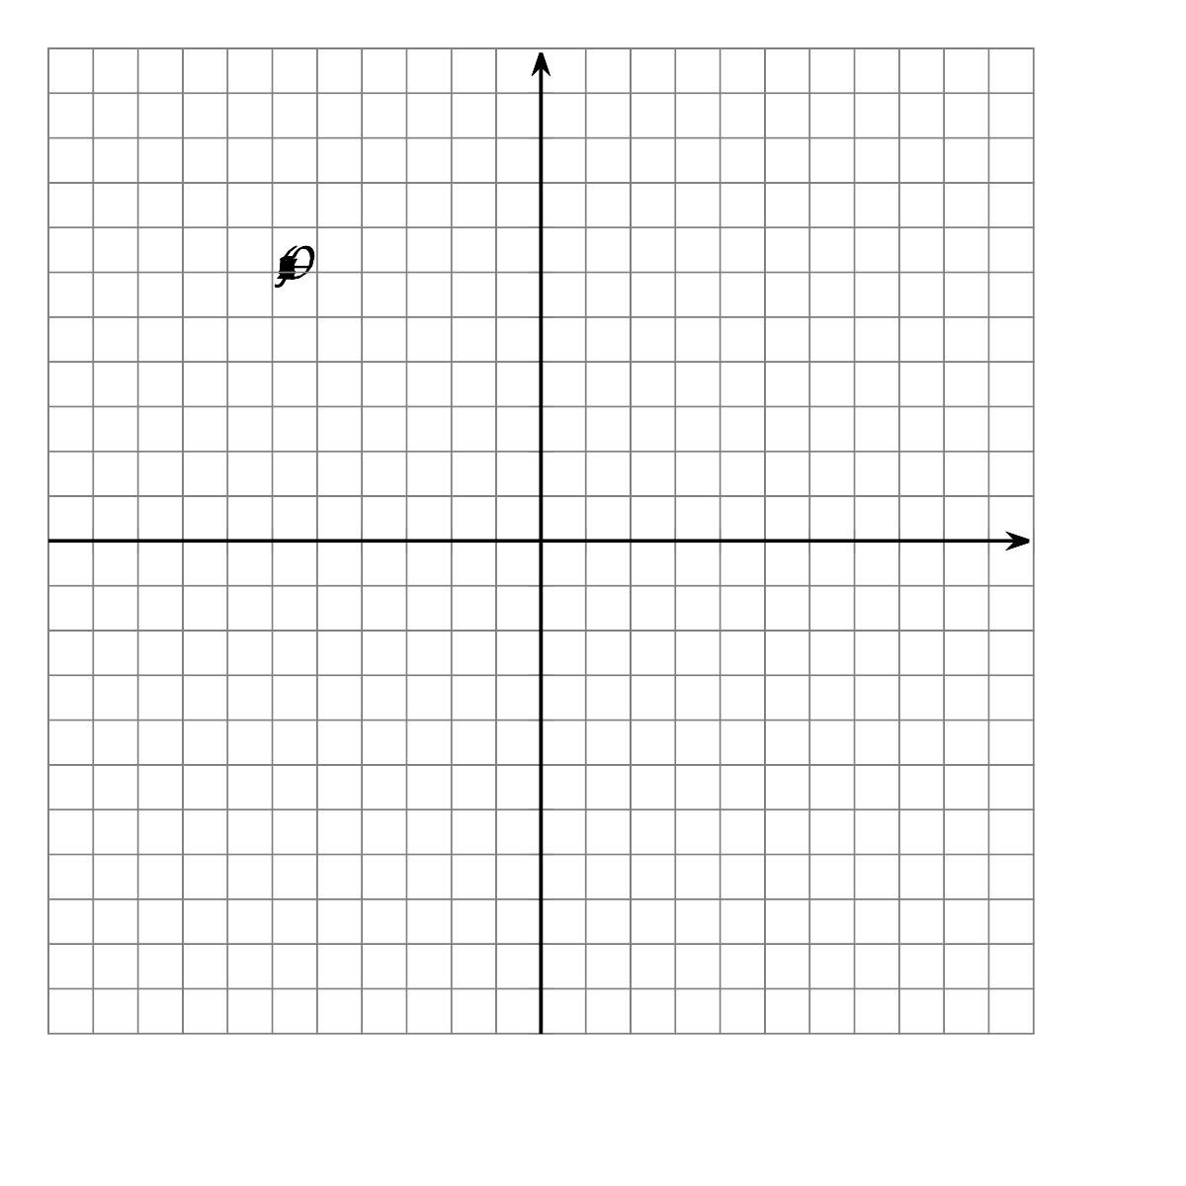
- (From Unit 6, Lesson 13.)
- A parabola has a focus of $(2,5)$ and a directrix of $y=1$. Decide whether each point on the list is on this parabola. Explain your reasoning.
  - $(\text{-}1,5)$
  - $(2,3)$
  - $(6,6)$
- (From Unit 6, Lesson 7.)
© CC BY 2019 by Illustrative Mathematics®

