Unit 3 Lesson 8: Ratios and Rates With Fractions

1 Number Talk: Dividing by Half as Much (Warm up)

Student Task Statement
Find each quotient mentally.
$743÷10$
$743÷5$
$99÷3$
$99÷\frac{3}{2}$

2 Using an Algorithm to Divide Fractions

Student Task Statement
Calculate each quotient. Show your thinking and be prepared to explain your reasoning.
- $\frac{8}{9}÷4$
- $\frac{3}{4}÷\frac{1}{2}$
- $3\frac{1}{3}÷\frac{2}{9}$
- $\frac{9}{2}÷\frac{3}{8}$
- $6\frac{2}{5}÷3$
- After biking $5\frac{1}{2}$ miles, Jada has traveled $\frac{2}{3}$ of the length of her trip. How long (in miles) is the entire length of her trip? Write an equation to represent the situation, and then find the answer.

3 A Train is Traveling at . . .

Student Task Statement
A train is traveling at a constant speed and goes 7.5 kilometers in 6 minutes. At that rate:
- How far does the train go in 1 minute?
- How far does the train go in 100 minutes?
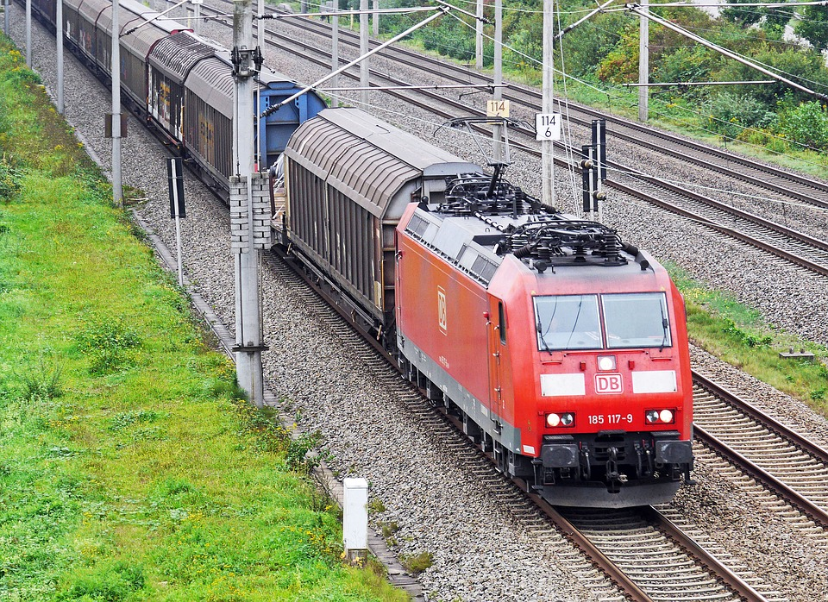

4 Comparing Running Speeds

Student Task Statement
Lin ran $2\frac{3}{4}$ miles in $\frac{2}{5}$ of an hour. Noah ran $8\frac{2}{3}$ miles in $\frac{4}{3}$ of an hour.
- Pick one of the questions that was displayed, but don’t tell anyone which question you picked. Find the answer to the question.
- When you and your partner are both done, share the answer you got (do not share the question) and ask your partner to guess which question you answered. If your partner can’t guess, explain the process you used to answer the question.
- Switch with your partner and take a turn guessing the question that your partner answered.
© CC BY Open Up Resources. Adaptations CC BY IM.

