Lesson 9: Escribamos números hasta 120

Standards Alignments
Addressing | 1.MD.A.2, 1.NBT.A.1

Teacher-facing Learning Goals
- Measure length and determine an efficient way to count the number of length units up to 120.
- Read and write numbers to 120.

Student-facing Learning Goals
- Contemos, escribamos y leamos números hasta 120.

Lesson Purpose
The purpose of this lesson is to count, read, and write numbers up to 120 in a measurement context.
In previous lessons, students learned how to count up to 110 objects and connected written numbers to quantities.
In this lesson, students measure a length between 95 and 120 length units long and represent their count using numbers. Then, students create a poster to show a drawing of their count, without including the written number. When students participate in a gallery walk to view each poster, they record the numbers represented.

Access for:

Students with Disabilities
- Representation (Activity 1)

English Learners
- MLR2 (Activity 1)

Instructional Routines
Choral Count (Warm-up), MLR7 Compare and Connect (Activity 2)

Materials to Gather
- Base-ten blocks: Activity 1
- Tape (painter's or masking): Activity 1
- Tools for creating a visual display: Activity 2

Lesson Timeline
Warm-up | 10 min
Activity 1 | 15 min
Activity 2 | 20 min
Lesson Synthesis | 10 min
Cool-down | 5 min

Teacher Reflection Question
What connections did students make between towers of ten and singles or base-ten diagrams and the written numbers up to 120? What questions did you ask to help make the connections more visible?

Cool-down
(to be completed at the end of the lesson) 5min
¿Cuántos cubos?

Standards Alignments
Addressing | 1.NBT.A.1

Student-facing Task Statement
¿Cuántos cubos hay?
- 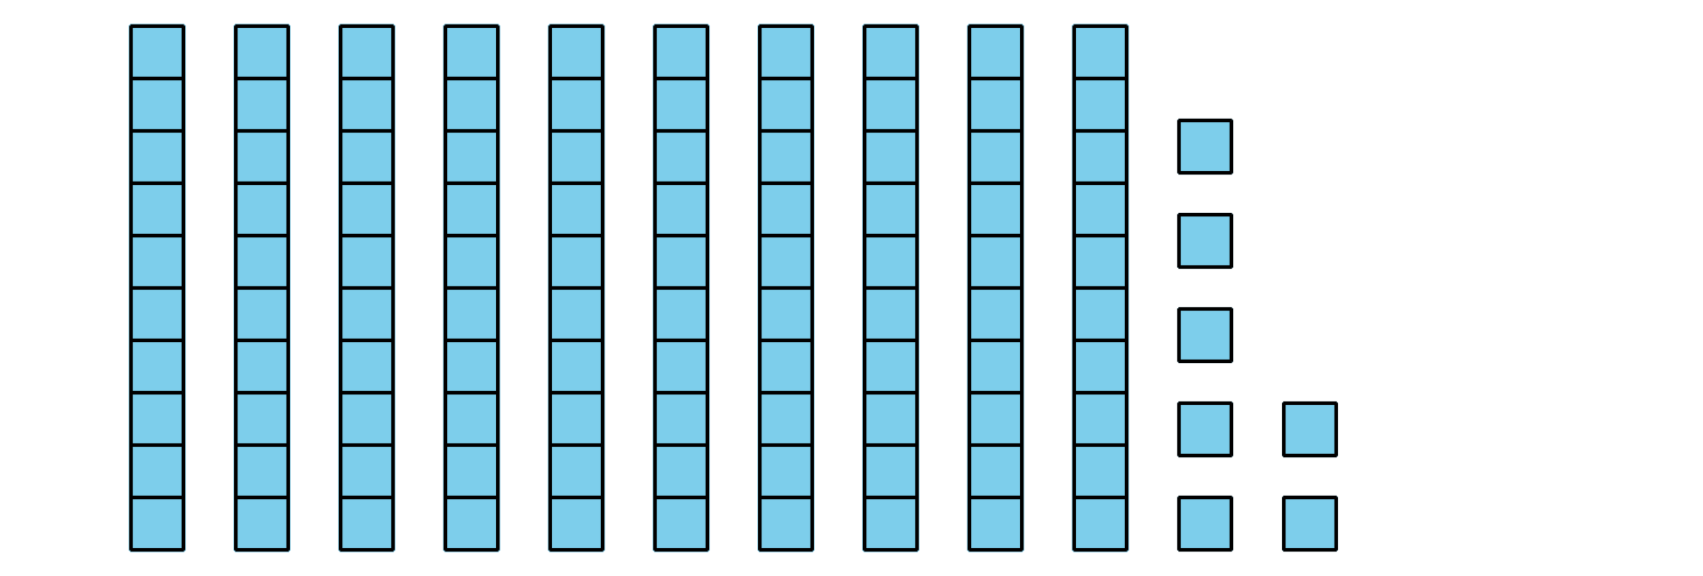
- _____________
- 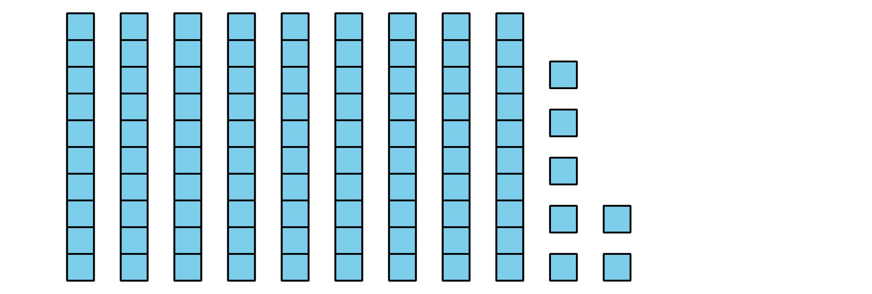
- _____________
- 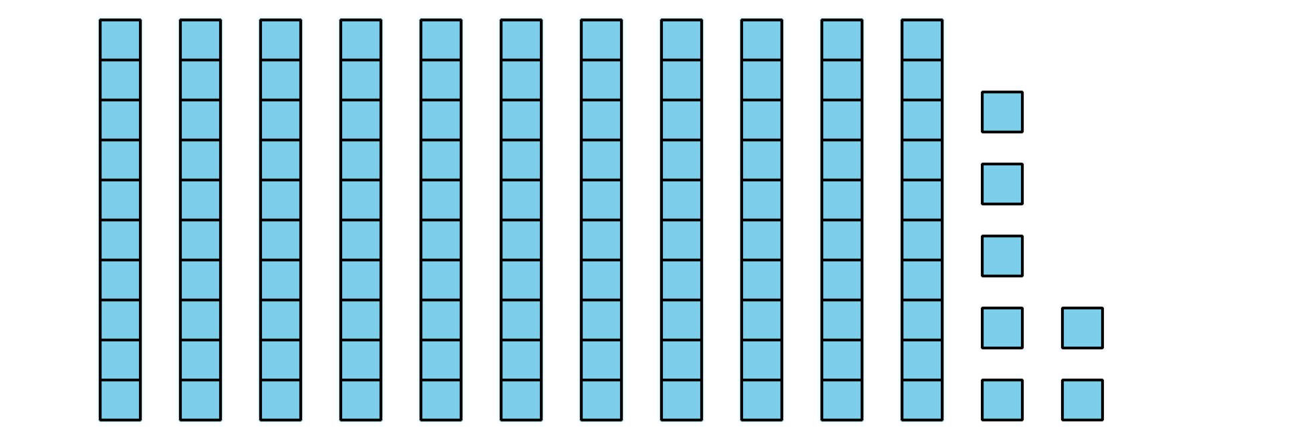
- _____________

Student Responses
- 107
- 97
- 117

