Unit 2 Lesson 11: Create Groups of Images

WU Questions About Us: Slide or Swings? (Warm up)

Student Task Statement

1 Draw Groups of Images

Student Task Statement
my group | my partner's group

my group | my partner's group

2 Introduce Less, Same, More, Drawings

Student Task Statement

Activity Synthesis

3 Centers: Choice Time

Student Task Statement
Choose a center.
Less, Same, More
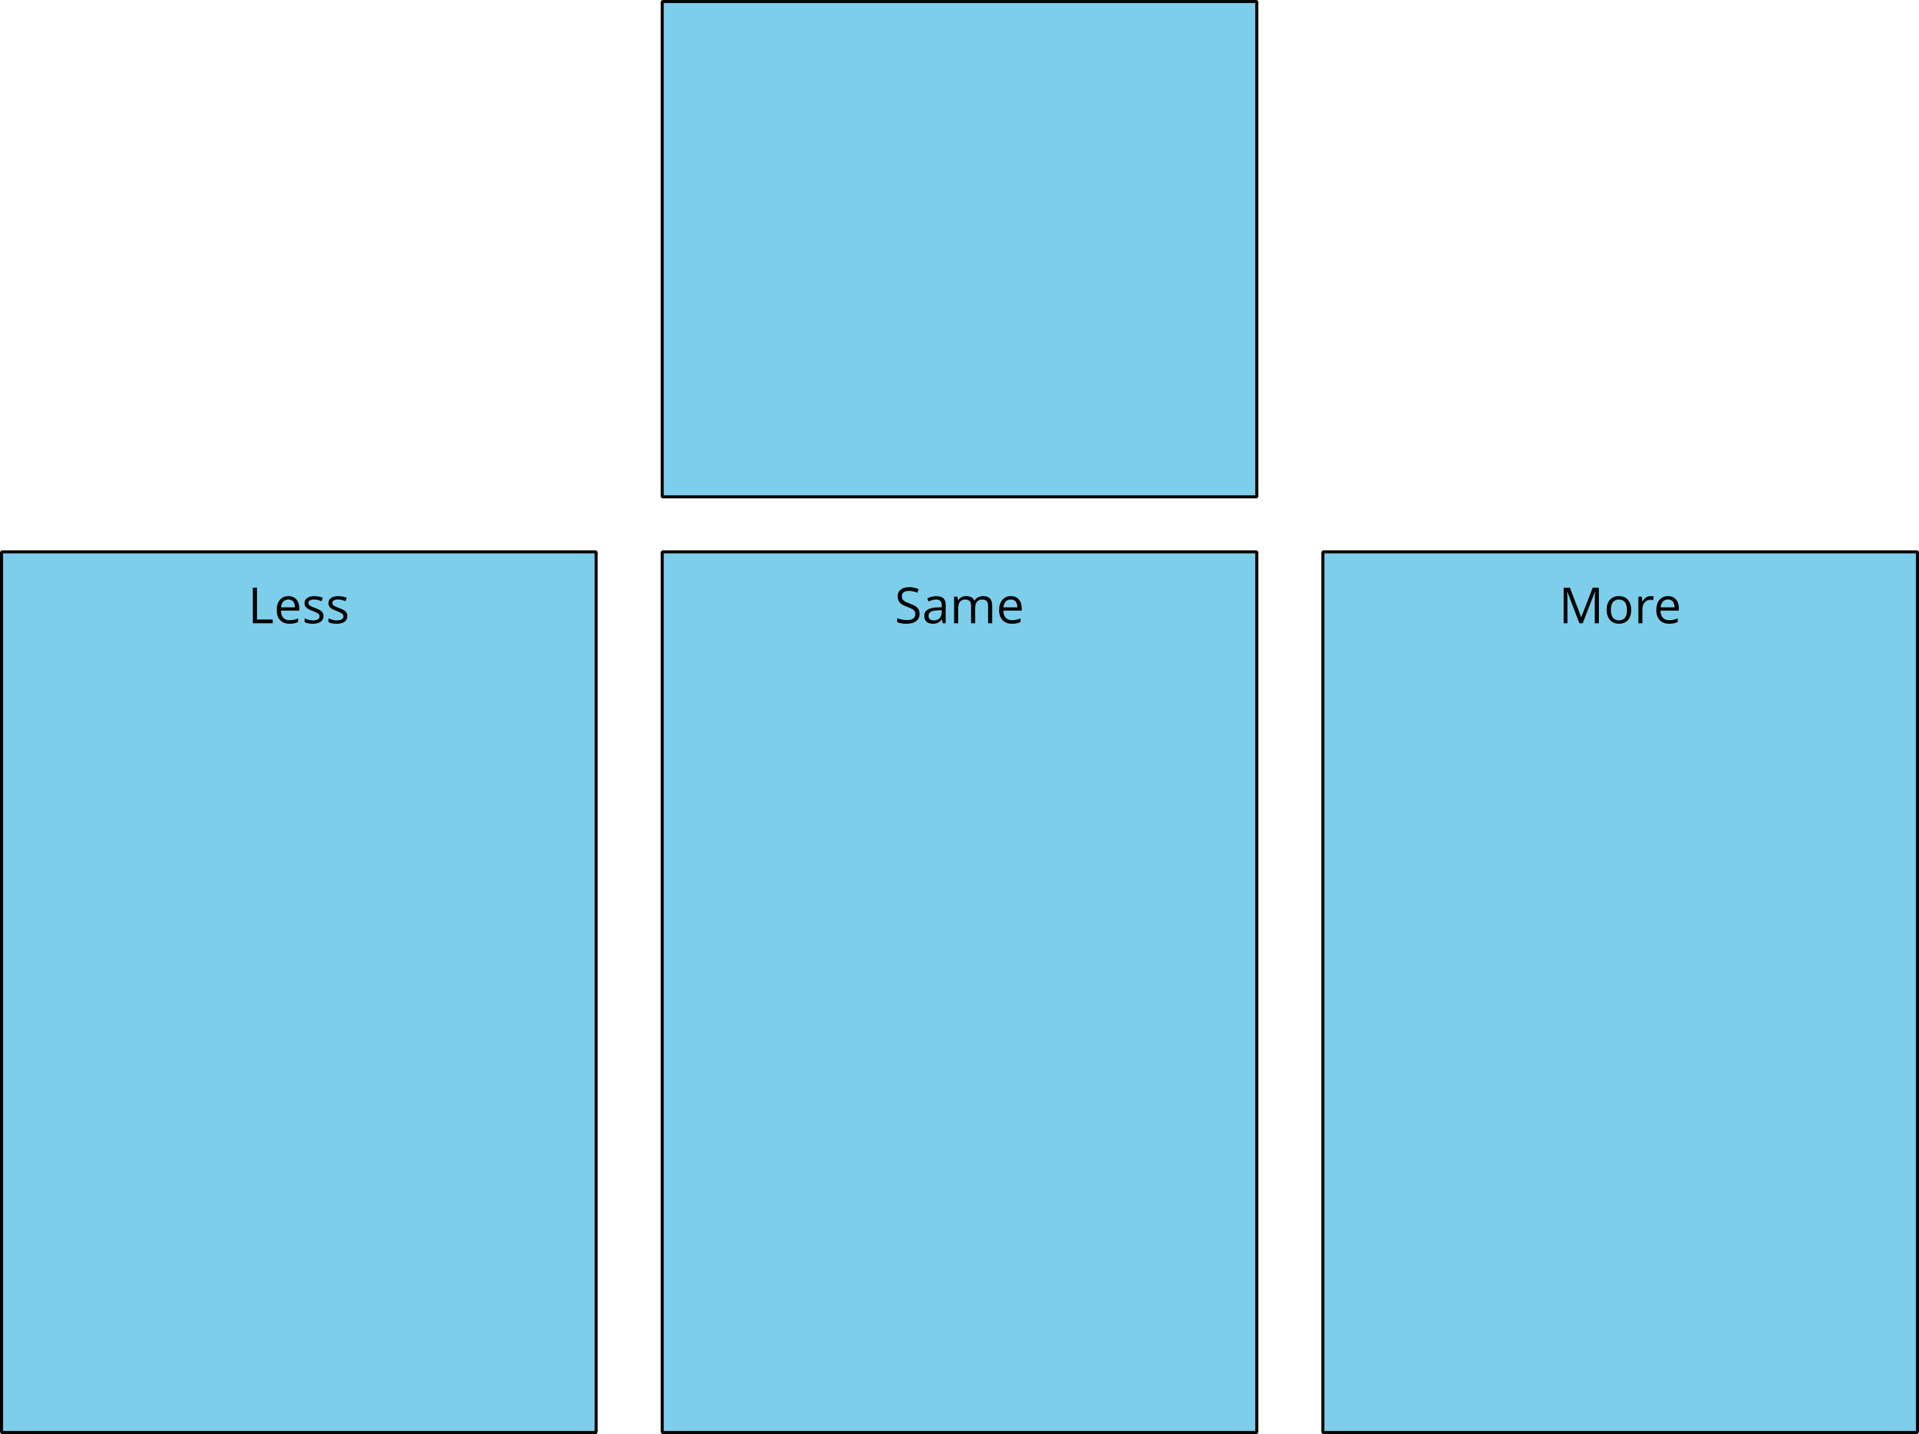
Bingo
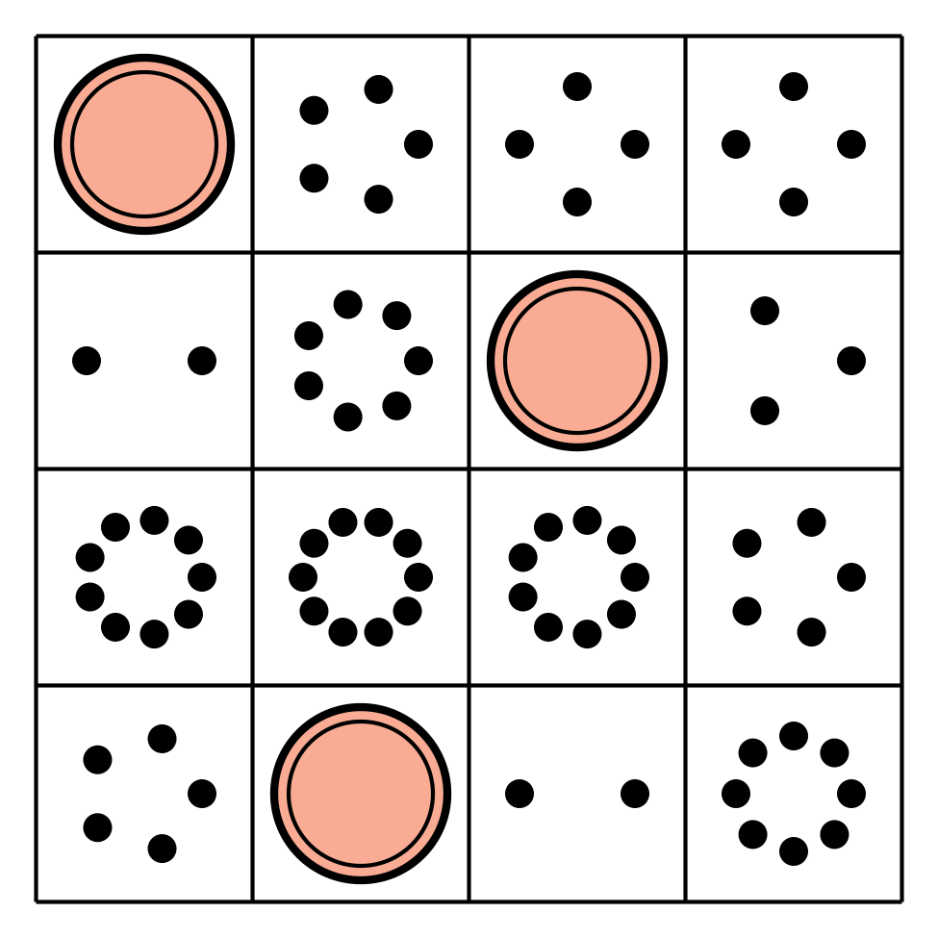
Math Stories
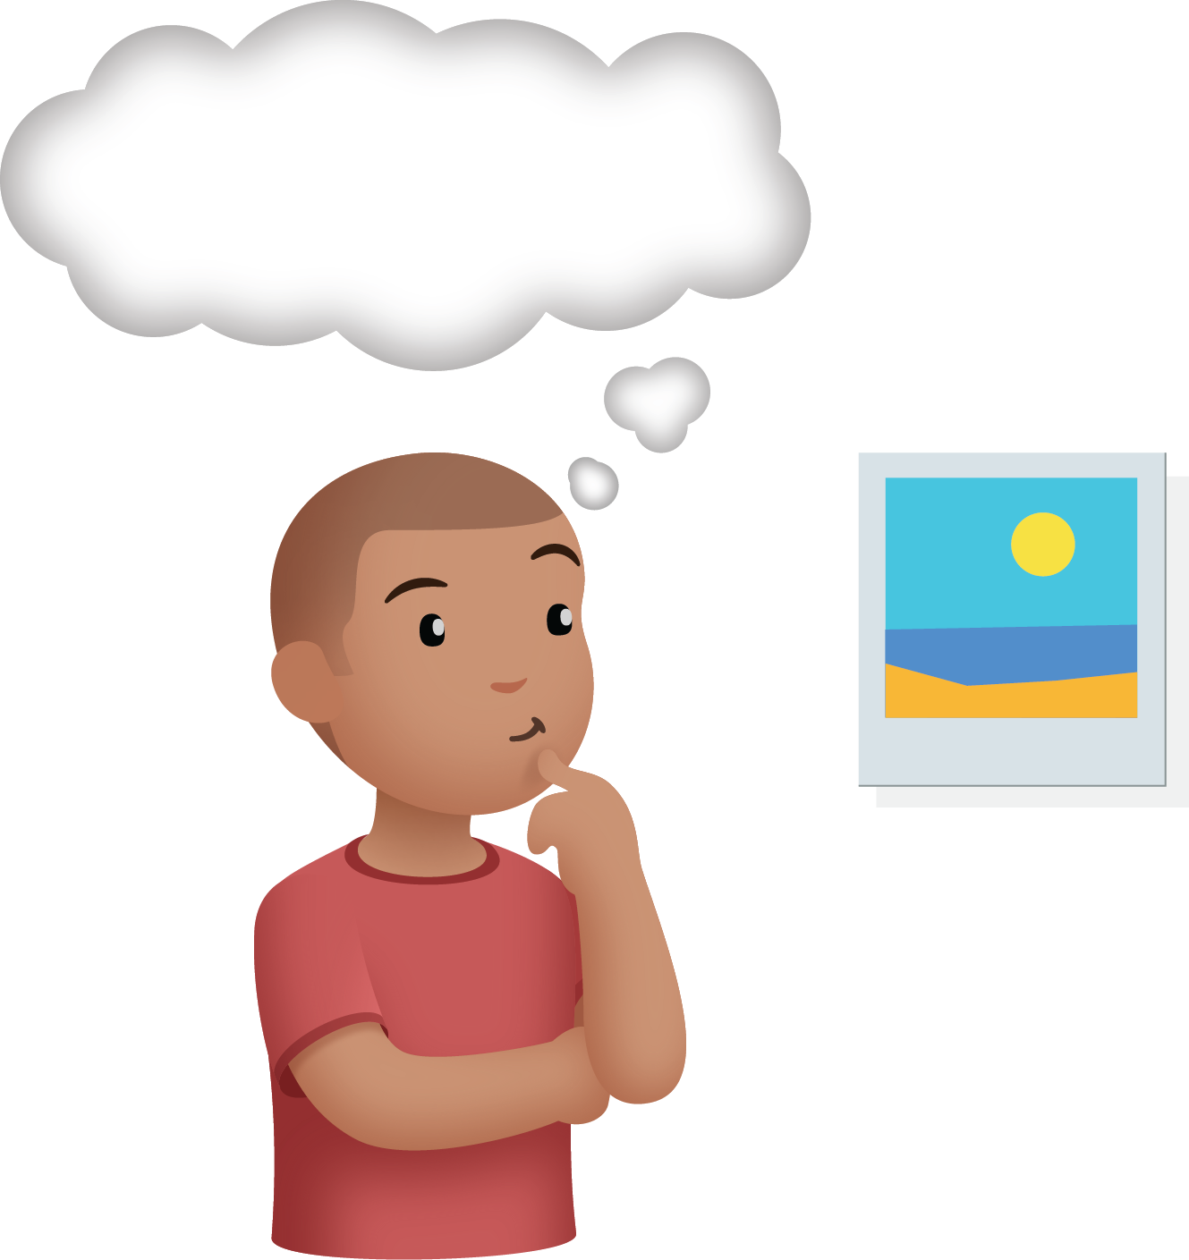
Connecting Cubes
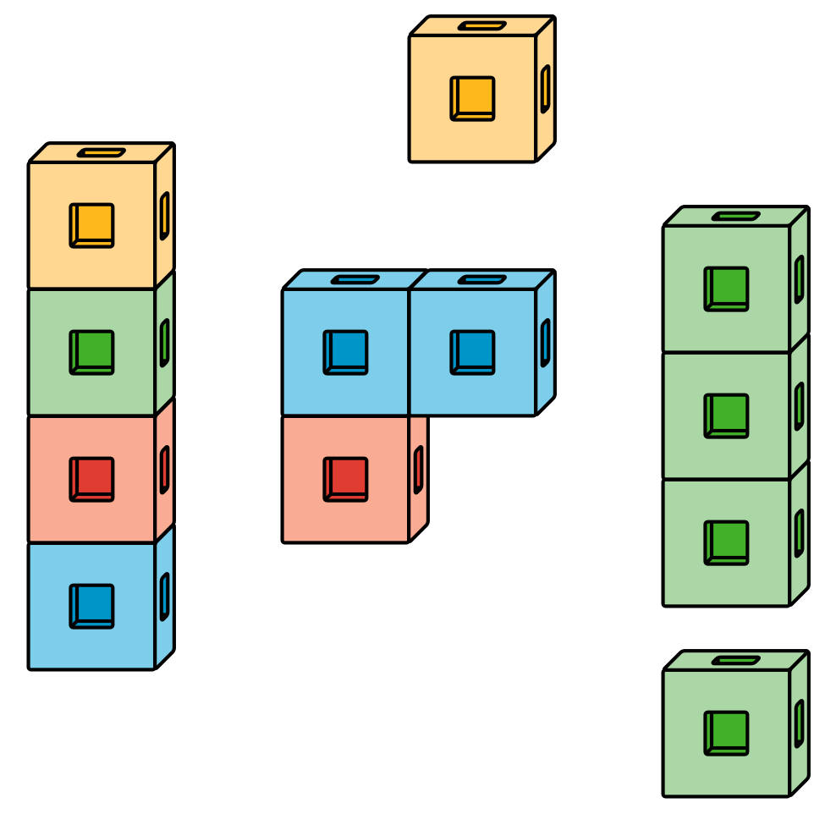
Number Race
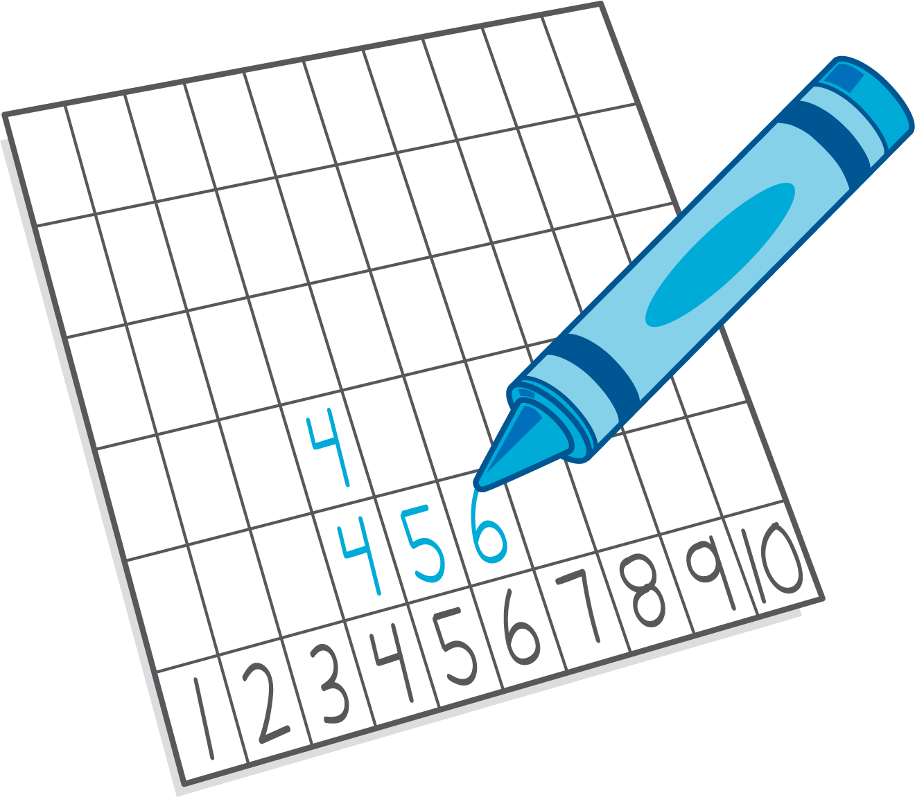

Images for Activity Synthesis
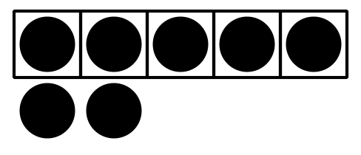
© CC BY 2021 Illustrative Mathematics®

