Lesson 4: Interpreting Functions
- Let’s interpret some functions.

4.1: Math Talk: Finding Outputs
Mentally evaluate the output for the input of 3.
$f\left(x\right)=4\left(x−\frac{1}{2}\right)$
$g\left(x\right)=2\left(6−x\right)$
$h\left(x\right)=\frac{5}{3}x+\frac{1}{3}$
$j\left(x\right)=0.2x−1$

4.2: It’s Getting Hotter
A machine in a laboratory is set to steadily increase the temperature inside. The temperature in degrees Celsius inside the machine after being turned on is a function of time, in seconds, given by the equation $f\left(t\right)=22+1.3t$.
- What does $f\left(3\right)$ mean in this situation?
- Find the value of $f\left(3\right)$ and interpret that value.
- What does the equation $f\left(t\right)=35$ mean in this situation?
- Solve the equation to find the value of $t$ for the previous question.
- Write an equation involving $f$ that represents each of these situations:
  - The temperature in the machine 30 seconds after it is turned on.
  - The time when the temperature inside the machine is 100 degrees Celsius.

4.3: You Charge How Much?
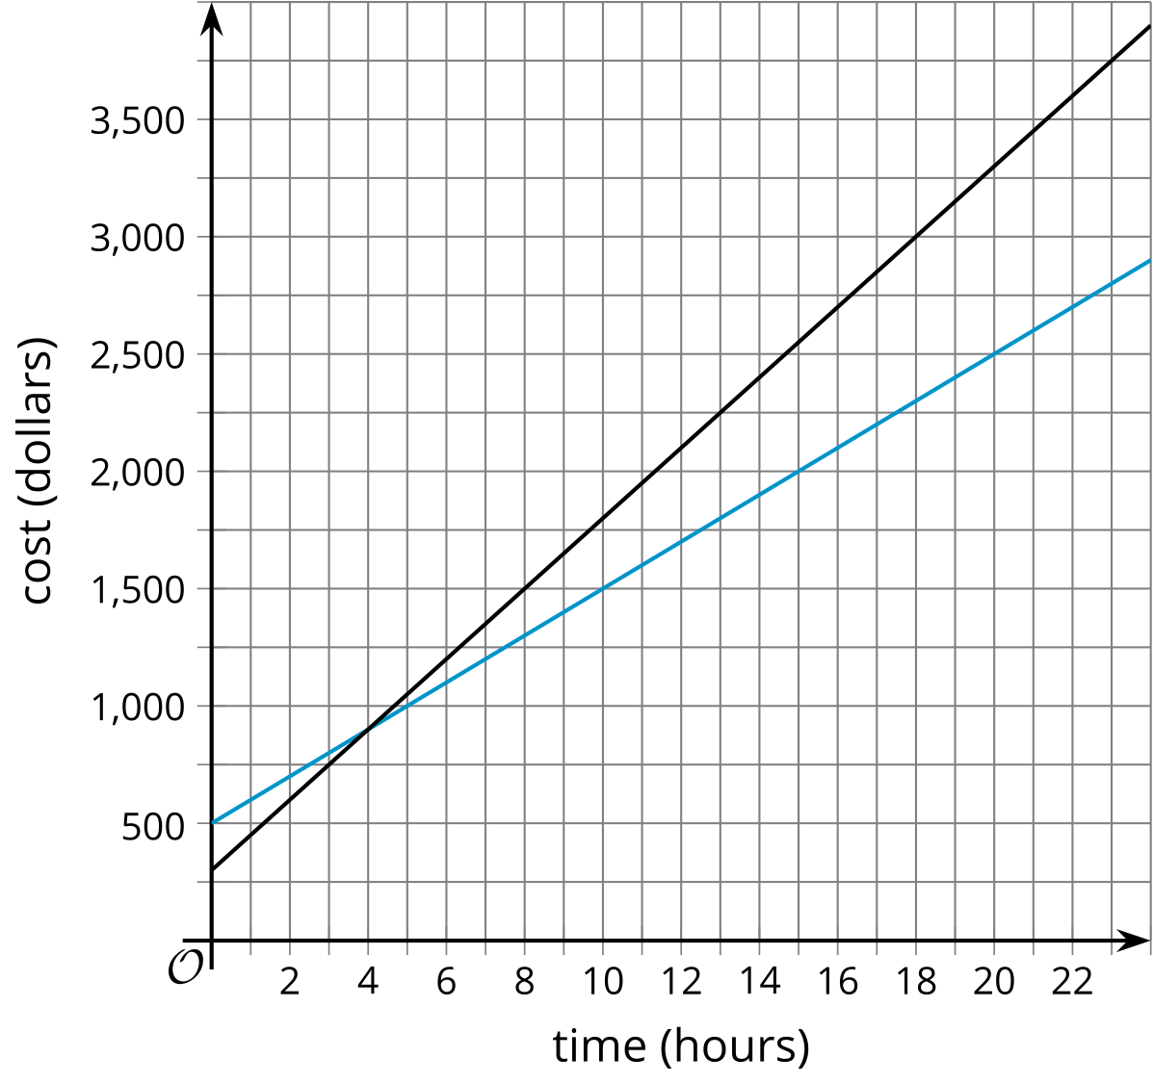
Two companies charge to rent time using their supercomputers. Their fees are given by the equations $f\left(t\right)=500+100t$ and $g\left(t\right)=300+150t$. The lines $y=f\left(t\right)$ and $y=g\left(t\right)$ are graphed.
- Which line represents $y=f\left(t\right)$? Explain how you know.
- The lines intersect at the point $\left(4,900\right)$. What does this point mean in this situation?
- Which is greater, $f\left(10\right)$ or $g\left(10\right)$? What does that mean in this situation?
- Your group has $1,500 to spend on supercomputer time. Which company should your group use?
  - Explain or show your reasoning using the equations.
  - Explain or show your reasoning using the graph.
© CC BY 2019 by Illustrative Mathematics®

