Lesson 2: Introducing Geometric Sequences
- Let’s explore growing and shrinking patterns.

2.1: Notice and Wonder: A Pattern in Lists
What do you notice? What do you wonder?
- 40, 120, 360, 1080, 3240
- 2, 8, 32, 128, 512
- 1000, 500, 250, 125, 62.5
- 256, 192, 144, 108, 81

2.2: Paper Slicing
Clare takes a piece of paper, cuts it in half, then stacks the pieces. She takes the stack of two pieces, then cuts in half again to form four pieces, stacking them. She keeps repeating the process.
number  of cuts | number  of pieces | area in square inches  of each piece
0
1
2
3
4
5
- The original piece of paper has length 8 inches and width 10 inches. Complete the table.
- Describe in words how you can use the results after 5 cuts to find the results after 6 cuts.
- On the given axes, sketch a graph of the number of pieces as a function of the number of cuts. How can you see on the graph how the number of pieces is changing with each cut?
- On the given axes, sketch a graph of the area of each piece as a function of the number of cuts. How can you see how the area of each piece is changing with each cut?
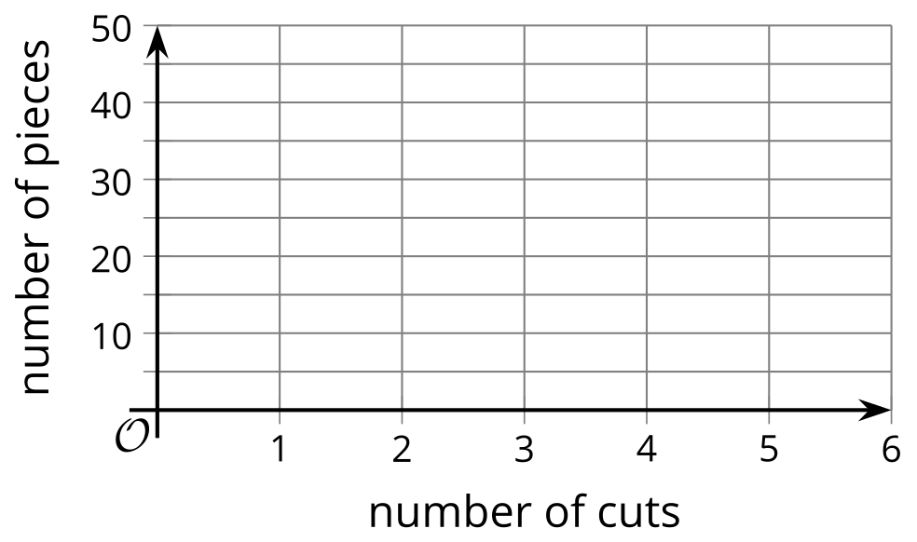

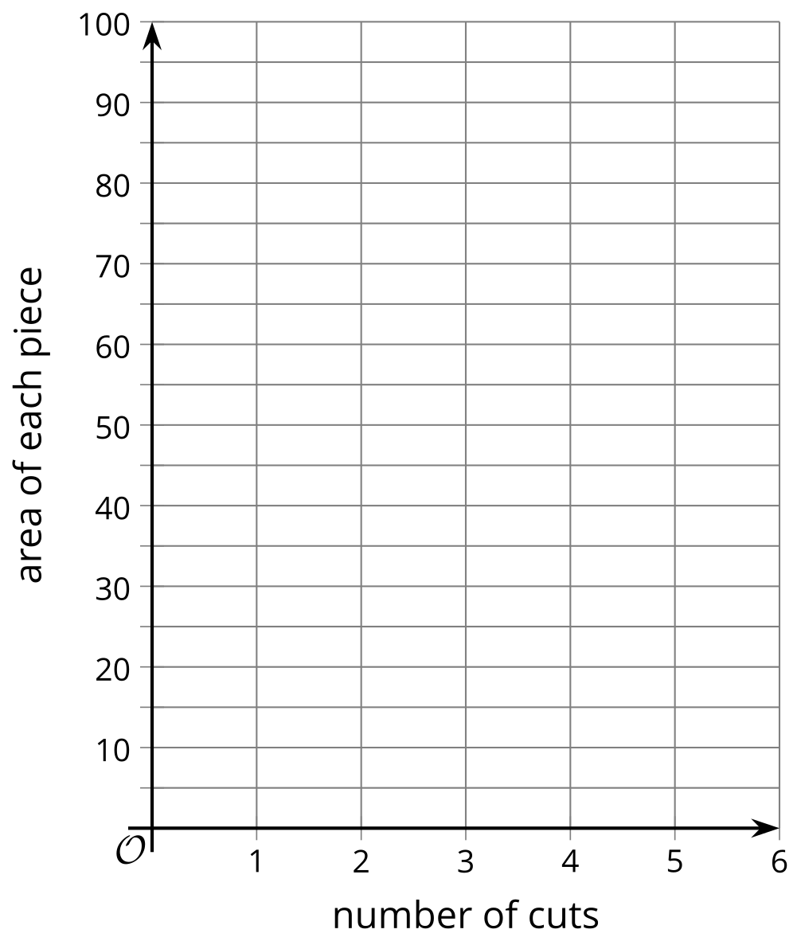

Are you ready for more?
- Clare has a piece of paper that is 8 inches by 10 inches. How many pieces of paper will Clare have if she cuts the paper in half $n$ times? What will the area of each piece be?
- Why is the product of the number of pieces and the area of each piece always the same? Explain how you know.

2.3: Complete the Sequence
- Complete each geometric sequence.
  - 1.5, 3, 6, ___, 24, ___
  - 40, 120, 360, ___, ___
  - 200, 20, 2, ___, 0.02, ___
  - $\frac{1}{7}$, ___, $\frac{9}{7}$, $\frac{27}{7}$, ___
  - 24, 12, 6, ___, ___
- For each sequence, find its growth factor.

Lesson 2 Summary
Consider the sequence 2, 6, 18, . . . How would you describe how to calculate the next term from the previous?
In this case, each term in this sequence is 3 times the term before it.
A way to describe this sequence would be: the starting term is 2, and the $\text{current term}=3⋅\text{previous term}$.
This is an example of a geometric sequence. A geometric sequence is one where the value of each term is the value of the previous term multiplied by a constant. If you know the constant to multiply by, you can use it to find the value of other terms.
This constant multiplier (the “3” in the example) is often called the sequence’s growth factor or common ratio. To find it, you can divide consecutive terms. This can also help you decide whether a sequence is geometric.
The sequence 1, 3, 5, 7, 9 is not a geometric sequence because $\frac{3}{1}≠\frac{5}{3}≠\frac{7}{5}$. The sequence 100, 20, 4, 0.8, however, is because if you divide each term by the previous term you get 0.2 each time: $\frac{20}{100}=\frac{4}{20}=\frac{0.8}{4}=0.2$.
© CC BY 2019 by Illustrative Mathematics®

