Lesson 6: Represent Numbers with Expressions
- Let’s compose and decompose numbers to make equal expressions.

Warm-up: True or False: Place Value
Decide if each statement true or false. Be prepared to explain your reasoning.
- 5 hundreds + 2 tens + 7 ones = 527
- 4 hundreds + 12 tens + 7 ones = 527
- 5 hundreds + 7 ones + 2 tens = 527

6.1: Make Equations True
Find the number that makes each equation true.
- 5 hundreds + _____ tens + 6 ones = 5 hundreds + 5 tens + 16 ones
- 1 hundred + 1 ten + 17 ones = 1 hundred + _____ tens + 7 ones
- 4 hundreds + 15 tens + 3 ones = _____ hundreds + 5 tens + 3 ones
- 4 hundreds + 3 tens + 7 ones = 3 hundreds + _____ tens + 7 ones
- 7 hundreds + 8 tens + 4 ones = 7 hundreds + 7 tens + _____ ones
- 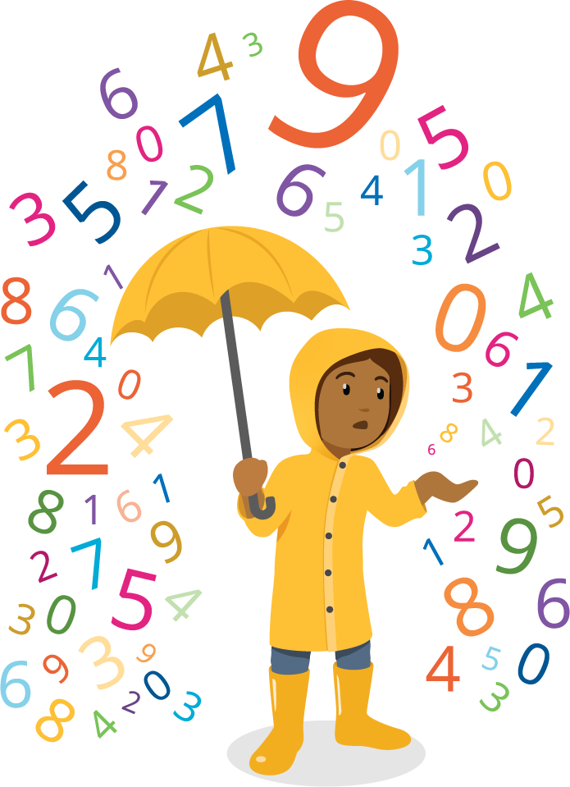
- 6 hundreds + 9 ones = 5 hundreds + _____ tens + 9 ones
- 2 hundreds + 9 tens + 17 ones = _____ hundreds + 7 ones
- 3 hundreds + 1 ten + 5 ones = 2 hundreds + 10 tens + _____ ones
If You Have Time: Make your own equation with a missing value for your partner.

6.2: Card Sort: Expressions with Three-digit Values
Group the cards into sets of expressions that have the same value. Record the letters of the matching cards. Write an expression that represents the same value.
- letters for matching expressions: __________________
- new expression:
- letters for matching expressions: __________________
- new expression:
- letters for matching expressions: __________________
- new expression:
- letters for matching expressions: __________________
- new expression:
© CC BY 2021 Illustrative Mathematics®

