Unit 6 Lesson 20: Interpret Remainders in Division Situations

WU Choral Count: 2, 3, and 5 (Warm up)

Student Task Statement

1 Muffins and Seats

Student Task Statement
- Two bakers at a bakery made 378 muffins. The muffins are put in boxes of 4.
  - The first baker says they will need 94 boxes for all the muffins.
  - The second baker says 95 boxes are needed.

- Who do you agree with? Explain or show your reasoning.
- An auditorium seats 258 people. The seats are arranged in rows of 9, but there is one short row with fewer than 9 seats.
- How many rows of 9 seats are there? How many seats are in the shorter row?

2 Save for a Garden

Student Task Statement
- A school needs $1,270 to build a garden. After saving the same amount each month for 8 months, the school is still short by $6.
- How much did they save each month? Explain or show your reasoning.
- 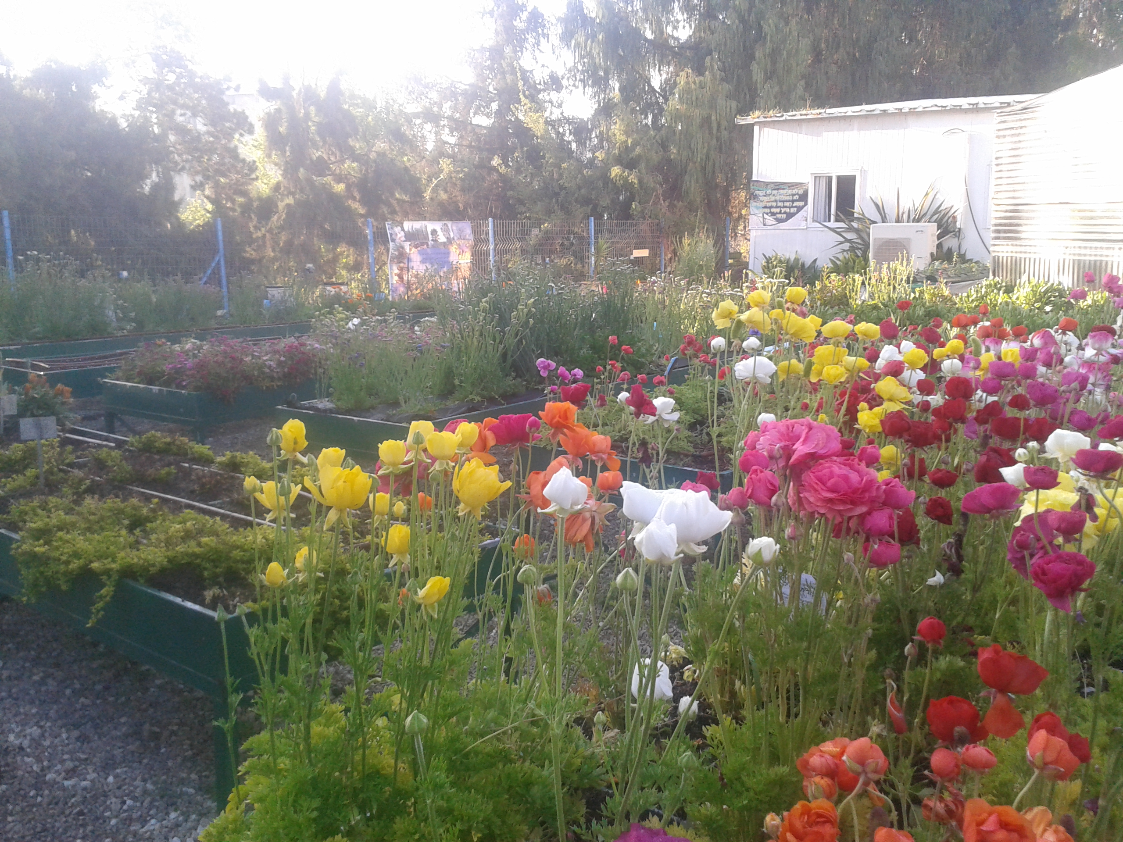
- Choose one of the following division expressions.
- $711÷3$
- $3,​128÷8$
  - Write a situation to represent the expression.
  - Find the value of the quotient. Show your reasoning.
  - What does the value of the quotient represent in your situation?
© CC BY 2021 Illustrative Mathematics®

