Lesson 16 Practice Problems
- Triangle $ABC$ and its medians are shown.
- Select all statements that are true.
  - The medians intersect at $\left(\frac{1}{3},2\right)$.
  - The medians and altitudes are the same for this triangle.
  - An equation for median $AE$ is $y=\frac{6}{7}(x+2)$.
  - Point $G$ is $\frac{2}{3}$ of the way from $A$ to $E$.
  - Median $BF$ is congruent to median $CD$.
- Triangle $ABC$ has vertices at $(\text{-}2,0),(\text{-}1,6),$ and $(6,0)$. What is the point of intersection of the triangle’s medians?
- Triangle $EFG$ and its medians are shown.
- Match each pair of segments with the ratios of their lengths.
  - $GK:KJ$
  - $GH:HF$
  - $HK:KE$
  - $1:1$
  - $1:2$
  - $2:1$
- Given $A=(\text{-}3,2)$ and $B=(7,\text{-}10)$, find the point that partitions segment $AB$ in a $1:4$ ratio.
- (From Unit 6, Lesson 15.)
- Graph the image of quadrilateral $ABCD$ under a dilation using center $A$ and scale factor $\frac{1}{3}$.
- 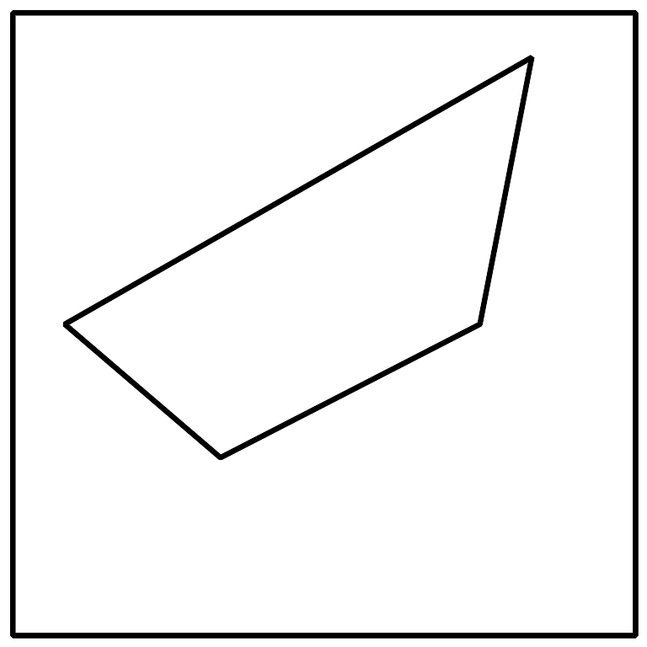
- (From Unit 6, Lesson 15.)
- A trapezoid is a quadrilateral with at least one pair of parallel sides. Show that the quadrilateral formed by the vertices $(0,0),(5,2),(10,10),$ and $(0,6)$ is a trapezoid.
- (From Unit 6, Lesson 14.)
- Here are the graphs of the circle centered at $(0,0)$ with radius 6 units and the line given by $2x+y=11$. Determine whether the circle and the line intersect at the point $(3,5)$. Explain or show your reasoning.
- 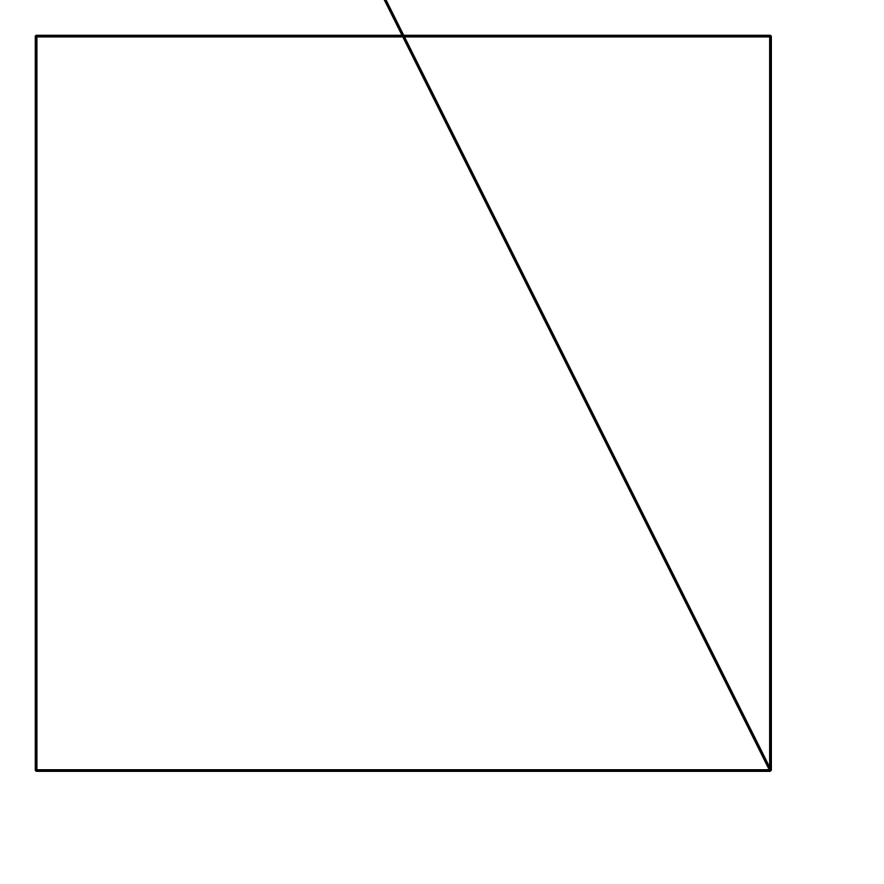
- (From Unit 6, Lesson 13.)
- A parabola has focus $(\text{-}3,2)$ and directrix $y=\text{-}3$. The point $(a,5)$ is on the parabola. How far is this point from the focus?
  - 8 units
  - 5 units
  - 3 units
  - 2 units
- (From Unit 6, Lesson 8.)
© CC BY 2019 by Illustrative Mathematics®

